#### Introduction

‘**Event Planner**’ is an idea that it self says that our project is about manage our college events online. User can register for the event which provided by the Admin. User has choice to participate in multiple events, and Admin can manage events and users as well.

Nowadays, handled events manually, so all kind of events are handling manually in paper work by each branch, and Its complicated to manage record of particular events. There is no system to check the past expenses on any event. To do this they have to check register and this task is quite time consuming and tiresome.

As an Existing system providing a functionality to handle events manually but there should be functionality to manage it online. This provides a single platform that can be used to handle several Campus Events of different branches like Engineering Department, BCA Department, BBA Department etc.

In any Shree Uttar Gujarat Campus events many student’s participant and it is very hard to manage these students. It is also important for event handler that he has all the contacts details of these students so that he can contact them any time. In present system Event Handler has to do all management work manually. They keep all information on papers. There is no system to check the past expenses on any event. To do this they have to check register and this task is quite time consuming and tiresome.

#### Core Components:

* + - **Add Events**
    - **Add Sub-Events**
    - **Daily Attendance**
    - **Practice Session Scheduling**
    - **Event Registration**
    - **Generate Dynamic Scheduling**
    - **Event Expense**

#### Targeted Users:

Our Targeted users are as follows:

|  |  |
| --- | --- |
| Users | Functionality |
| Admin | Manage Users, Manage Events, Manage Sub-Events, Manage Branches, Manage Roles, Manage Venues, Manage Expenses Type, Manage Choreographer, Manage Group, Manage Division, Manage Stream |
| Event Handler | Manage Sub-Events, Accept / Reject Expenses, Edit & Delete Attendance, Manage Scheduling, Manage Group, Manage Choreographer, Manage Users |
| Faculty Coordinator | Modify User Roles, Add Expenses, Manage Attendance, Manage Practice Scheduling, Manage Costumes |
| Student | Registration for Event, See Registered Events, Change Password, Forgot Password Through Email, Update Profile |
| Student Coordinator | Registration for Event, Add Expenses, Add Attendance |

#### 1.1 Project Profile

|  |  |
| --- | --- |
| Project Title | “Event Planner” |
| Project Duration | 2 Months |
| Project Internal Guide | Prof. Bincy Ruwala |
| Front End | Laravel, Jquery, Bootstrap-sass |
| Back End | PHP |
| Database | MySQL Server 10.3.16-MariaDB |
| Operating System | Windows |

**2.1 Hardware & Software Requirements**

There are many available ways for requirement gathering like,

* + 1. User Interaction
    2. Similar website study
    3. Questionnaire / Survey

For our system we have choose Similar website study. By which, we observed and decide the necessary requirements.

* + - * **Hardware Requirement**
        + **Client-Side Tools**

Processor: Intel ® Core™ i5-4200U CPU @ 1.60GHz 2.30GHz

RAM: 4 GB

Hard Disk: 500 MB Hard disk space

* + - * + **Server-Side Tools**

Processor: Intel ® i5 (3.1 GHz) (minimum)

RAM: 8 MB (minimum)

Hard Disk: 1 TB Hard disk space (minimum)

* + - * **Software Requirement**
* Operating System: Windows, Ubuntu
* Front-end: Laravel, Jquery, Bootstrap-sass
* Back-end: PHP, Laravel
* Database-technology: MySQL
* Development Tools: Visual Studio Code

**2.2 Technology Used**

* **PHP**

PHP is a general-purpose scripting language geared towards web

development. It was originally created by Danish-Canadian programmer Rasmus Lerdorf in 1993 and released in 1995. PHP was originally an abbreviation of Personal Home Page, but it now stands for the recursive initialism PHP: Hypertext Preprocessor.

* **PHP is an amazing and popular language!**
* PHP code is executed on the server.
* It is powerful enough to be at the core of the biggest blogging system on the web (WordPress)!
* It is deep enough to run large social networks!
* It is also easy enough to be a beginner's first server

side language!

* **What Can PHP Do?**
* PHP can generate dynamic page content
* PHP can create, open, read, write, delete, and close files on the server
* PHP can collect form data
* PHP can send and receive cookies
* PHP can add, delete, modify data in your database
* PHP can be used to control user-access
* PHP can encrypt data

* **Why PHP?**
* PHP runs on various platforms (Windows, Linux, Unix, Mac

OS X, etc.)

* PHP is compatible with almost all servers used today (Apache, IIS, etc.)
* PHP supports a wide range of databases

* **Laravel**

Laravel is a free and open-source PHP web framework, created by Taylor Otwell and intended for the development of web applications following the model–view–controller (MVC) architectural pattern and based on Symfony. Some of the features of Laravel are a modular packaging system with a dedicated dependency manager, different ways for accessing relational databases, utilities that aid in application deployment and maintenance,and its orientation toward syntactic sugar.

* **Advantages of Laravel**
* The web application becomes more scalable, owing to the

Laravel framework.

* Considerable time is saved in designing the web application,

since Laravel reuses the components from other framework in

developing web application.

* It includes namespaces and interfaces, thus helps to organize

and manage resources.

* **Features of Laravel**
* Authentication
* Testability
* Routing
* Configuration Management
* Query Builder and ORM
* Schema Builder
* Template Engine
* E-Mail
* **JQuery**

jQuery is a JavaScript library designed to simplify HTML DOM tree

traversal and manipulation, as well as event handling, CSS animations, and Ajax. It is free, open-source software using the permissive MIT License.

As of August 2022, jQuery is used by 77% of the 10 million most popular websites. Web analysis indicates that it is the most widely deployed

JavaScript library by a large margin, having at least three to four times more usage than any other JavaScript library.

* **Why jQuery?**
* There are lots of other JavaScript libraries out there, but jQuery is probably the most popular, and also the most extendable.
* jQuery is a lightweight, "write less, do more", JavaScript library.

#### 3.1 Data Dictionary

|  |  |
| --- | --- |
| **Sr No** | **Table Name** |
| 1 | Branch Master |
| 2 | Venue |
| 3 | Role |
| 4 | Stream Master |
| 5 | Division Master |
| 6 | Event Master |
| 7 | Sub-Event Master |
| 8 | User Master |
| 9 | Group |
| 10 | Event Registration |
| 11 | Expense Type |
| 12 | Expense |
| 13 | Guest Invitation |
| 14 | Guest |
| 15 | Choreographer |
| 16 | Costume |
| 17 | Practice Schedule |
| 18 | Attendance |
| 19 | Scheduling |

**BRANCH MASTER**

* This table contains all details of Branches.

|  |  |  |  |  |
| --- | --- | --- | --- | --- |
| **Field Name** | **Data Type** | **Constraint** | **Description** | **Sample Data** |
| B_ID | INT (5) | PK | Unique Branch id | 1 |
| B_CODE | INT (5) | NOT NULL | Code of the Branch | 517 |
| B_NAME | VARCHAR (50) | NOT NULL | Name of the Branch | LJMCA |

**VENUE**

* This table contains all details of Event Venues.

|  |  |  |  |  |
| --- | --- | --- | --- | --- |
| **Field Name** | **Data Type** | **Constraint** | **Description** | **Sample Data** |
| V_ID | INT (5) | PK | Unique Venue id | 1 |
| V_NAME | VARCHAR (50) | NOT NULL | Name of the Venue | Tagor Hall |
| V_ADDRESS | VARCHAR (255) | NOT NULL | Address of the Venue | Near iscon temple |

**ROLE**

* This table contains all details of User Roles.

|  |  |  |  |  |
| --- | --- | --- | --- | --- |
| Field Name | Data Type | Constraint | Description | Sample Data |
| R_ID | INT (5) | PK | Unique Role id | 1 |
| R_NAME | VARCHAR (20) | NOT NULL | Name of the Role | Student Coordinator |

**STREAM MASTER**

* This table contains all details of Stream.

|  |  |  |  |  |
| --- | --- | --- | --- | --- |
| **Field Name** | **Data Type** | **Constraint** | **Description** | **Sample Data** |
| S_ID | INT (5) | PK | Unique Stream id | 1 |
| B_ID | INT (5) | FK | Reference to Branch Id | 1 |
| S_NAME | VARCHAR (50) | NOT NULL | Stream name | MCA |

**DIVISION MASTER**

* This table contains all details of Division.

|  |  |  |  |  |
| --- | --- | --- | --- | --- |
| **Field Name** | **Data Type** | **Constraint** | **Description** | **Sample Data** |
| D_ID | INT (5) | PK | Unique Division id | 1 |
| S_ID | INT (5) | FK | Reference to Stream Id | 1 |
| D_NAME | VARCHAR (10) | NOT NULL | Division name | C |

#### EVENT MASTER

* This table contains all details of Events.

|  |  |  |  |  |
| --- | --- | --- | --- | --- |
| **Field Name** | **Data Type** | **Constraint** | **Description** | **Sample Data** |
| E_ID | INT (5) | PK | Unique Event id | 1 |
| B_ID | INT (5) | FK | Reference to Branch Id | 1 |
| V_ID | INT (5) | FK | Reference to Venue Id | 1 |
| E_NAME | VARCHAR (30) | NOT NULL | Name of the Event | Enthusia |
| E_START_TIME | TIME | NOT NULL | Event Start Time | 5:00PM |
| E_END_TIME | TIME | NOT NULL | Event End Time | 9:00PM |
| E_DESCRIPTION | TEXT | NOT NULL | Description of Event | Annual function |
| E_STATUS | BOOLEAN | NOT NULL | Event Status | TRUE |
| START_DATE | DATE | NOT NULL | Event Start Date | 25/2/2020 |
| END_DATE | DATE | NOT NULL | Event End Date | 25/2/2020 |

**SUB EVENT MASTER**

* This table contains all details of Sub-Events.

|  |  |  |  |  |
| --- | --- | --- | --- | --- |
| **Field Name** | **Data Type** | **Constraint** | **Description** | **Sample Data** |
| S_E_ID | INT (5) | PK | Unique Sub Event id | 1 |
| E_ID | INT (5) | FK | Reference to Event Id | 1 |
| S_E_NAME | VARCHAR (30) | NOT NULL | Name of the Sub Event | Ramp Walk |
| DESCRIPTION | TEXT | NOT NULL | Description of Sub Event | Ramp Walk |
| DURATION | TIME | NOT NULL | Duration of Sub Event | 4 min |
| STATUS | BOOLEAN | NOT NULL | Status of Sub Event | TRUE |

#### USER MASTER

* This table contains all details of Users.

|  |  |  |  |  |
| --- | --- | --- | --- | --- |
| **Field Name** | **Data Type** | **Constraint** | **Description** | **Sample Data** |
| U_ID | INT (5) | PK | Unique User id | 1 |
| B_ID | INT (5) | FK | Reference to Branch Id | 1 |
| S_ID | INT (5) | FK | Reference to Stream Id | 1 |
| D_ID | INT (5) | FK | Reference to Division Id | 1 |
| USER_TYPE | INT (5) | FK | Reference to Role table | 4 |
| F_NAME | VARCHAR (20) | NOT NULL | First name of the User | Sunil |
| L_NAME | VARCHAR (20) | NOT NULL | Last name of the User | Gorasiya |
| EMAIL | VARCHAR (40) | UNIQUE | Email id of User | sunil@gmail. com |
| PHONE | VARCHAR (13) | UNIQUE | Mobile number of the User | 7852369412 |
| DOB | DATE | NOT NULL | User Date of Birth | 23/5/1995 |
| GENDER | CHAR (1) | NOT NULL | Gender of User | M |
| PASSWORD | TEXT | NOT NULL | Password of User | ********* |
| ENROLLMENT_NO | VARCHAR (12) | NULL | Enrollment number  of User | 17517369205  0 |

**GROUP**

* This table contains all details of Groups.

|  |  |  |  |  |
| --- | --- | --- | --- | --- |
| **Field Name** | **Data Type** | **Constraint** | **Description** | **Sample Data** |
| G_ID | INT (5) | PK | Unique Group id | 1 |
| E_ID | INT (5) | FK | Reference to Event Id | 1 |
| U_ID | INT (5) | FK | Reference to User Id | 1 |
| S_E_ID | INT (5) | FK | Reference to Sub Event Id | 1 |
| R_ID | INT (5) | FK | Reference to Role Id | 1 |

**EVENT REGISTRATION**

* This table contains all details of Event Registrations.

|  |  |  |  |  |
| --- | --- | --- | --- | --- |
| **Field Name** | **Data Type** | **Constraint** | **Description** | **Sample Data** |
| E_R_ID | INT (5) | PK | Unique Event Register Id | 1 |
| S_E_ID | INT (5) | FK | Reference to Sub Event Id | 1 |
| U_ID | INT (5) | FK | Reference to User Id | 1 |
| R_ID | INT (5) | FK | Reference to Role Id | 1 |
| G_ID | INT (5) | FK | Reference to Group Id | 1 |
| STATUS | BOOLEAN | NOT NULL | Event Status for Registration | TRUE |

**EXPENSE TYPES**

* This table contains all details of Expense types.

|  |  |  |  |  |
| --- | --- | --- | --- | --- |
| **Field Name** | **Data Type** | **Constraint** | **Description** | **Sample Data** |
| E_T ID | INT (5) | PK | Unique Choreographer id | 1 |
| E NAME | VARCHAR (20) | NOT NULL | Expense name | Food |

**CHOREOGRAPHER**

* This table contains all details of Choreographer.

|  |  |  |  |  |
| --- | --- | --- | --- | --- |
| **Field Name** | **Data Type** | **Constraint** | **Description** | **Sample Data** |
| C_ID | INT (5) | PK | Unique Choreographer id | 1 |
| S_E_ID | INT (5) | FK | Reference to Sub Event Id | 1 |
| C_NAME | VARCHAR (20) | NOT NULL | Name of the Choreographer | Tushar |
| C_PHONE | VARCHAR (13) | UNIQUE | Choreographer Contact no. | 9874512365 |
| C_EMAIL | VARCHAR (40) | UNIQUE | Choreographer Email id | [tushar@gmail.com](mailto:tushar@gmail.com) |

|  |  |  |  |  |
| --- | --- | --- | --- | --- |
| **Field Name** | **Data Type** | **Constraint** | **Description** | **Sample Data** |
| EXPENCE_ID | INT (5) | PK | Unique Expense id | 1 |
| E_ID | INT (5) | FK | Reference to Event Id | 1 |
| S_E_ID | INT (5) | FK | Reference to Sub Event Id | 1 |
| U_ID | INT (5) | FK | Reference to User Id | 1 |
| E_T_ID | INT (5) | FK | Reference to Expense type Id | Snacks |
| AMOUNT | INT (5) | NOT NULL | Amount of expense | 3000 |
| DESCRIPTION | TEXT | NOT NULL | Expense Description | Snacks |
| STATUS | BOOLEAN | NOT NULL | Expense Status | TRUE |

**EXPENCE**

* This table contains all details of Expense.

#### COSTUME

* This table contains all details of Costumes.

|  |  |  |  |  |
| --- | --- | --- | --- | --- |
| **Field Name** | **Data Type** | **Constraint** | **Description** | **Sample Data** |
| COSTUME_ID | INT (5) | PK | Unique Costume id | 1 |
| S_E_ID | INT (5) | FK | Reference to Sub Event Id | 1 |
| U_ID | INT (5) | FK | Reference to User Id | 1 |
| ISSUER | INT (5) | FK | Costume issuer Id (User) | 1 |
| RETURNER | INT (5) | FK | Costume returner Id (User) | 1 |
| ISSUE_DATE | DATE | NOT NULL | Issue Date of Costume | 1/2/2020 |
| RETURN_DATE | DATE | NULL | Return Date of Costume | null |
| STATUS | BOOLEAN | NOT NULL | Status of Costume | TRUE |

**PRACTICE SCHEDULE**

* This table contains all details of Practice Session Scheduling.

|  |  |  |  |  |
| --- | --- | --- | --- | --- |
| **Field Name** | **Data Type** | **Constraint** | **Description** | **Sample Data** |
| P_ID | INT (5) | PK | Unique Practice Schedule id | 1 |
| S_E_ID | INT (5) | FK | Reference to Sub Event Id | 1 |
| U_ID | INT (5) | FK | Reference to User Id | 1 |
| PARTICIPANTS | LONGTEXT | NOT NULL | Total participants | 10 |
| DESCRIPTION | TEXT | NOT NULL | Practice Schedule Description | Ramp Walk |
| TIME | TIME | NOT NULL | Practice Schedule Time | 4:00 PM |
| DATE | DATE | NOT NULL | Practice Schedule Date | 10/2/2020 |

**GUESTINVITATIONS**

* This table contains all details of Guest Invitations.

|  |  |  |  |  |
| --- | --- | --- | --- | --- |
| **Field Name** | **Data Type** | **Constraint** | **Description** | **Sample Data** |
| I_ID | INT (5) | PK | Unique Invitation id | 1 |
| E_ID | INT (5) | FK | Reference to Event Id | 1 |
| GUEST_ID | INT (5) | FK | Reference to Guest Id | 1 |
| DESCRIPTION | TEXT | NOT NULL | Invitations Description | Prize Distribution |
| DATE | DATE | NOT NULL | Invitation Date | 10/2/2020 |

**Guests**

* This table contains all details of Guests.

|  |  |  |  |  |
| --- | --- | --- | --- | --- |
| **Field Name** | **Data Type** | **Constraint** | **Description** | **Sample Data** |
| GUEST ID | INT (5) | PK | Unique Scheduling id | 1 |
| EMAIL | VARCHAR (60) | NOT NULL | Guest Mail Id | [nitin@gmail.com](mailto:nitin@gmail.com) |
| NAME | VARCHAR (20) | NOT NULL | Guest Name | Nitin Jani |
| PHON | VARCHAR (13) | NOT NULL | Guest Contact Number | 9978564332 |

**ATTENDANCE**

* This table contains all details of Attendance.

|  |  |  |  |  |
| --- | --- | --- | --- | --- |
| **Field Name** | **Data Type** | **Constraint** | **Description** | **Sample Data** |
| A_ID | INT (5) | PK | Unique Attendance id | 1 |
| U_ID | INT (5) | FK | Reference to User Id | 1 |
| S_E_ID | INT (5) | FK | Reference to Sub Event Id | 1 |
| PRESENT | LONGTEXT | NOT NULL | Present mark in Attendance | YES |
| DATE | DATE | NOT NULL | Date of Attendance taken | 5/2/2020 |

**SCHEDULING**

* This table contains all details of Events Scheduling.

|  |  |  |  |  |
| --- | --- | --- | --- | --- |
| **Field Name** | **Data Type** | **Constraint** | **Description** | **Sample Data** |
| SCHED_ID | INT (5) | PK | Unique Scheduling id | 1 |
| E_ID | INT (5) | FK | Reference to Event Id | 1 |
| DETAILS | LONGTEXT | NOT NULL | Details of Scheduling | Event Scheduling |
| TIME | TIME | NOT NULL | Time of Generating Schedule | 5.38 PM |

* 1. **Feasibility Analysis**
     + A Feasibility Study plays very important role in the development of any system. But when it is the case of development of any Website then it’s important to increases much more because in this case one should be very clear about the availability of the time and resources.
     + Before starting the development of the software one should give considerable amount of time for feasibility study because the successful completion of the Project depends upon its Feasibility.

**3.2.1 Economic Feasibility**

The economic feasibility analysis for the Event Management System (EMS) assesses the financial viability and potential returns on investment.

* **Cost-Benefit Analysis:**

A thorough cost-benefit analysis has been conducted, accounting for initial development costs, ongoing maintenance, and potential revenue streams. The benefits include increased efficiency in event planning and execution, reduced manual workload, and improved client satisfaction.

* **Return on Investment (ROI):**

The projected ROI demonstrates the financial viability of the project. Calculations indicate that the benefits derived from the EMS, such as time savings and enhanced client relationships, outweigh the initial and ongoing costs.

* **Revenue Model:**

The revenue model includes event planning service charges, premium features, and potential partnerships with vendors. This diversified approach ensures sustainable revenue generation, contributing to the project's economic success.

**3.2.2 Technical Feasibility**

The technical feasibility analysis ensures that the Event Management System can be successfully developed, implemented, and maintained in a PHP environment.

* **Technology Stack**

The PHP programming language, coupled with a robust database system,

has been selected as the core technology stack. The compatibility and scalability of PHP ensure a reliable and efficient system that can handle varying workloads.

* **Development and Implementation Plan:**

A detailed plan outlines the development stages, including database design, user interface development, and testing phases. The plan ensures a systematic

approach, allowing for efficient collaboration among developers and timely delivery of milestones.

* **Scalability and Performance:**

The system architecture is designed to be scalable, accommodating a growing

user base and increasing data volumes. Performance testing has been conducted to guarantee optimal response times and resource utilization.

* **Security Measures:**

Security protocols, including data encryption, user authentication, and secure API integrations, have been implemented to safeguard sensitive information. Regular security audits will be conducted to identify and address potential vulnerabilities.

**3.2.3 Behavioral Feasibility**

Behavioral feasibility analyzes how the introduction of the Event Management System will impact individuals, teams, and organizational culture.

* **Stakeholder Analysis:**

A comprehensive stakeholder analysis has been performed to understand the expectations and concerns of clients, event planners, and system administrators. Communication strategies have been devised to address stakeholder needs and foster support.

* **Training and Change Management:**

A tailored training program has been developed to ensure that users can effectively utilize the EMS. Change management strategies are in place to address any potential resistance to adopting new processes, promoting a positive transition within the organization.

* **User Experience (UX):**

The user interface has been designed with a focus on usability and a positive user experience. Regular feedback sessions and user testing have been conducted to refine the system based on user preferences, ensuring high levels of user acceptance.

* **Continuous Improvement:**

A feedback loop and continuous improvement process have been established to gather insights from users and stakeholders.

This iterative approach ensures that the Event Management System evolves in response to changing user needs and industry trends.

In conclusion, the feasibility analysis establishes the economic, technical, and behavioral foundations for the successful development and implementation of the Event Management System in PHP. This comprehensive analysis ensures that the project is strategically positioned for success in meeting the needs of both clients and end-users.

**3.3 E-R Diagrame**

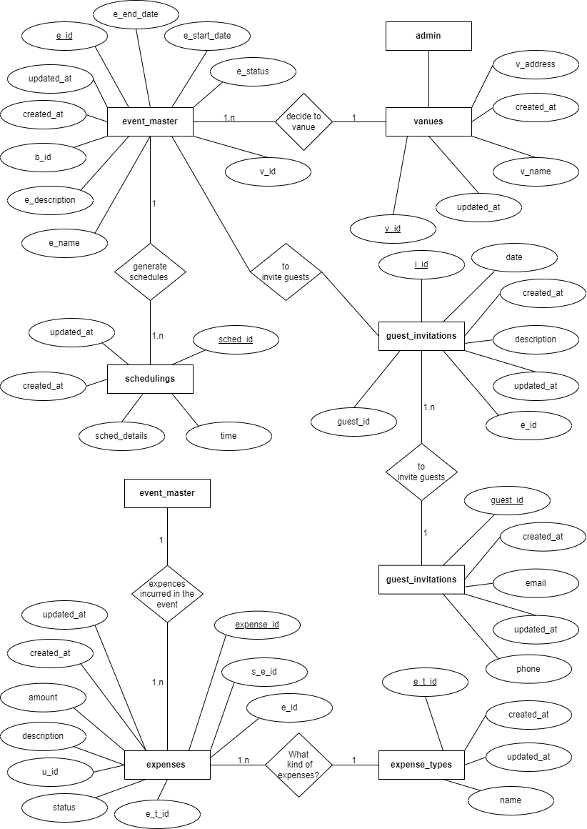

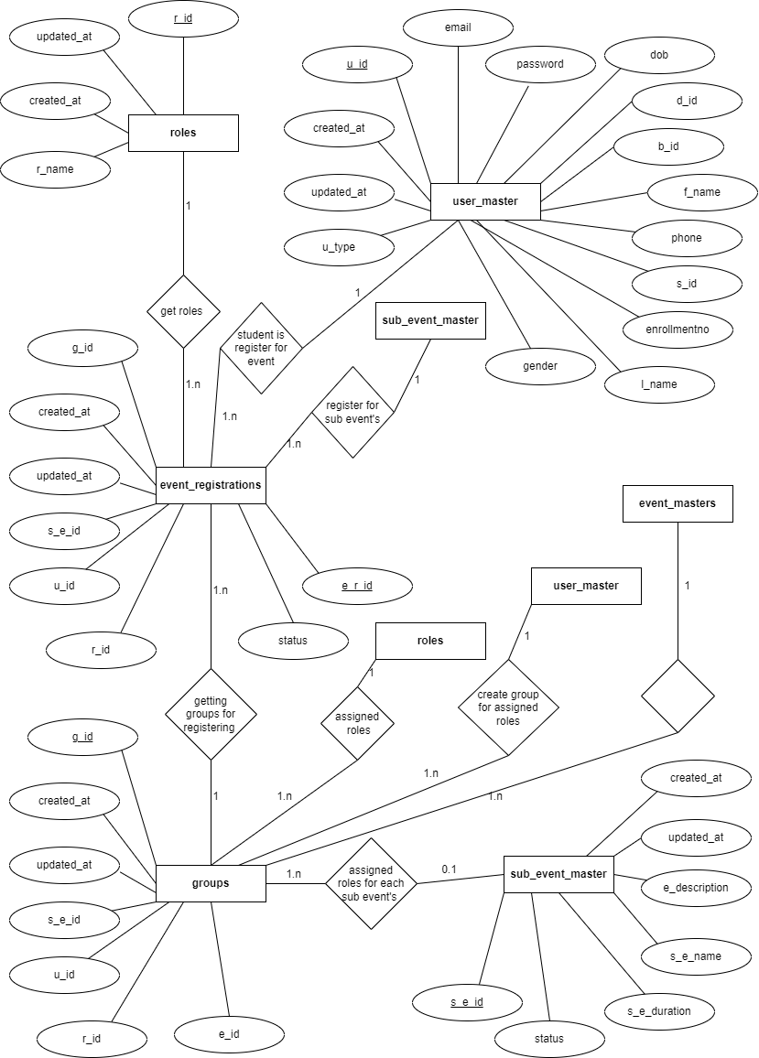

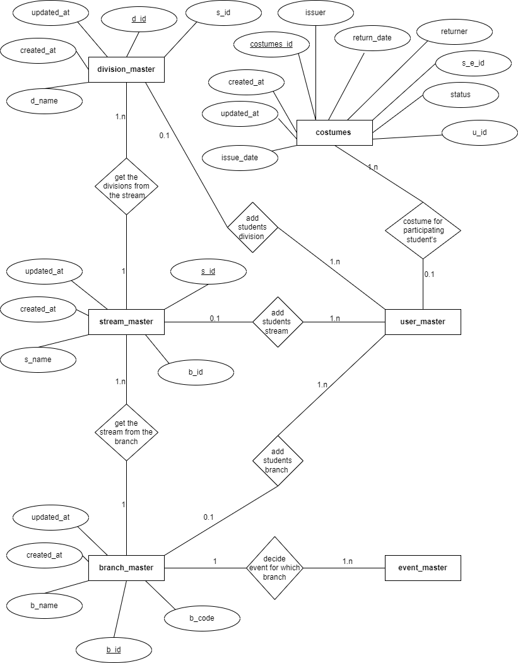

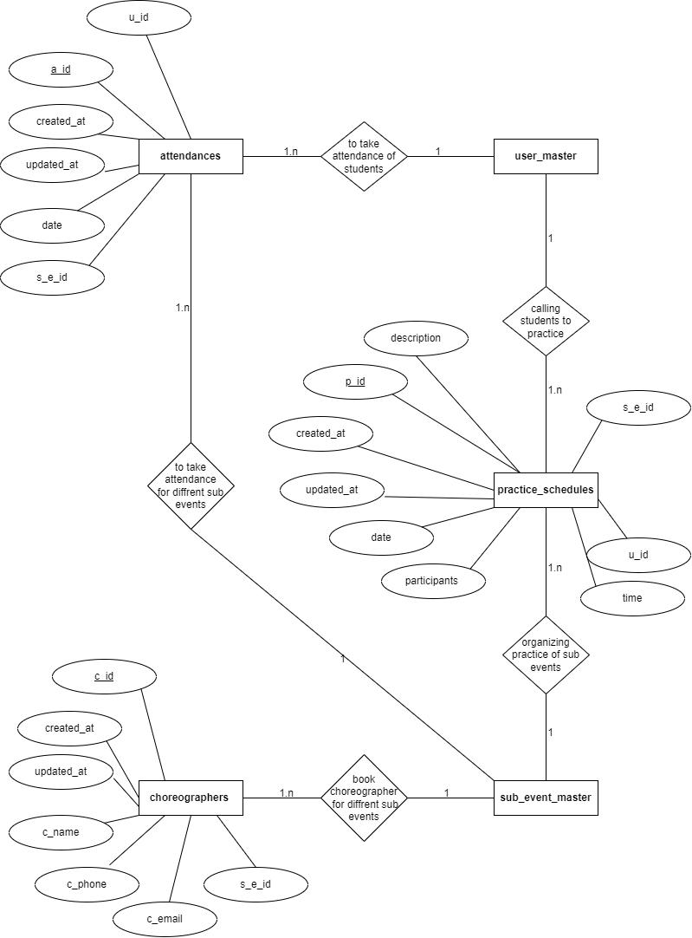

**3.4 Use Case Diagrame**

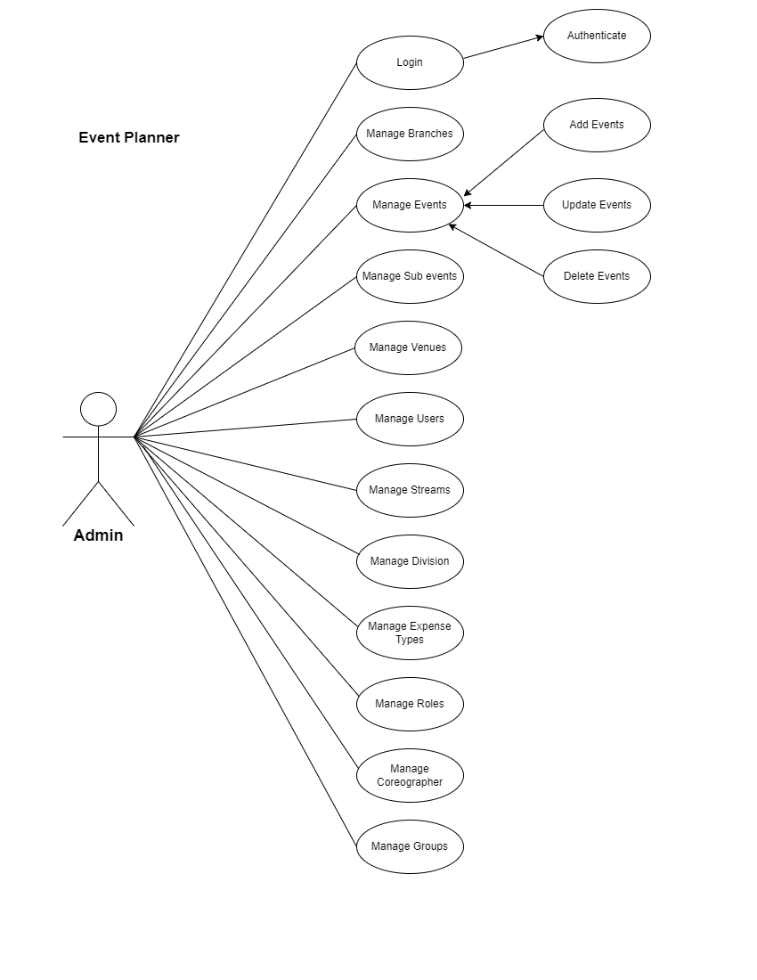

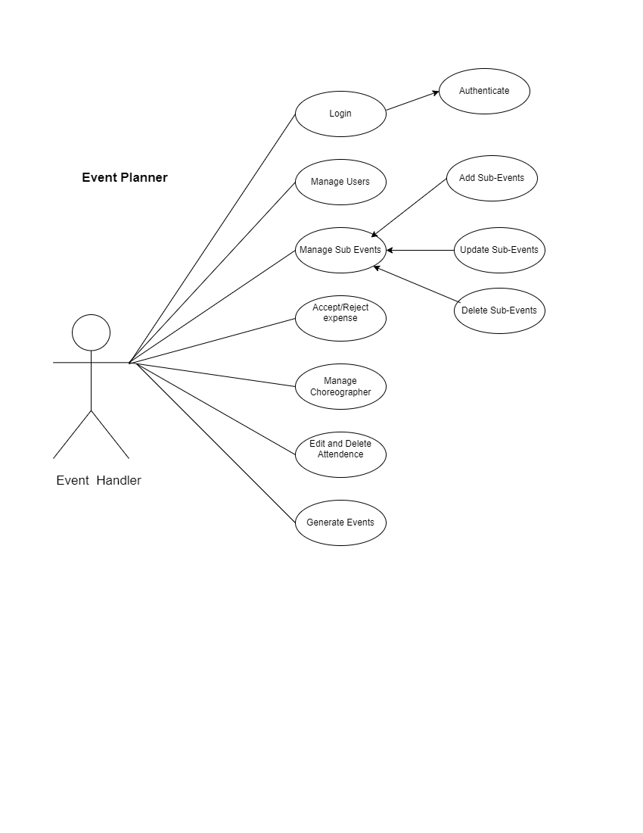

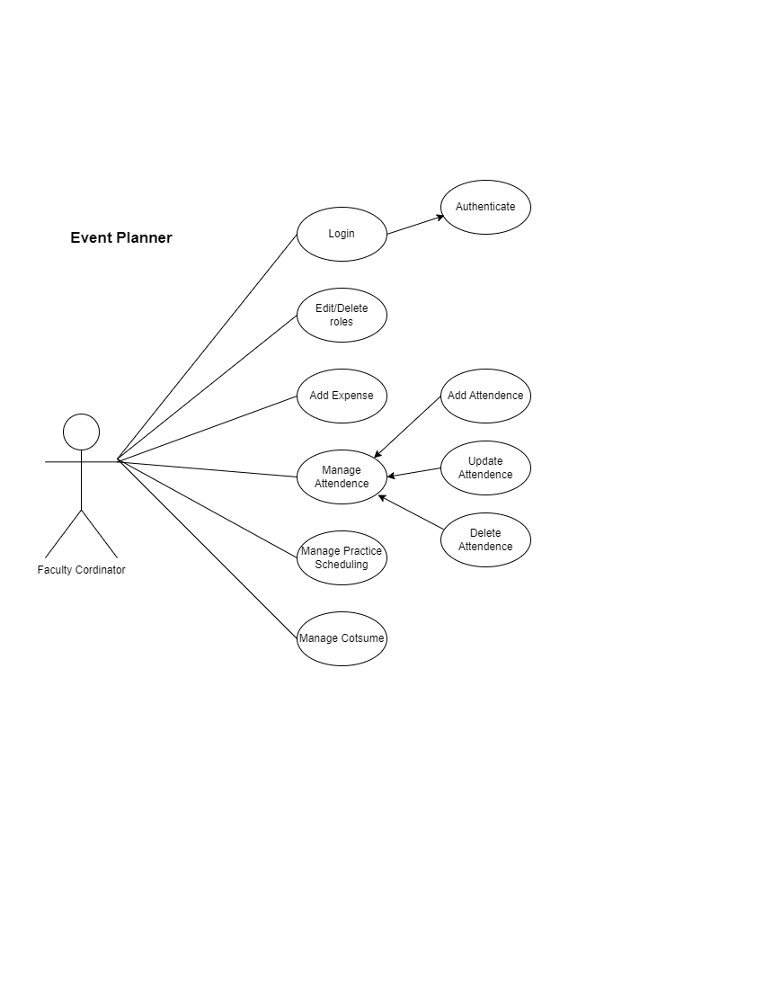

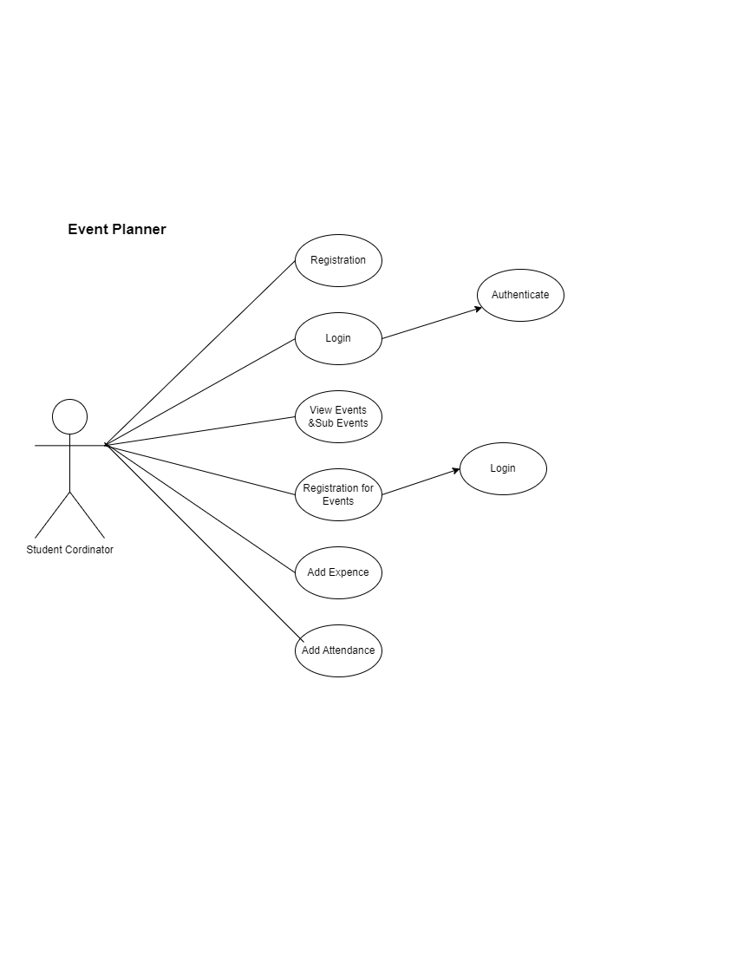

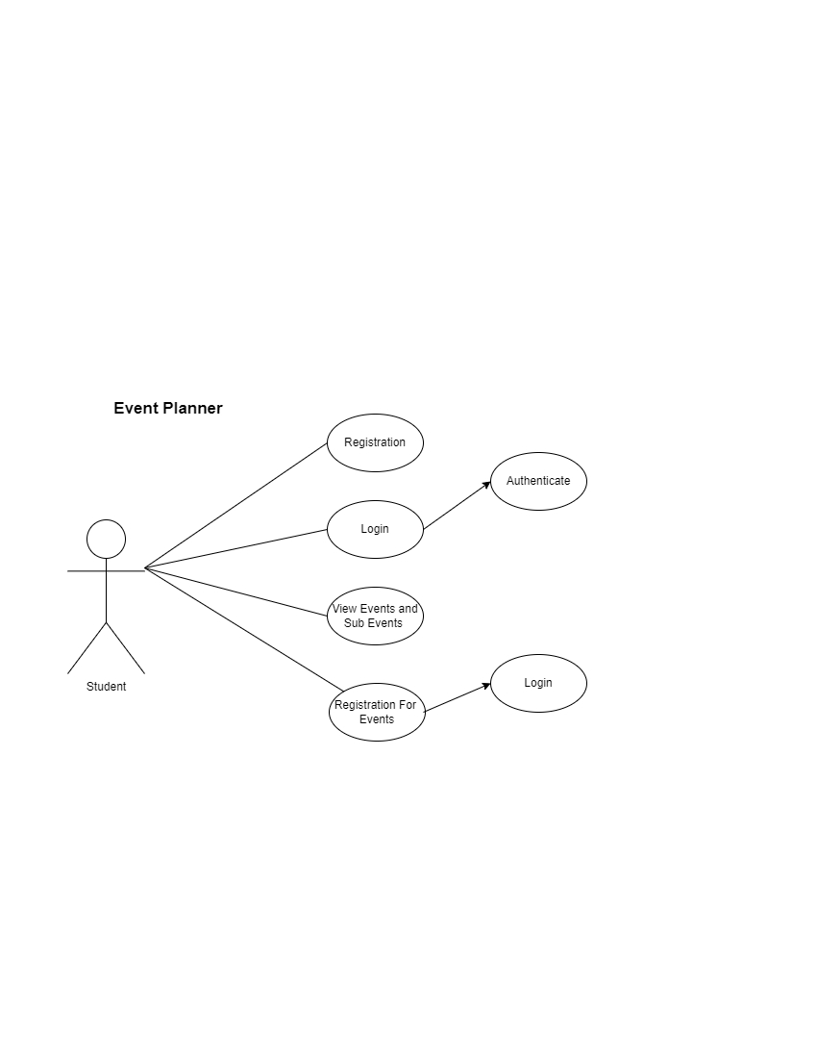

**4.1 Scope**

* The scope of the Event Management System (EMS) project encompasses the design, development, and implementation of a comprehensive web-based application using PHP to facilitate efficient and organized event planning and management. The system aims to cover a broad spectrum of events, including conferences, seminars, parties, and corporate gatherings.
* Key features within the scope include:
* **User Management:**

Allow different user roles such as administrators, event planners, and participants with varying levels of access and permissions.

* **Registration and Ticketing:**

Implement a secure registration system with ticketing functionality, enabling participants to register for events, purchase tickets, and receive confirmations.

* **Venue Management:**

Include features for managing event venues, including details on available spaces, amenities, and booking information.

* **Reporting and Analytics:**

Generate reports on event attendance, financials, and participant feedback to aid in decision-making and future planning.

* **Security and Access Control:**

Implement robust security measures to protect user data, financial transactions,

and ensure only authorized access to sensitive information.

**4.2 Objectives**

* To manage User’s Role, Groups, Events, Sub events of events, Users.
* To handle different Branches, Streams and Divisions.
* To manage Events Venues, Events Expense, Sub Events Expense, Total Expense.
* Dynamic scheduling Generation for Sub Events and Attendance Management for Specific Event Scheduling, Notification Reminder to Student for practice

Schedule.

* To Manage Previous Year Events records.
* **Efficiency Enhancement:**

Streamline the event planning and management processes to increase efficiency

for both organizers and participants.

* **Customization:**

Allow organizers to customize event details, registration forms, and

communication templates to meet the unique requirements of different events.

.

**4.3 Expected Advantages**

* Event Scheduling Completed within couple of minutes.
* To Maintain events records yearly.
* Practice session notification to all registered student.
* Overcomes the dependency of a single person handling all the activities.
* Student can register from anywhere not necessary to come college.
* **Time Savings:**

Automation of repetitive tasks will save time for event organizers, allowing them

to focus on creating memorable experiences.

* **Improved Organization:**

Centralized event planning and management will lead to better organization, reducing the likelihood of errors and oversights.

* **Enhanced User Experience:**

Participants will benefit from a seamless registration process, timely notifications, and easy access to event information, contributing to a positive overall experience.

* **Data-Driven Decision Making:**

Robust reporting and analytics features will enable data-driven decision-making

or event organizers, leading to more informed choices and improvements in future events.

In summary, the Event Management System project aims to deliver a robust,

user-friendly, and scalable solution that enhances the efficiency of event planning and management, providing a positive experience for both organizers and participants.

**Output Design**

**Admin**

**Login**

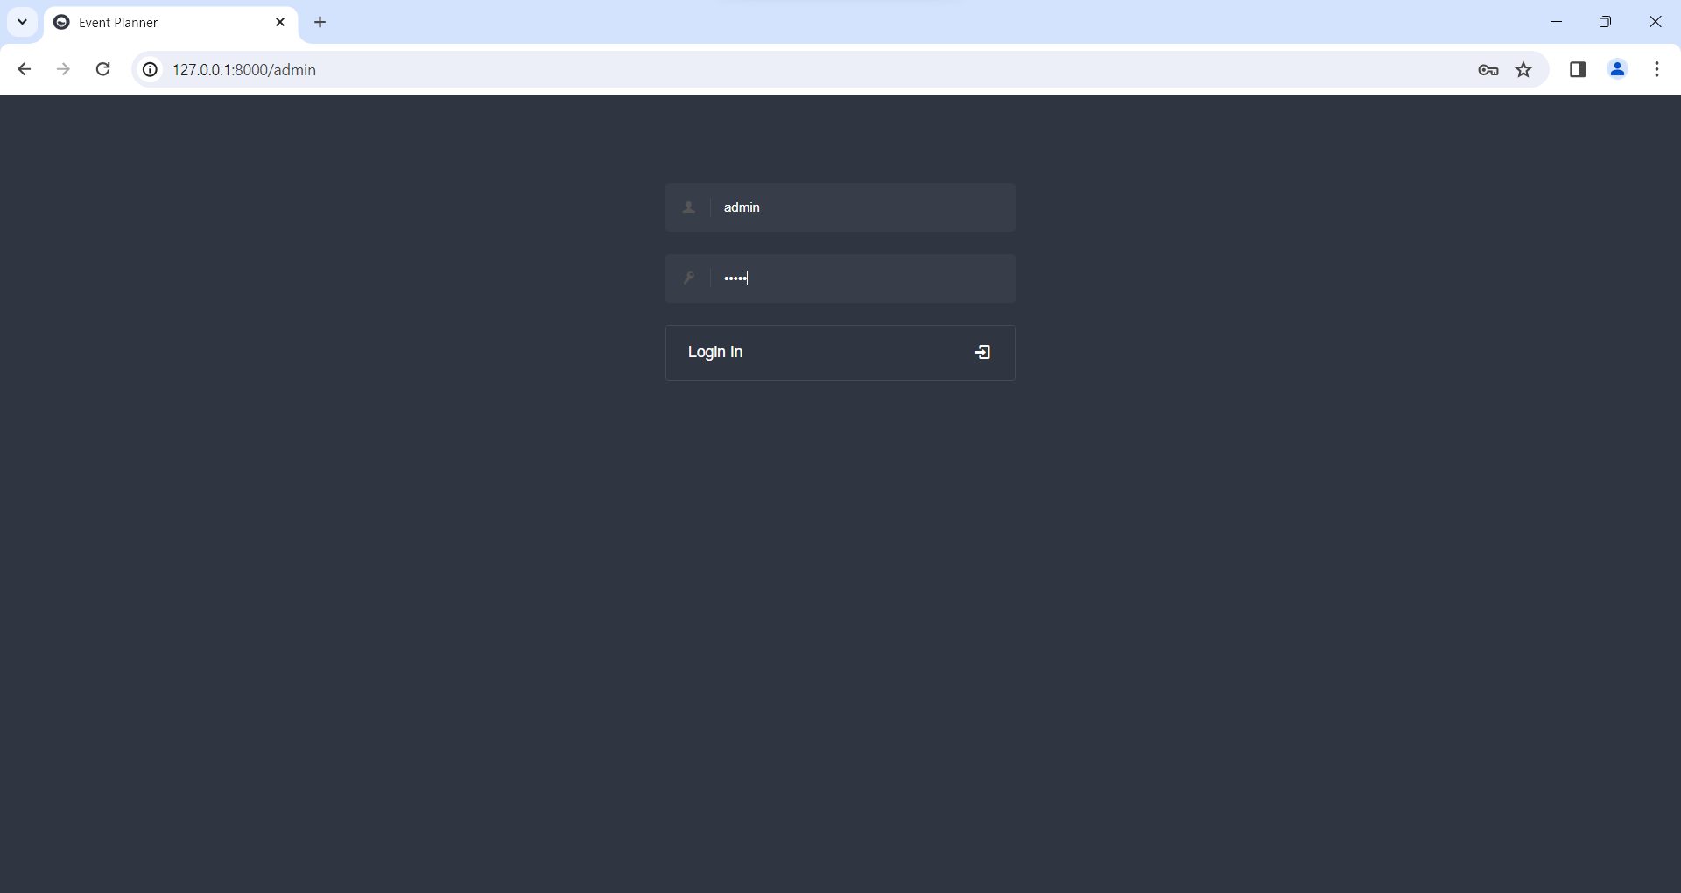

**Dashboard**

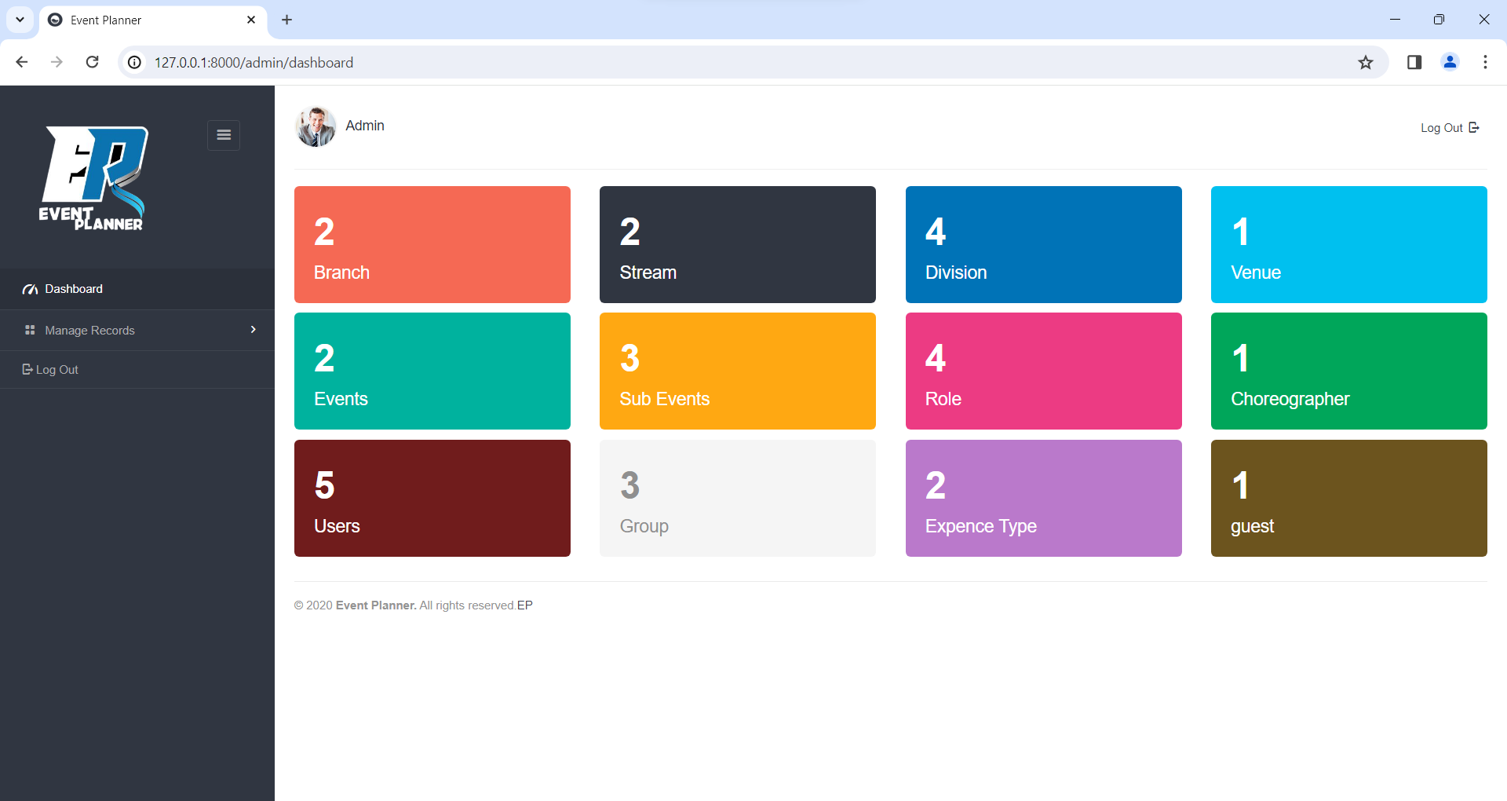

**Add Branch**

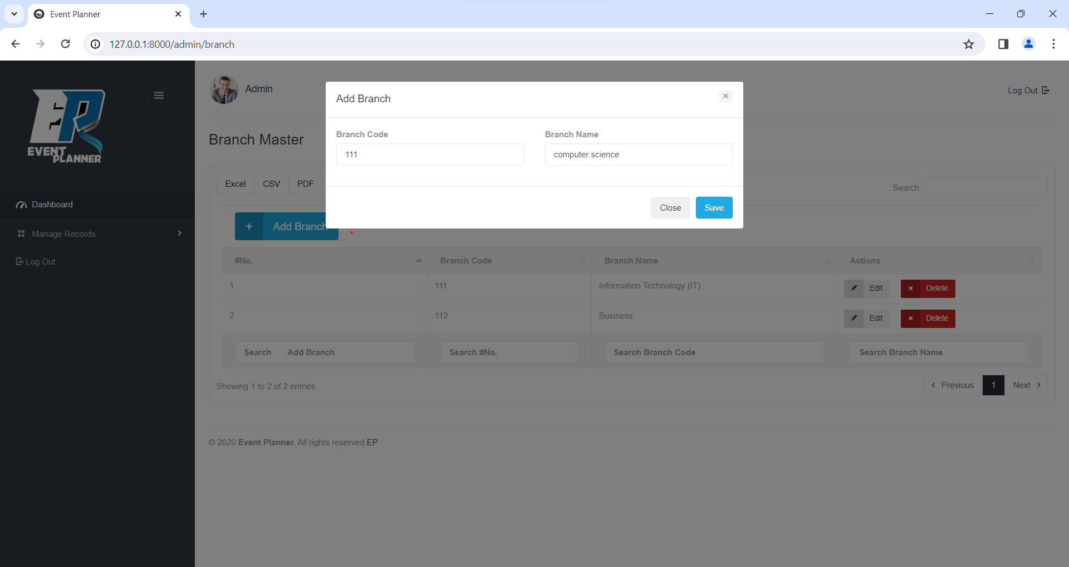

**View Branch**

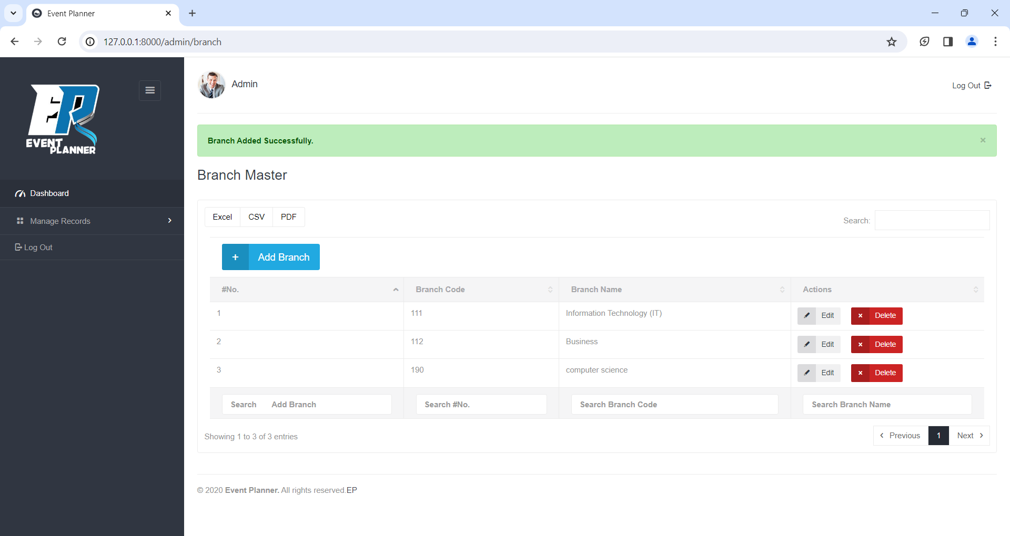

**Update Branch**

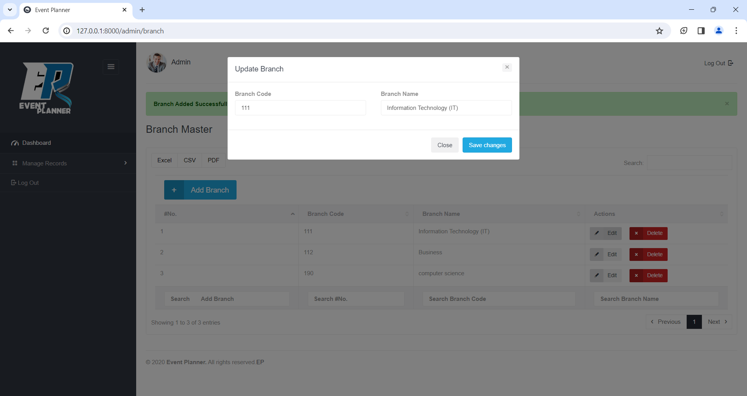

**Delete Branch**

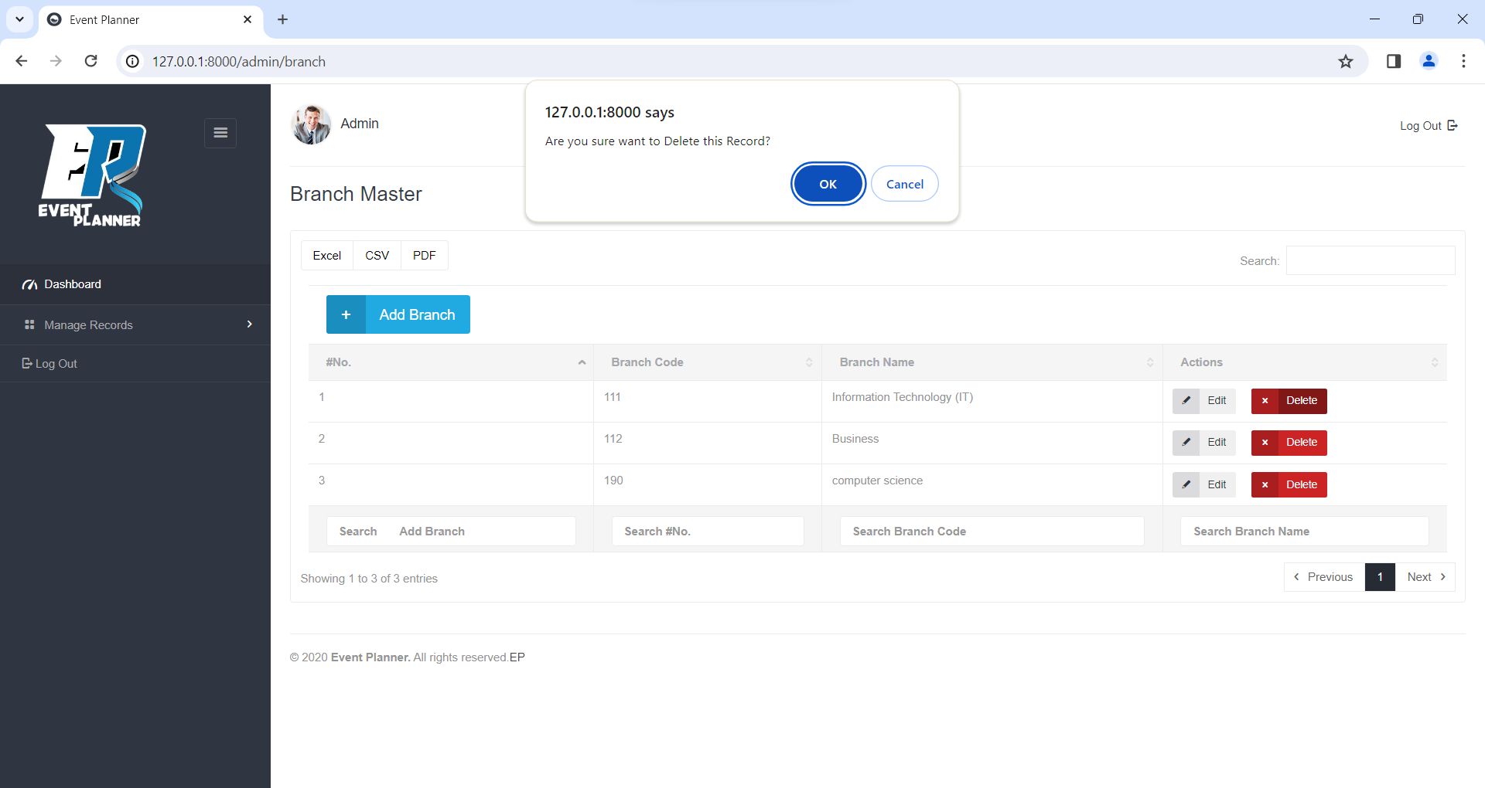

**Add Stream**

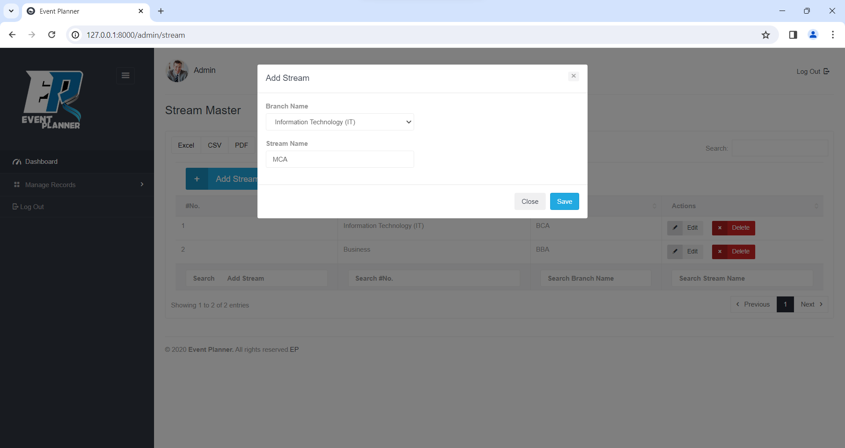

**View Stream**

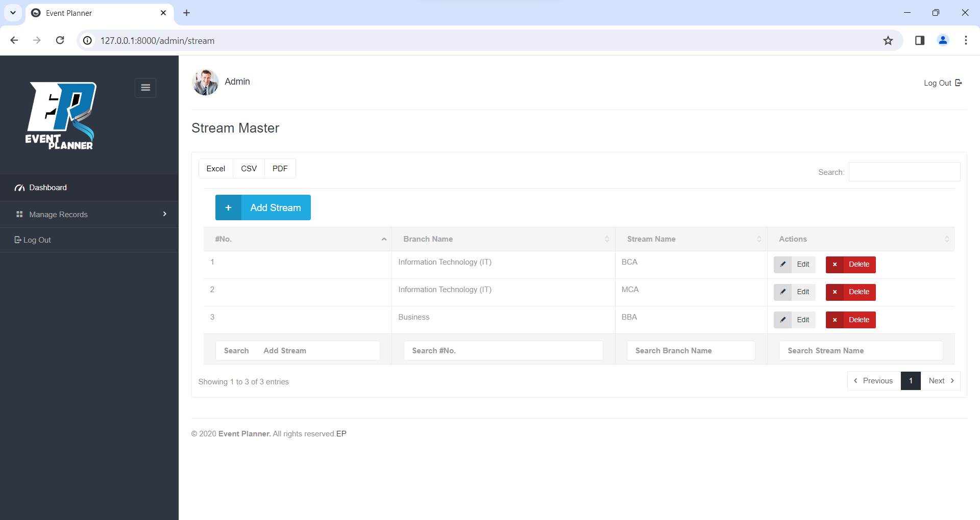

**Update Stream**

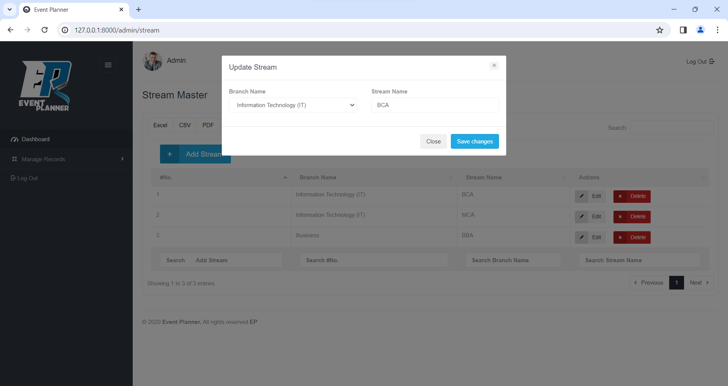

**Delete Stream**

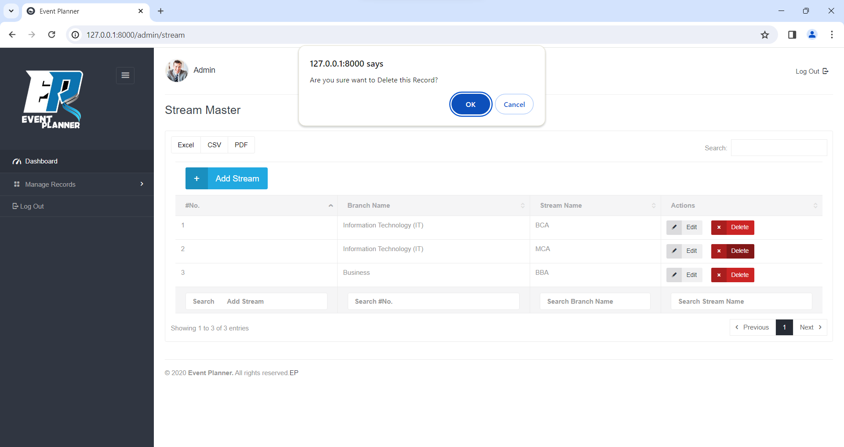

**Add Division**

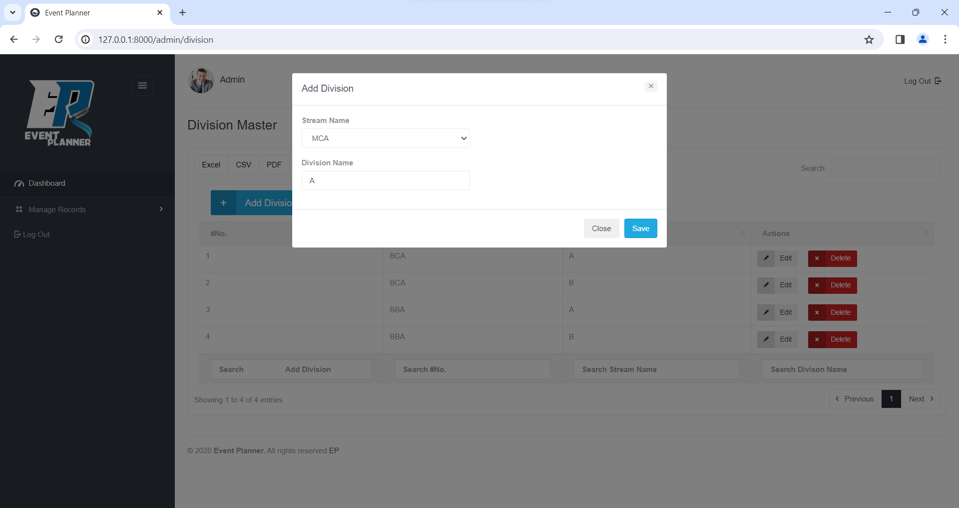

**View Division**

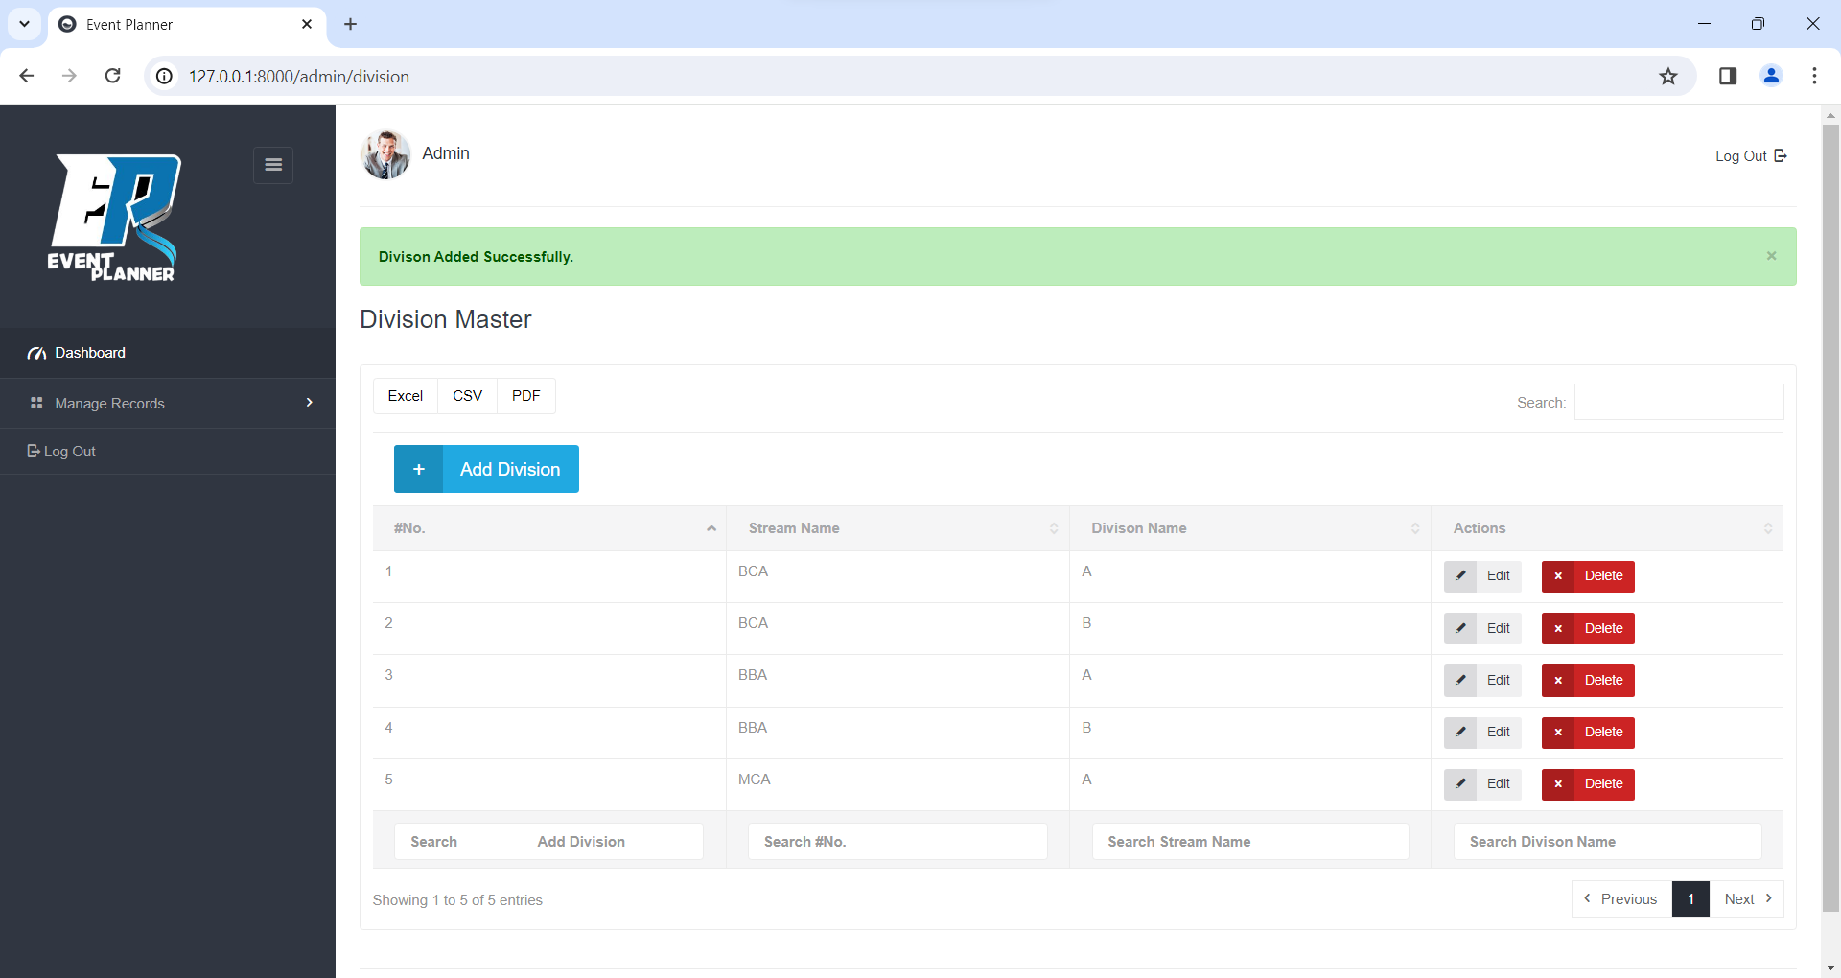

**Update Division**

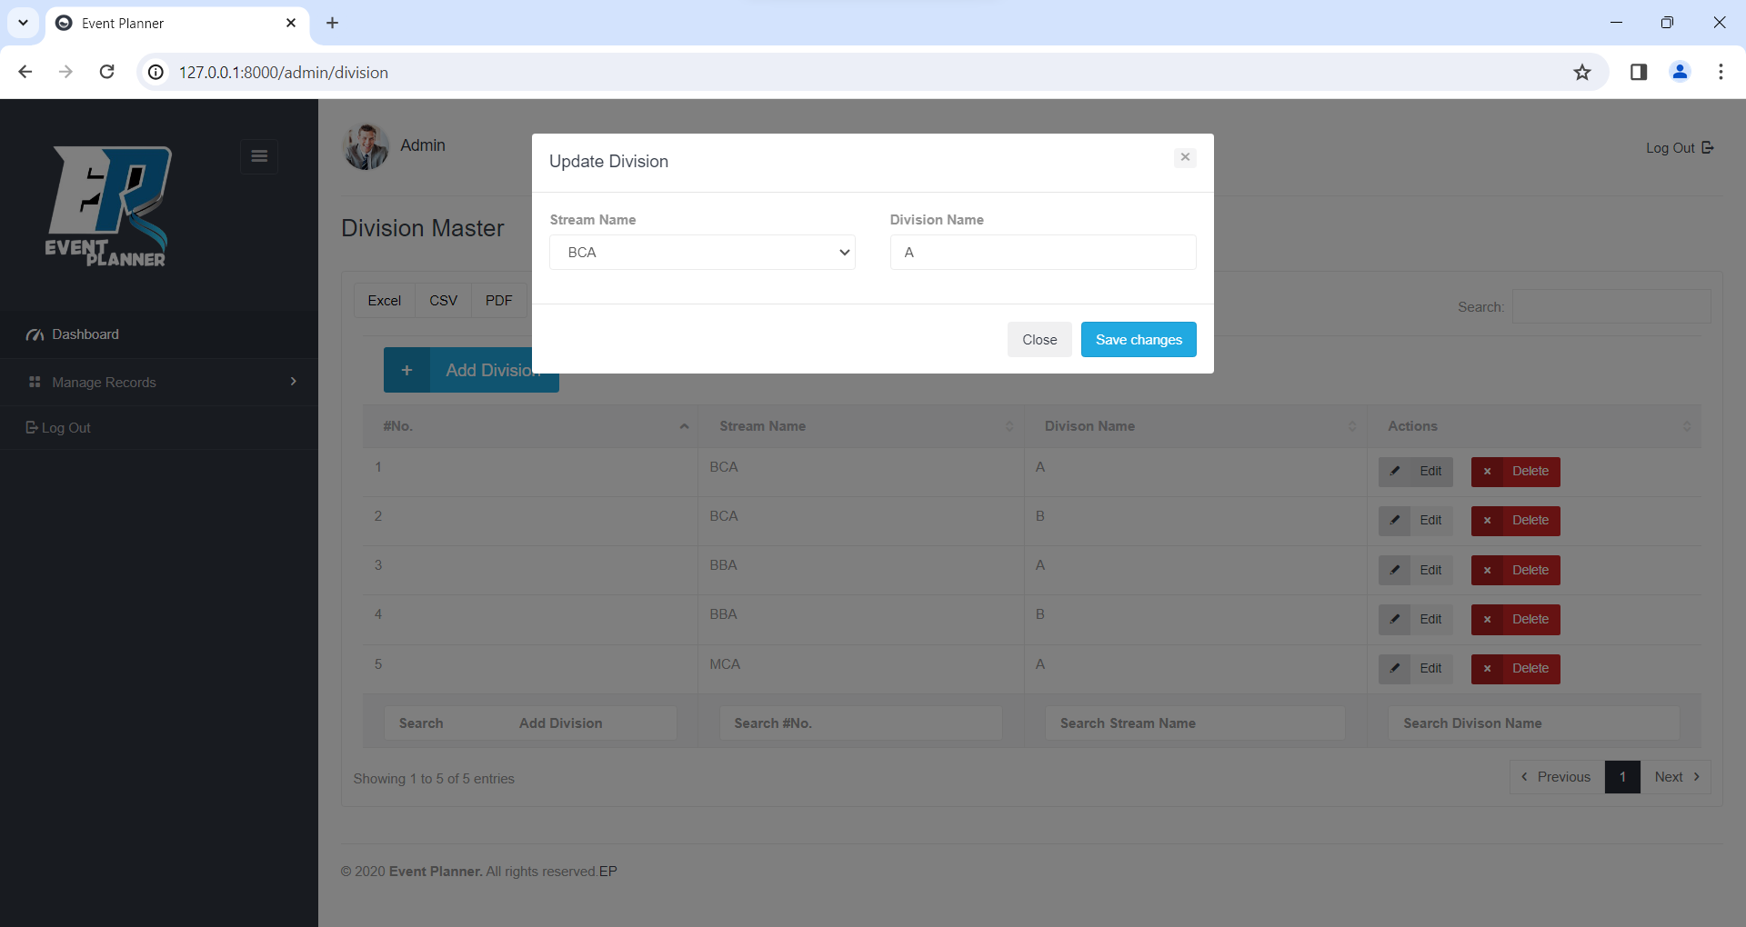

**Delete Division**

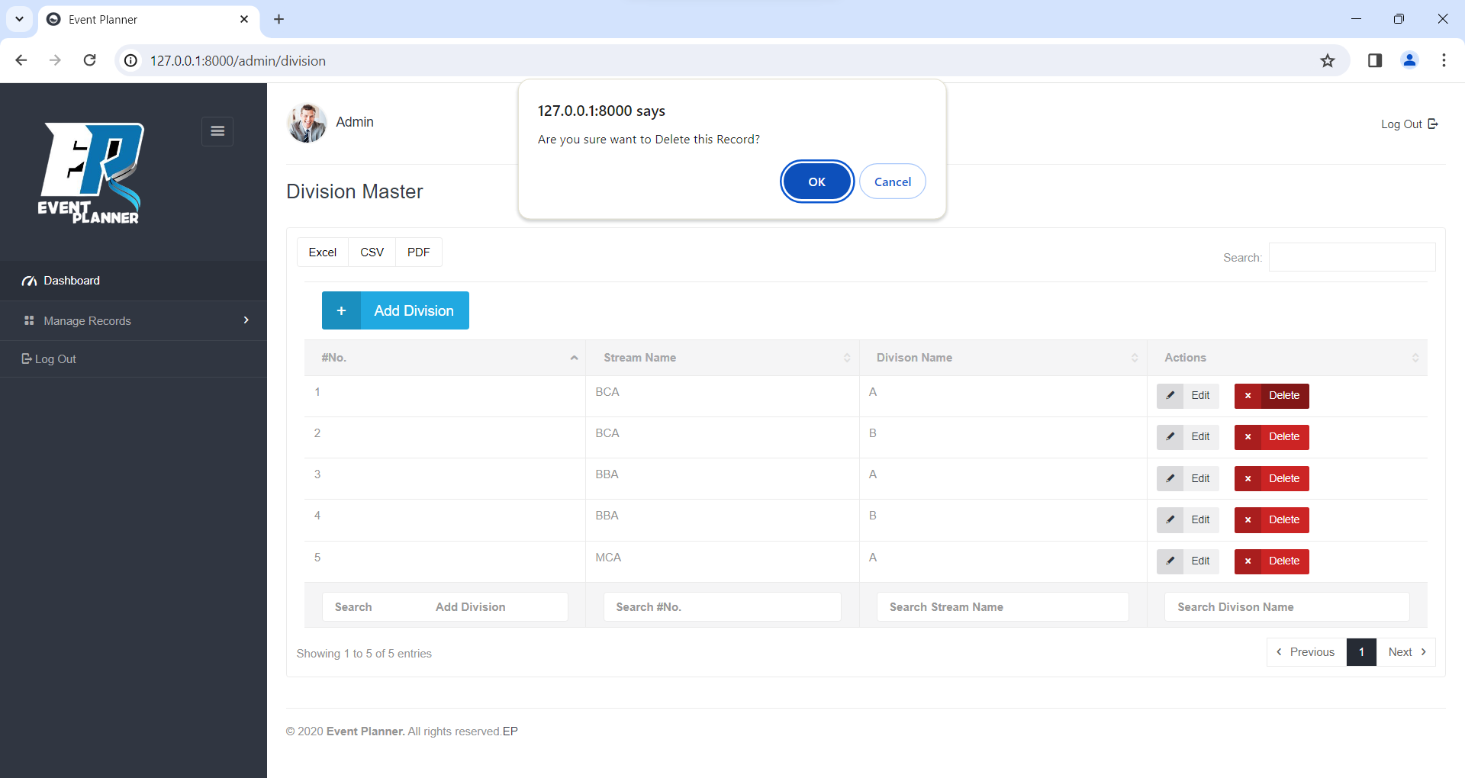

**Add Venue**

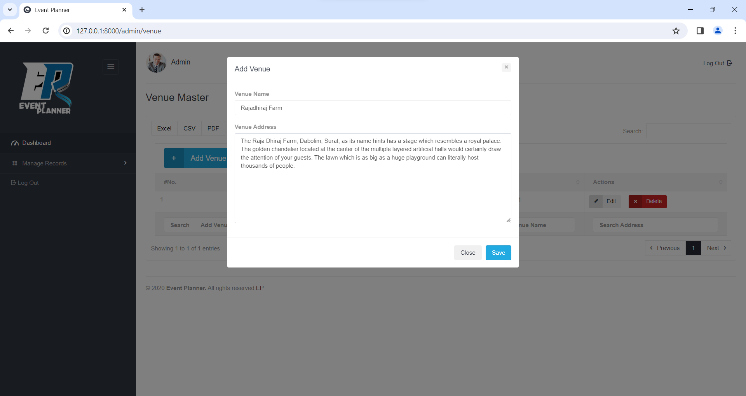

**View Venue**

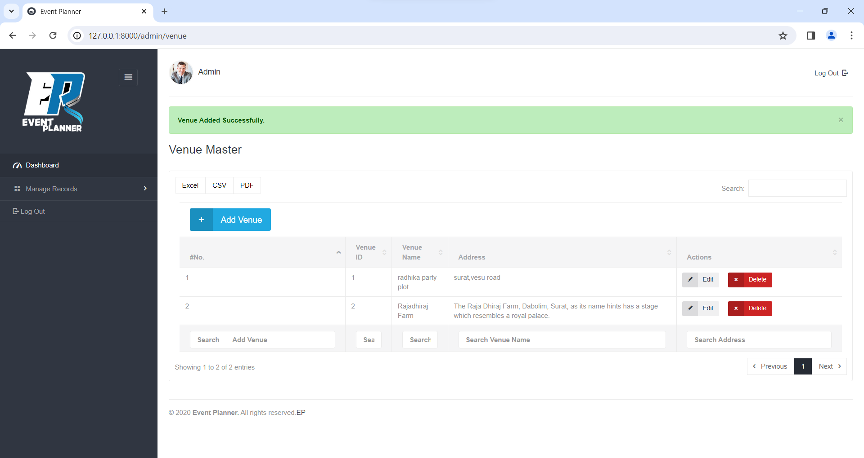

**Update Venue**

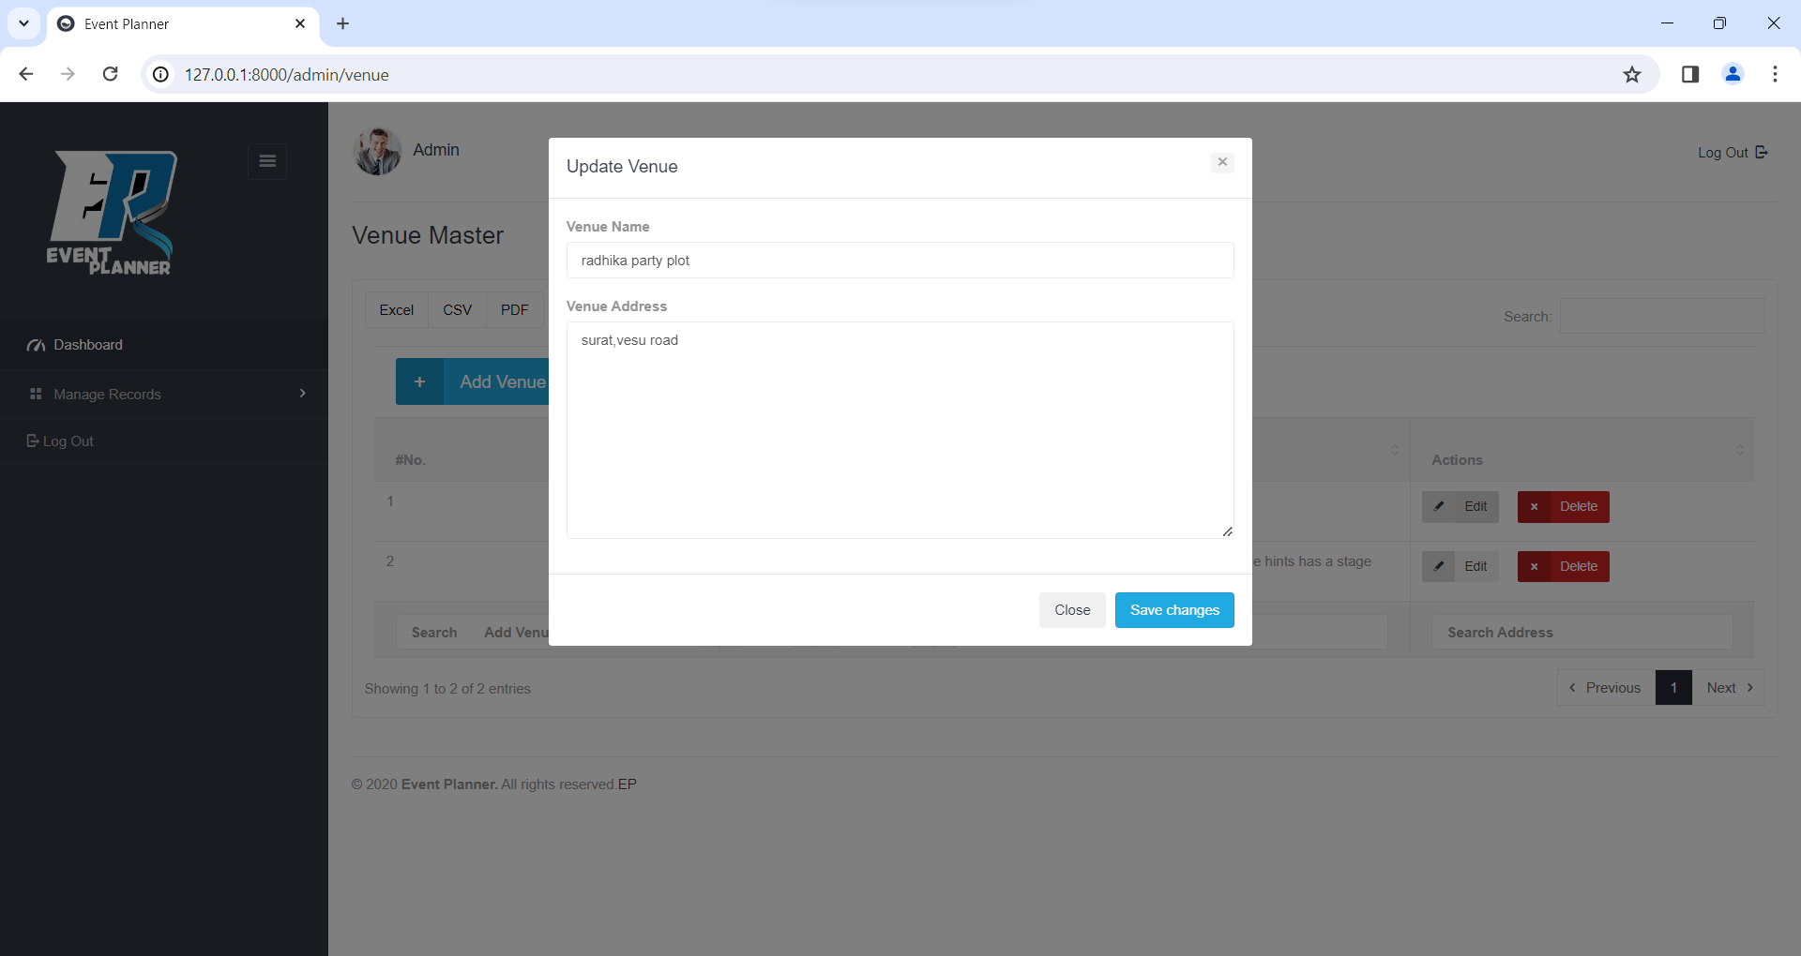

**Delete Venue**

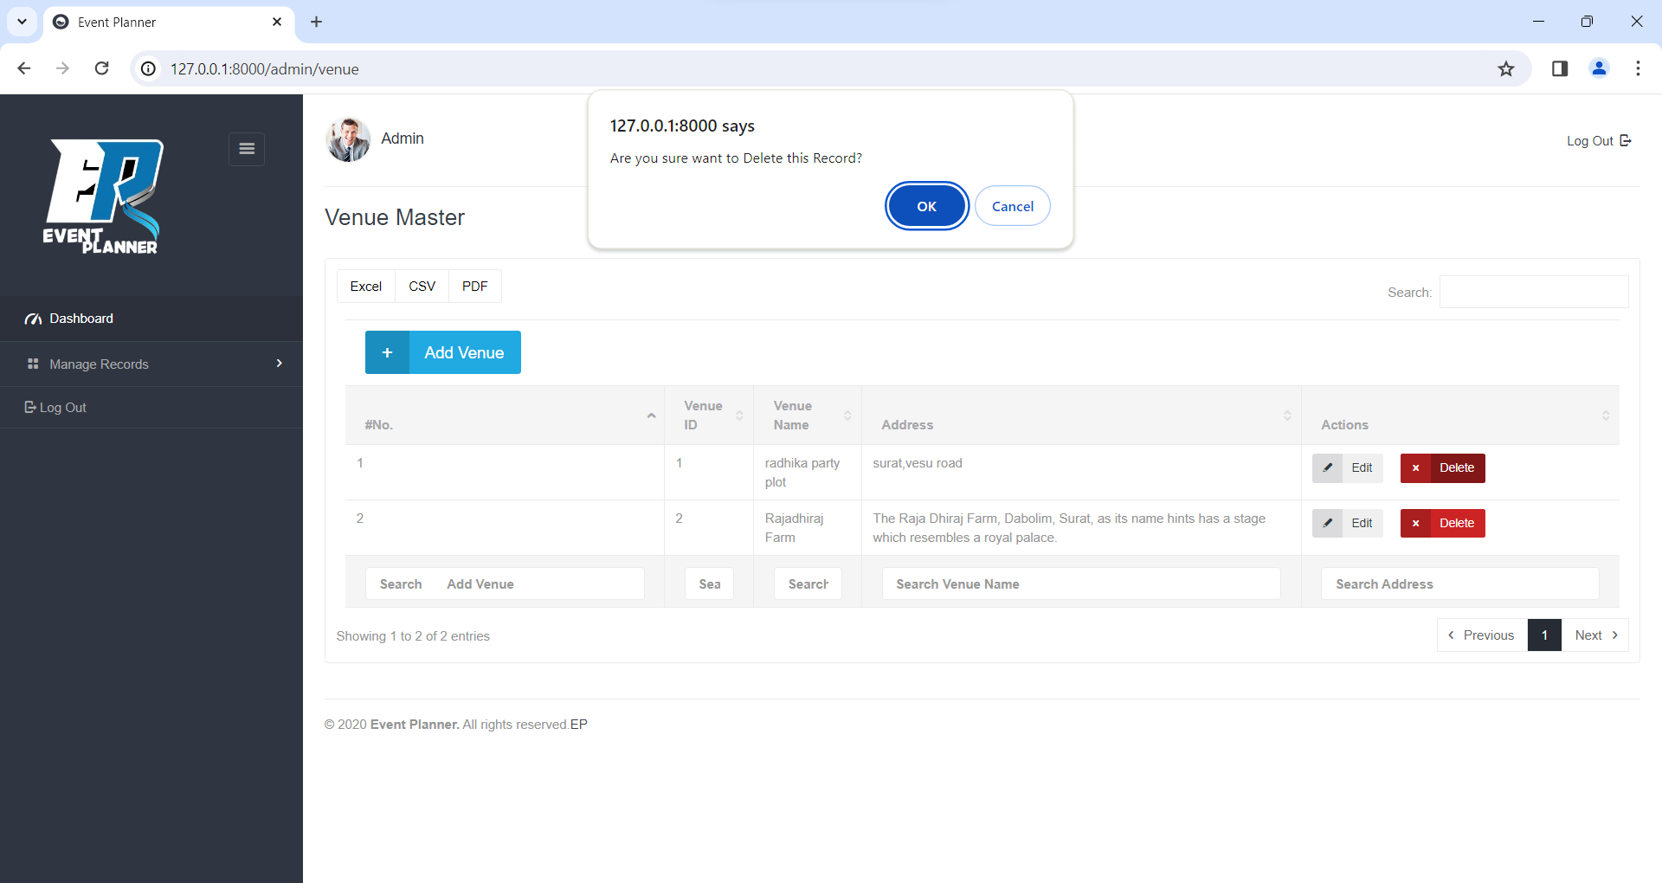

**Add Event**

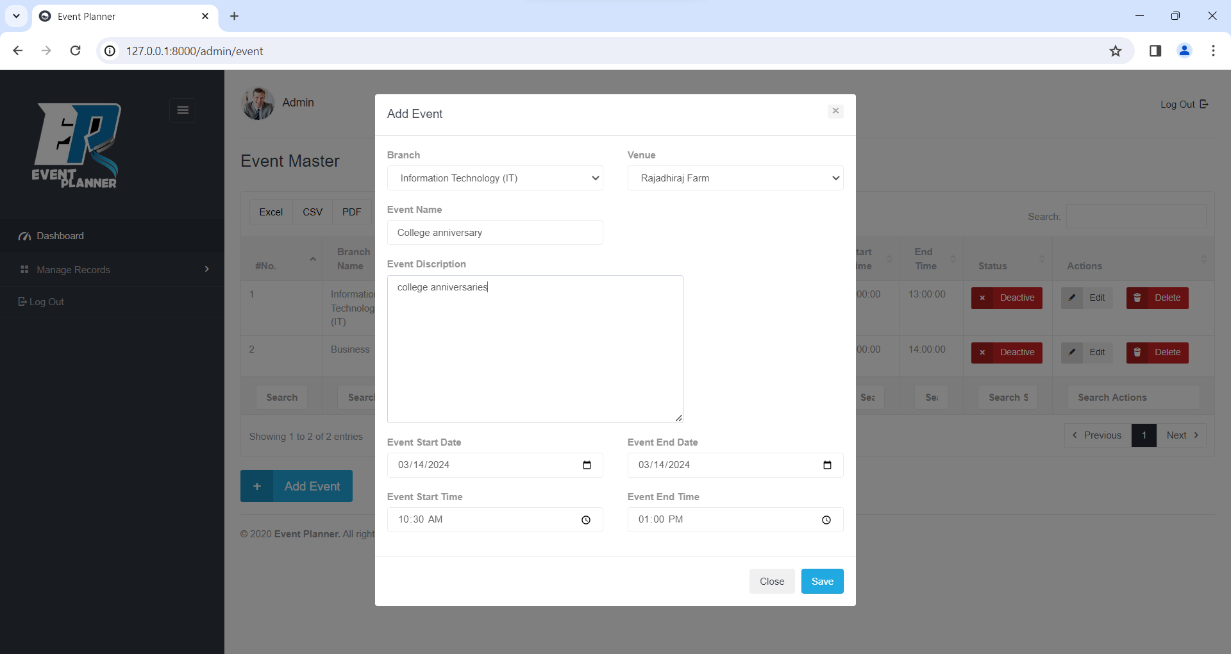

**View Event**

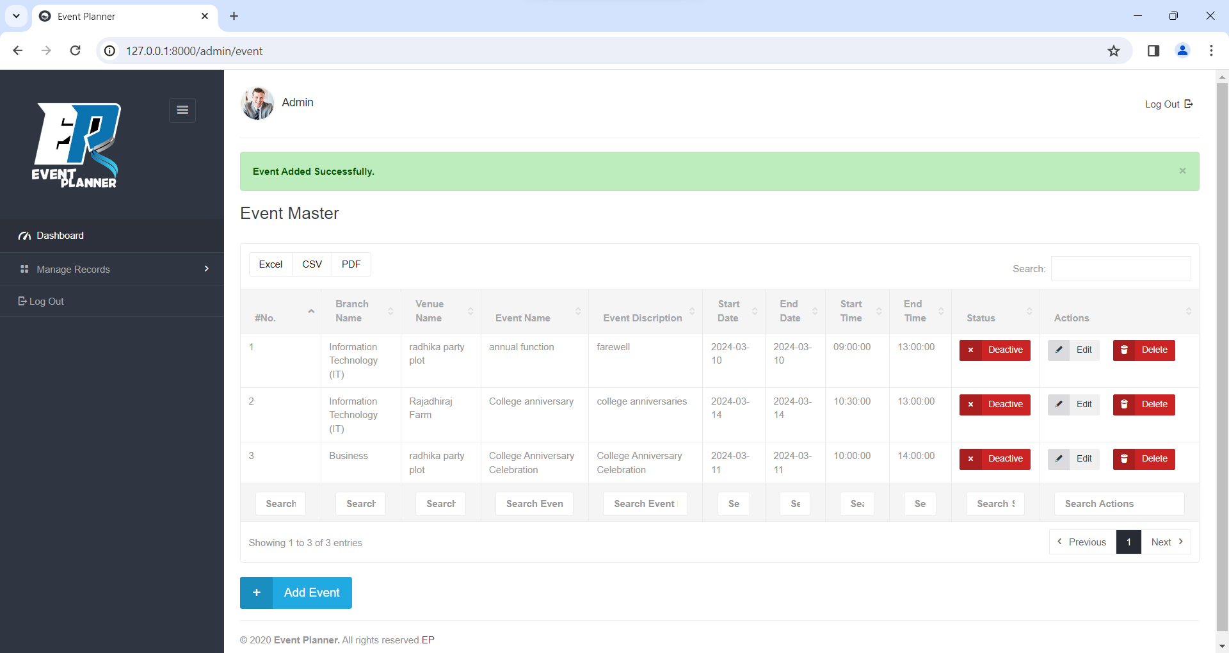

**Update Event**

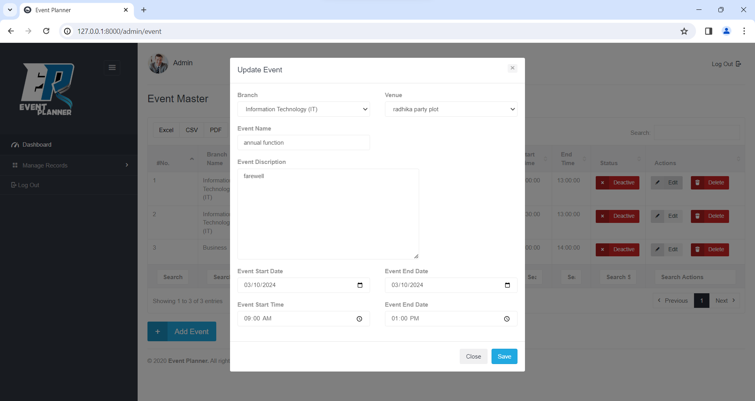

**Delete Event**

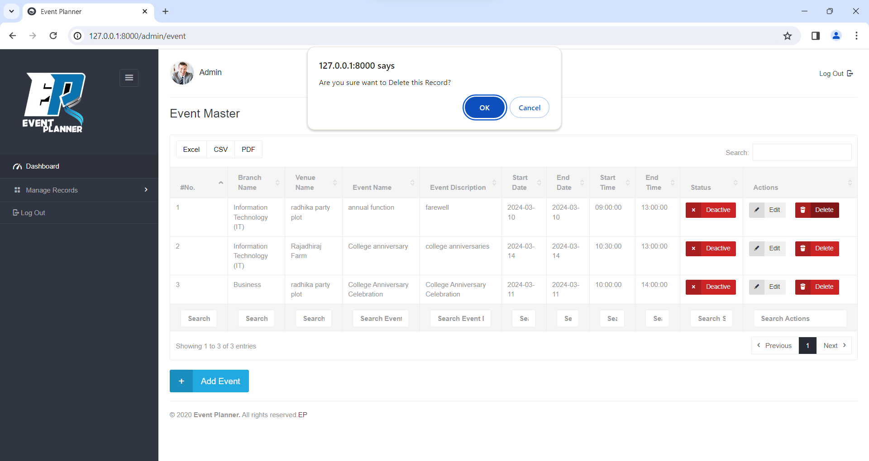

**Add Sub Event**

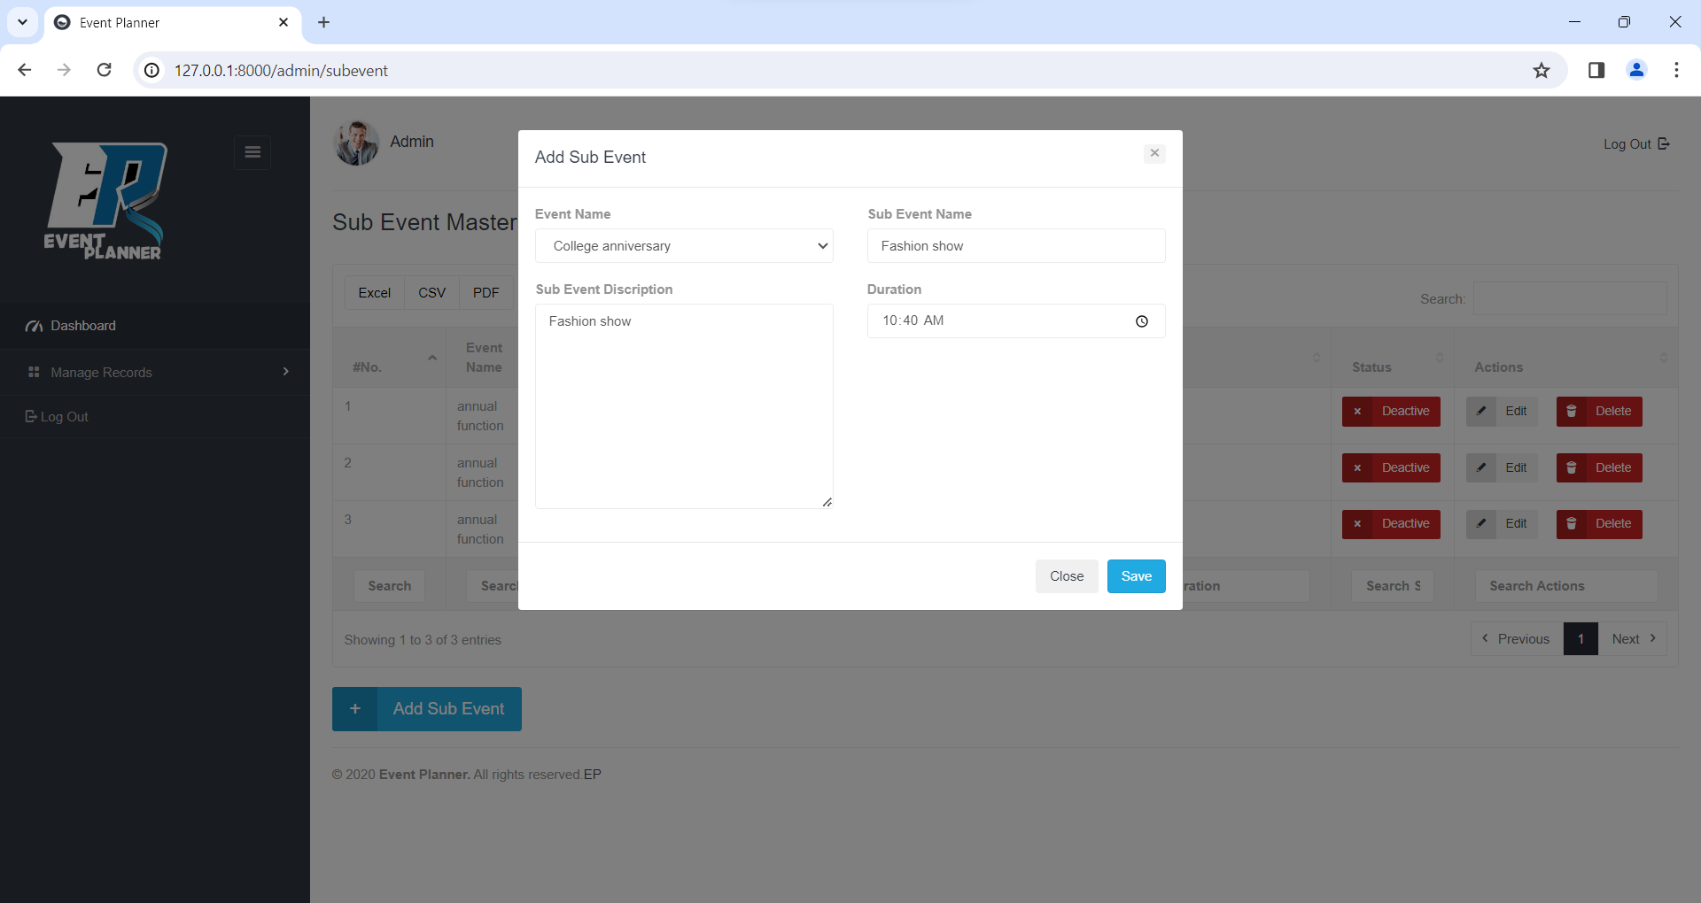

**View Sub Event**

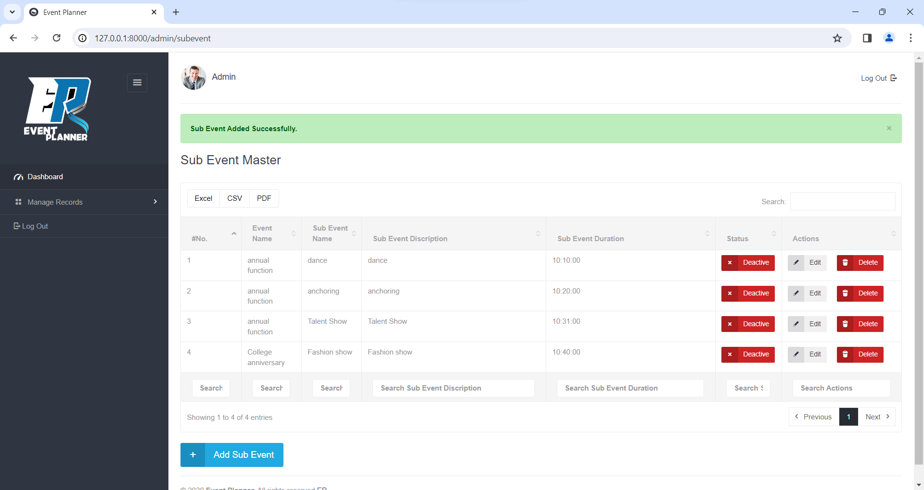

**Update Sub Event**

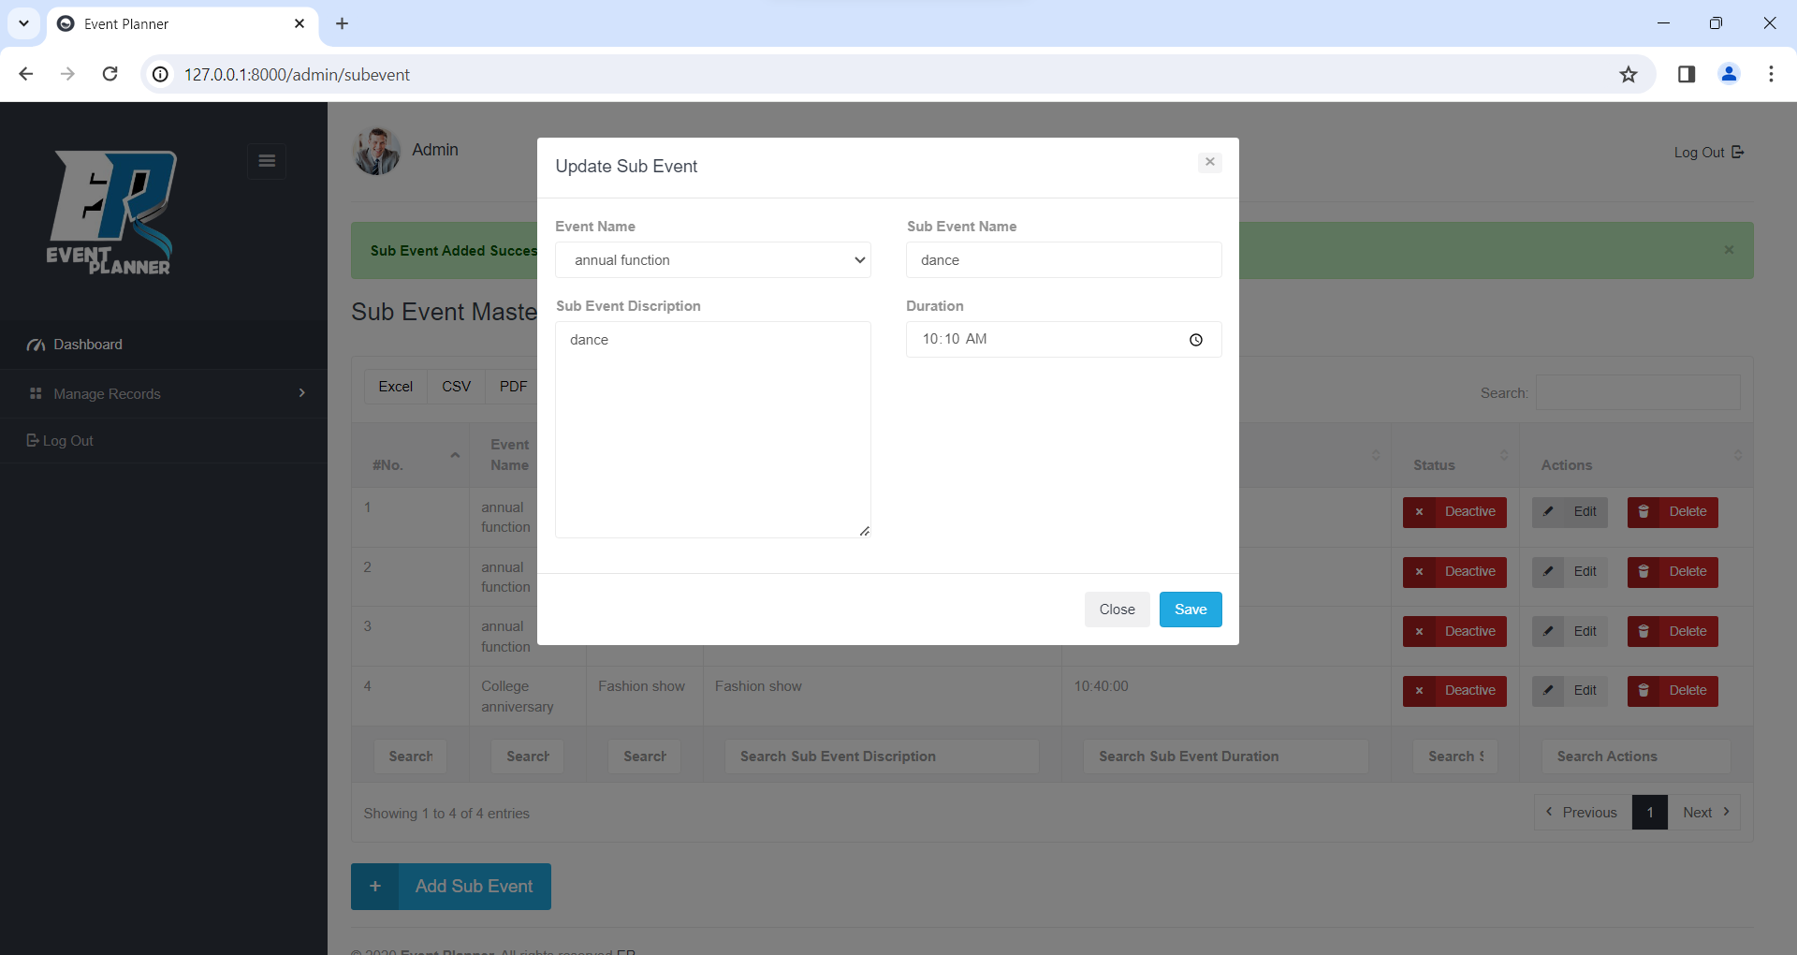

**Delete Sub Event**

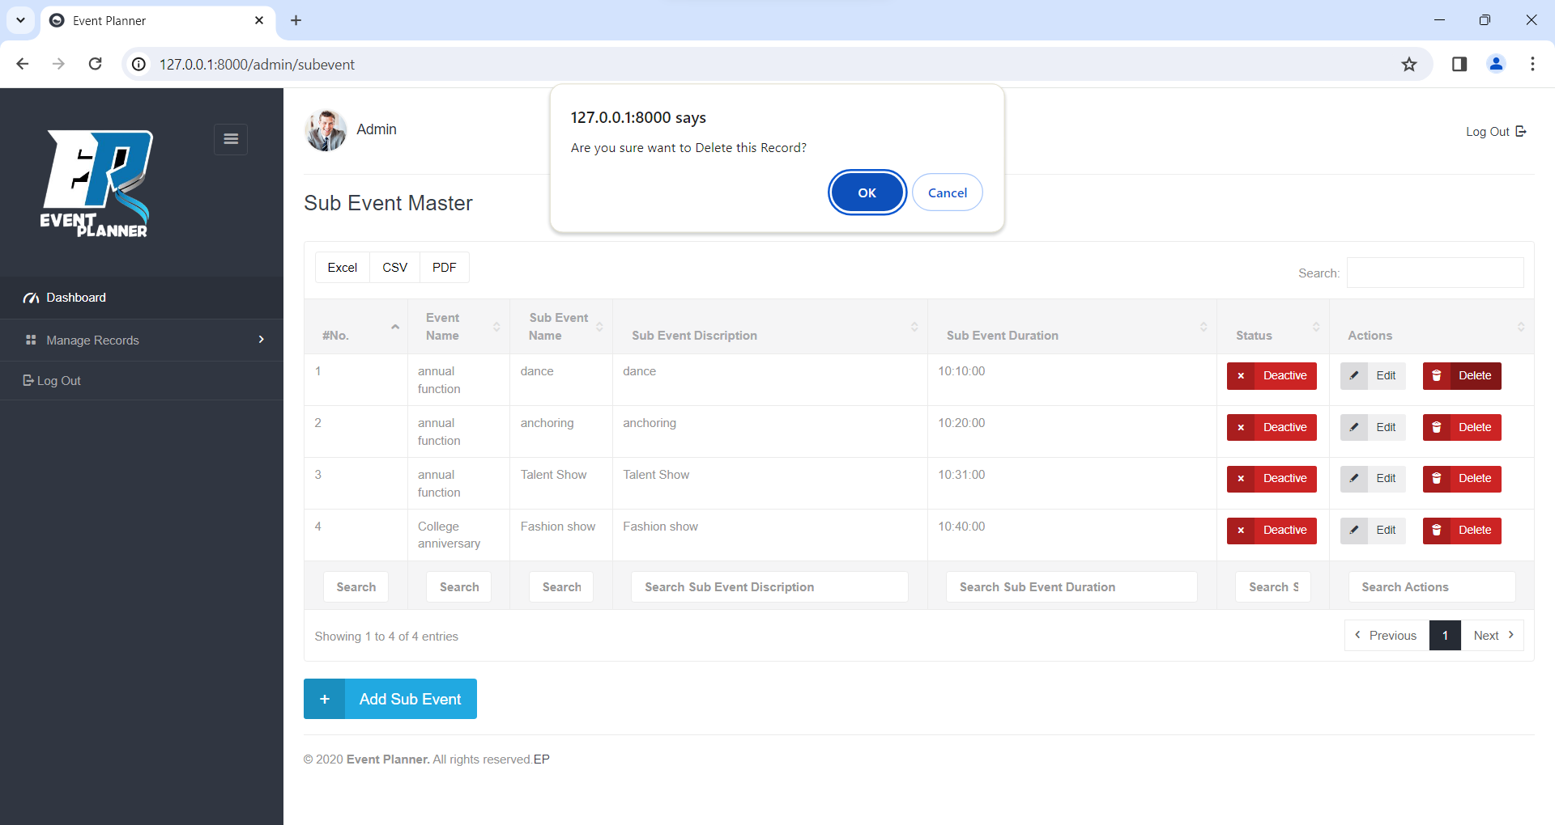

**Add Role**

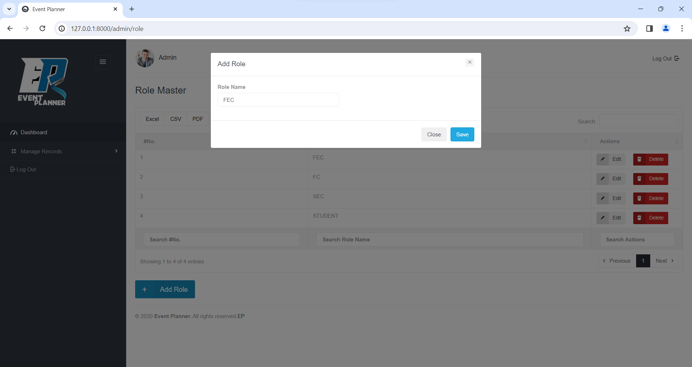

**View Role**

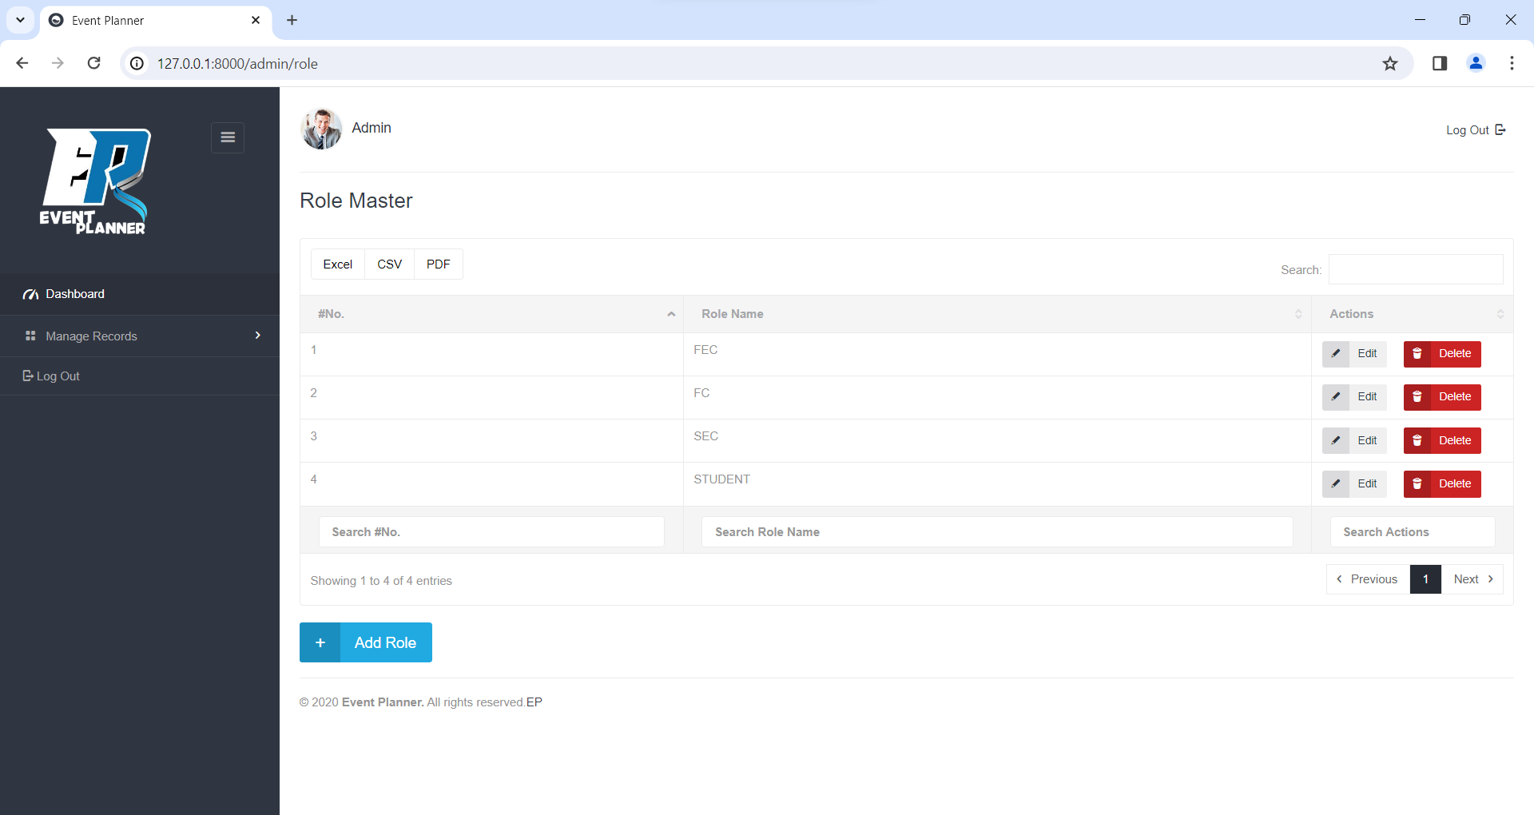

**Update Role**

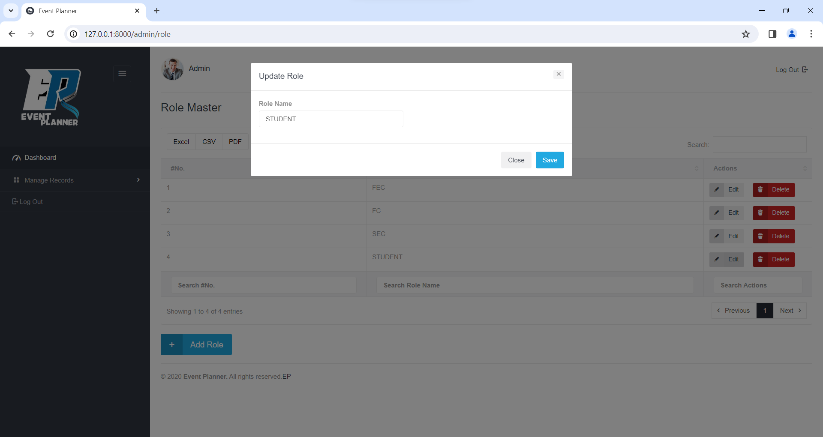

**Delete Role**

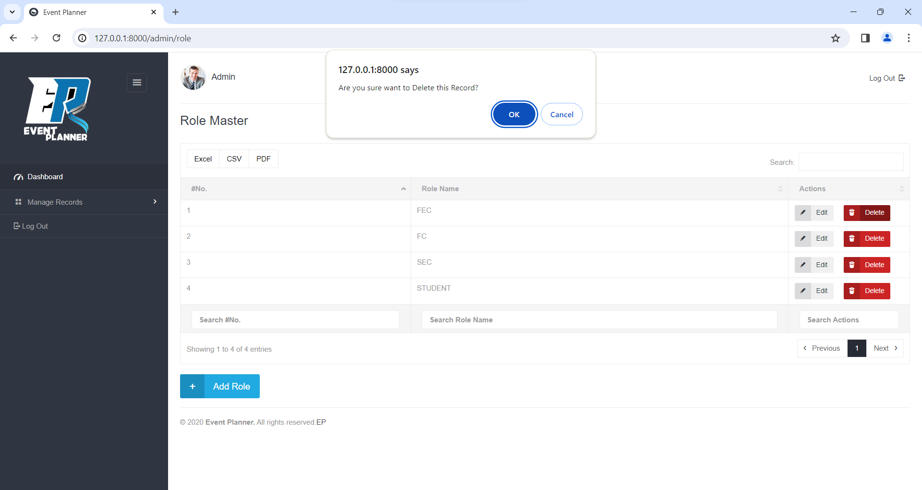

**Add Choreographer**

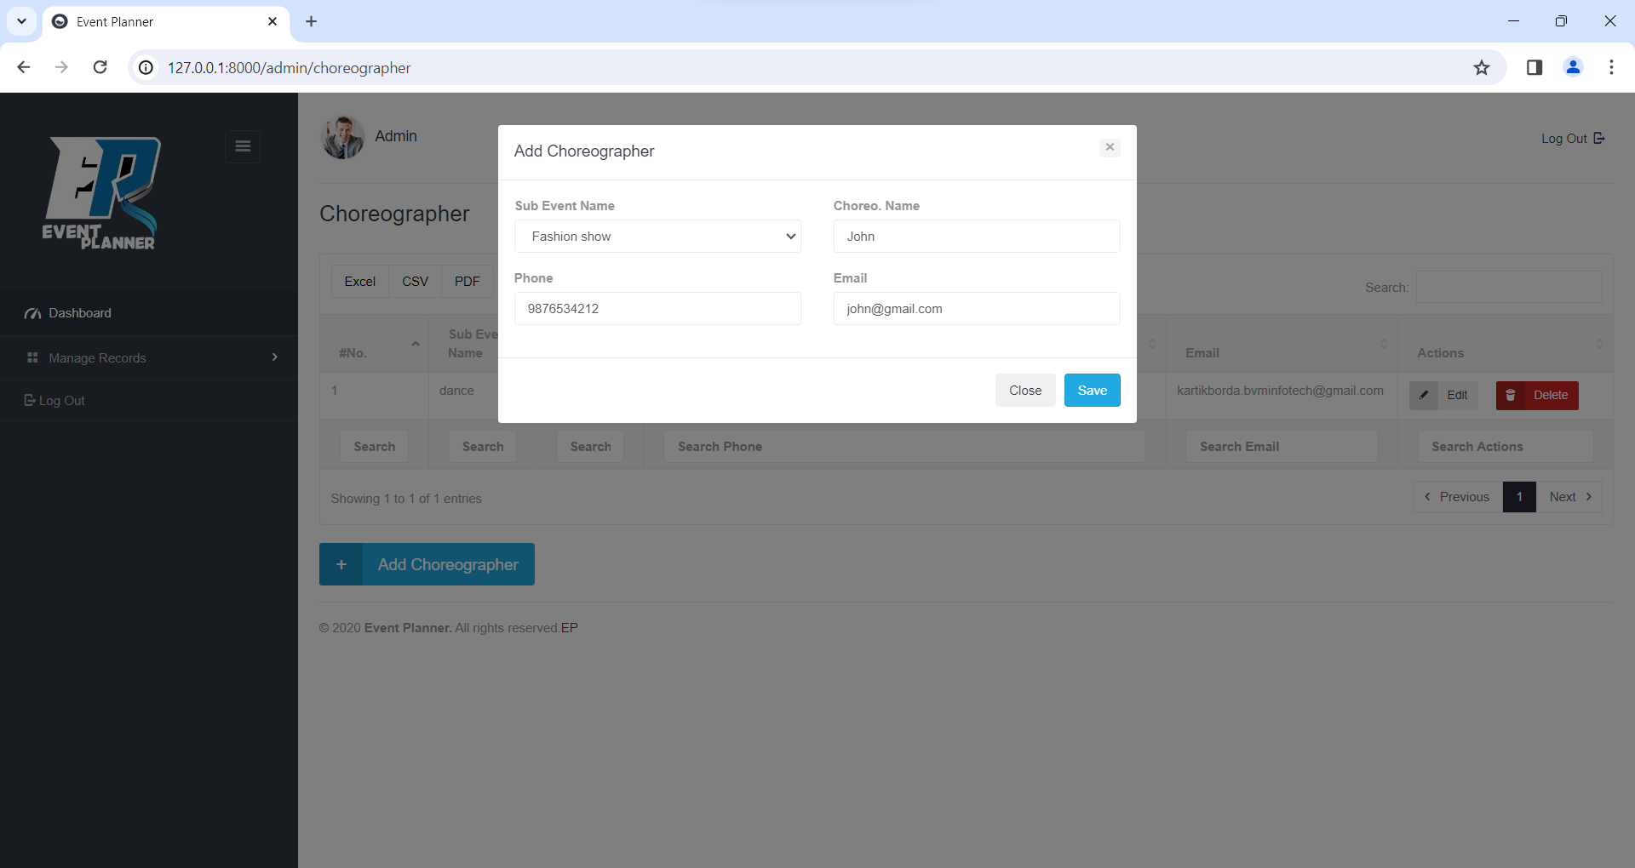

**View Choreographer**

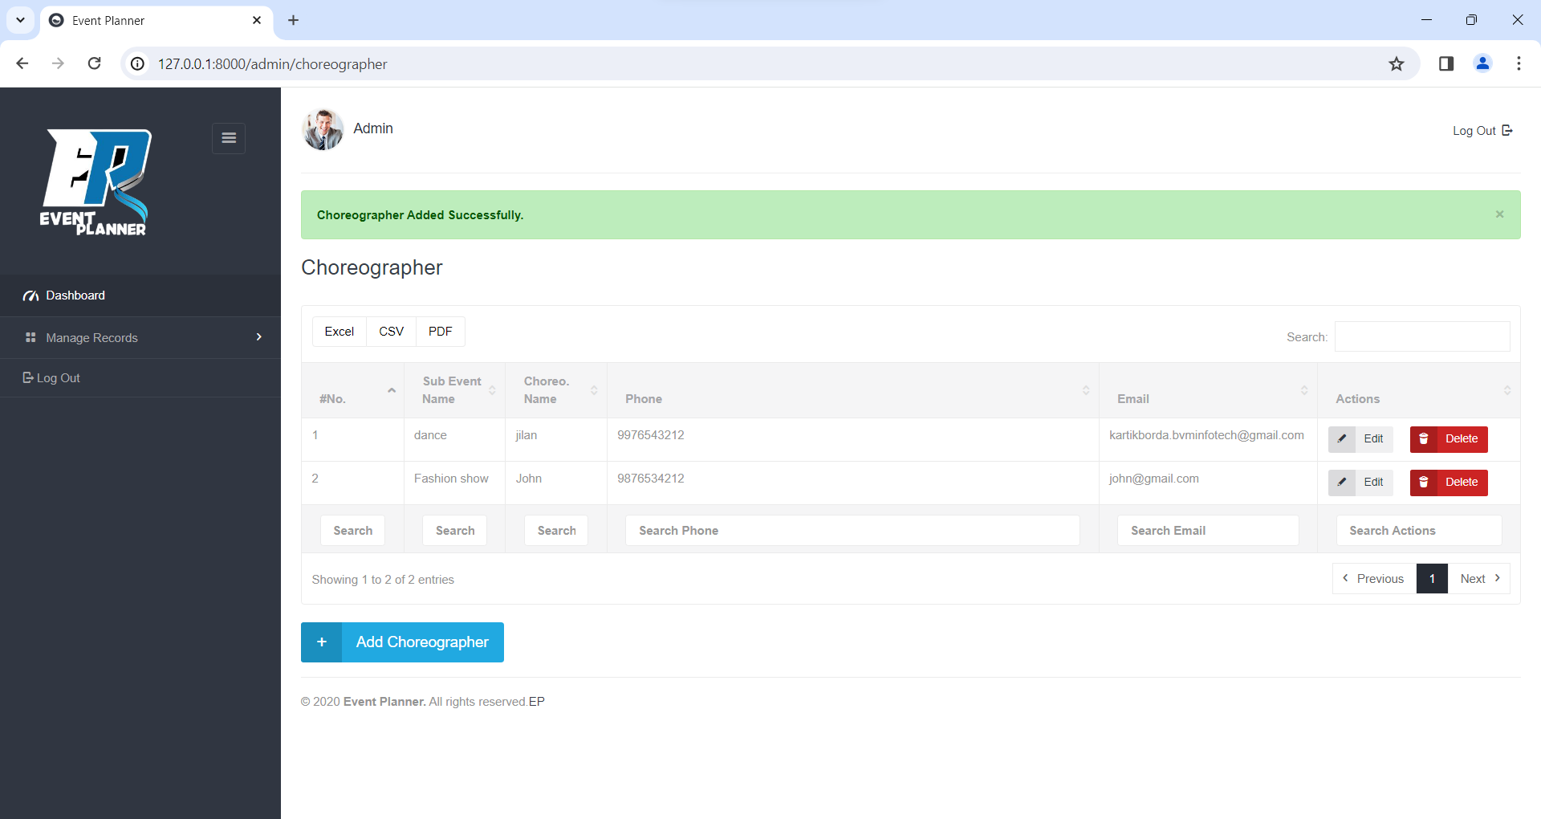

**Update Choreographer**

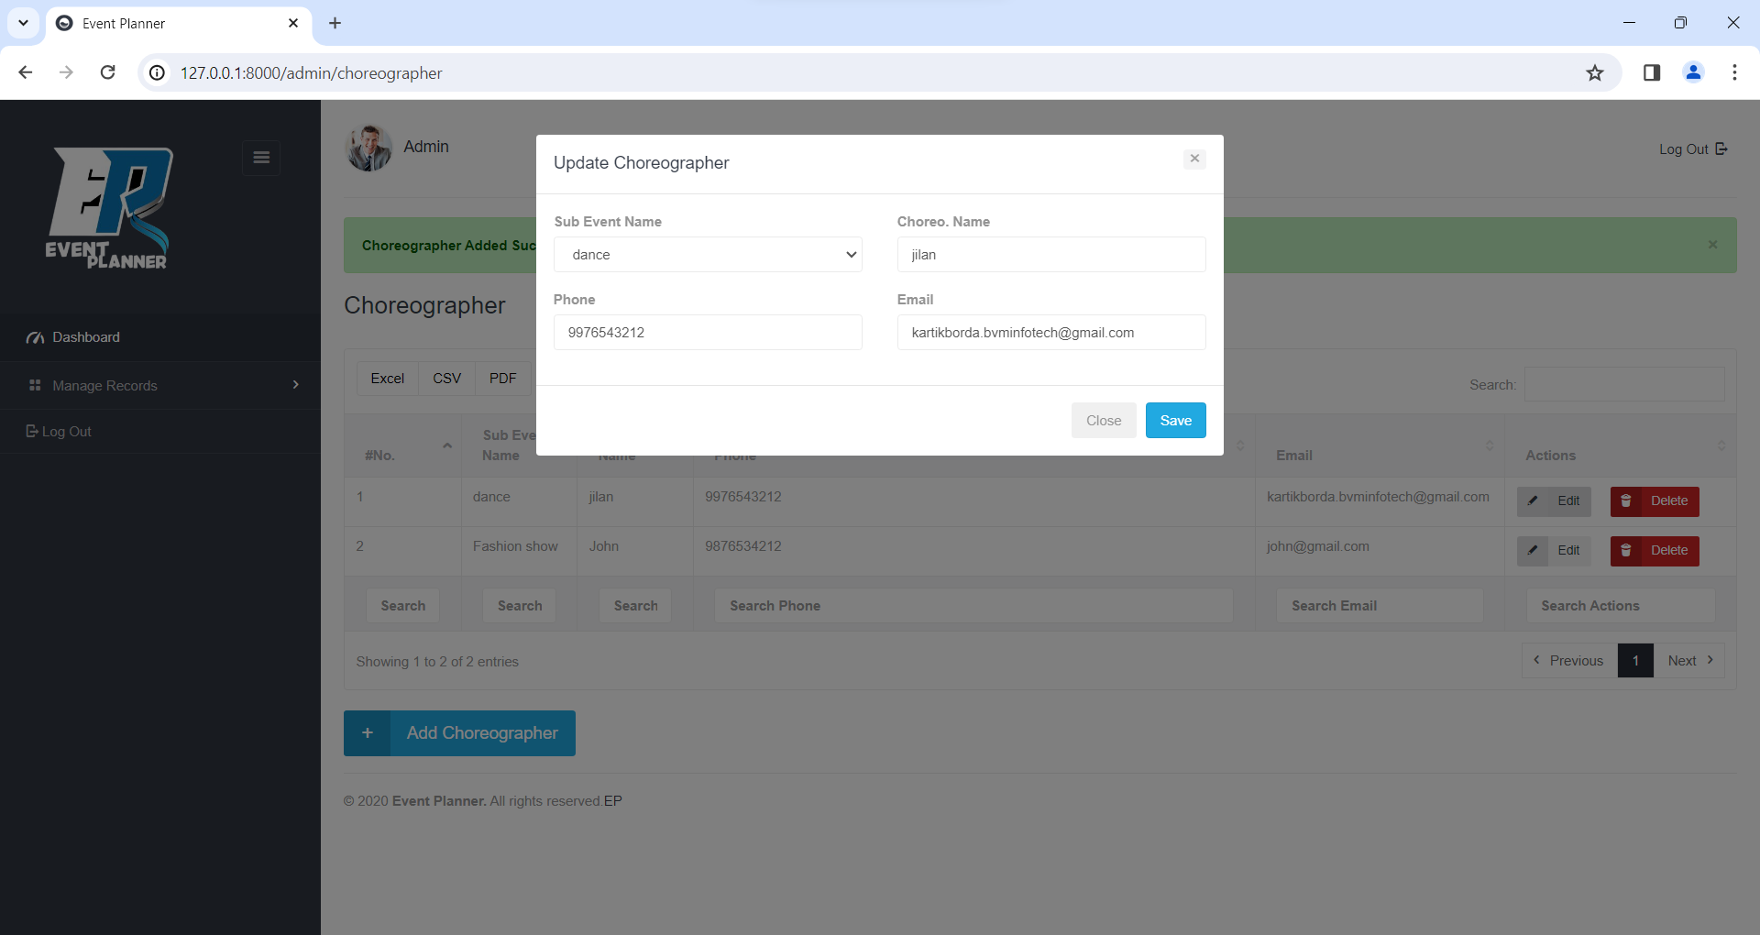

**Delete Choreographer**

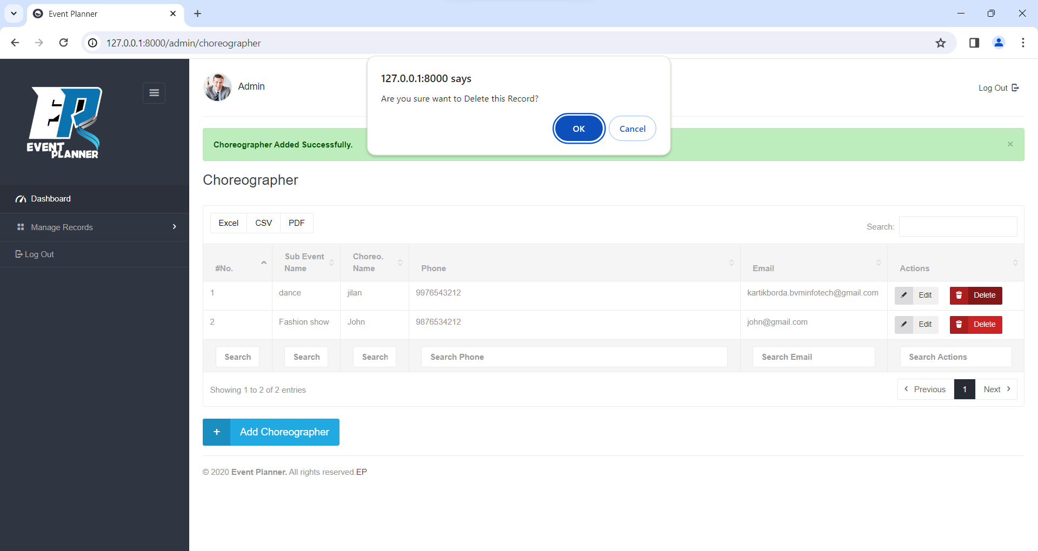

**Add User**

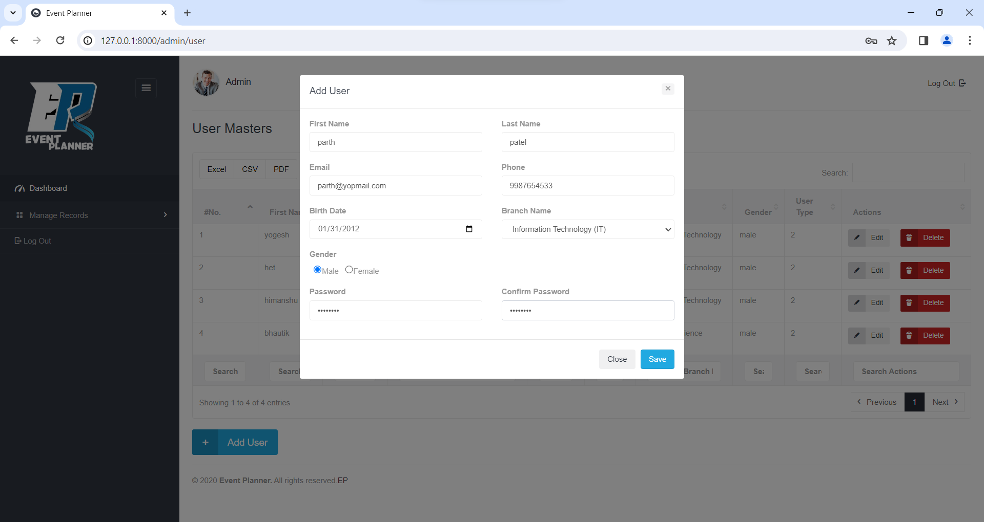

**View User**

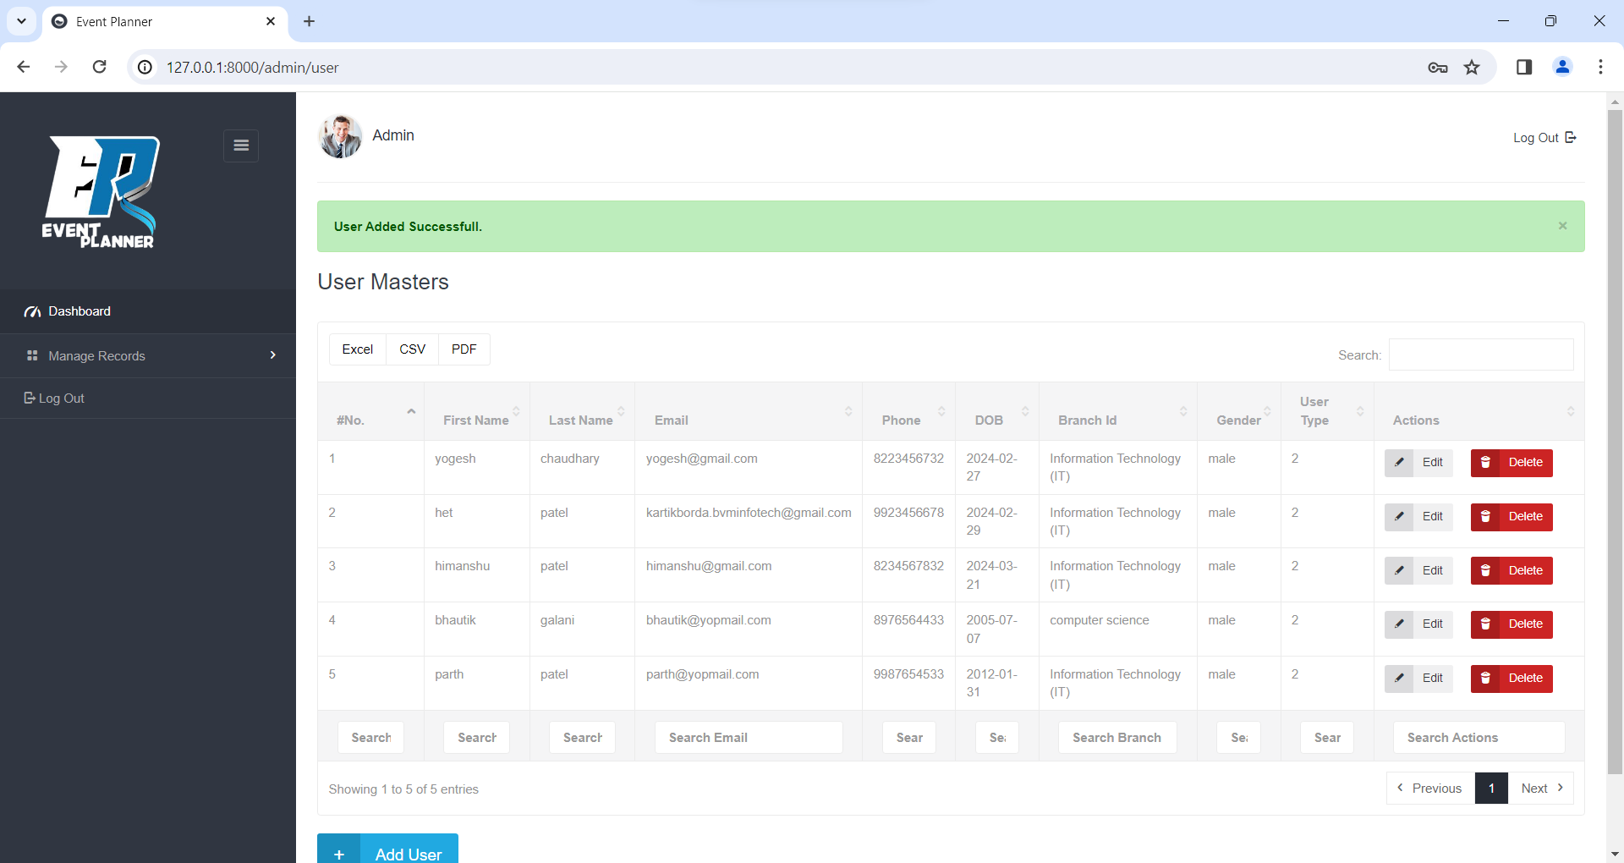

**Update User**

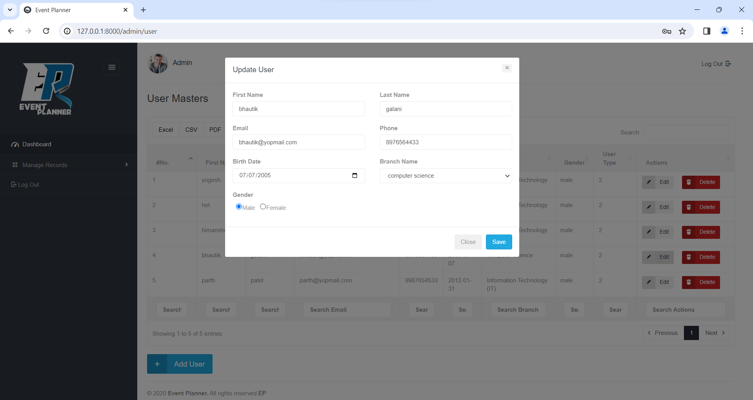

**Delete User**

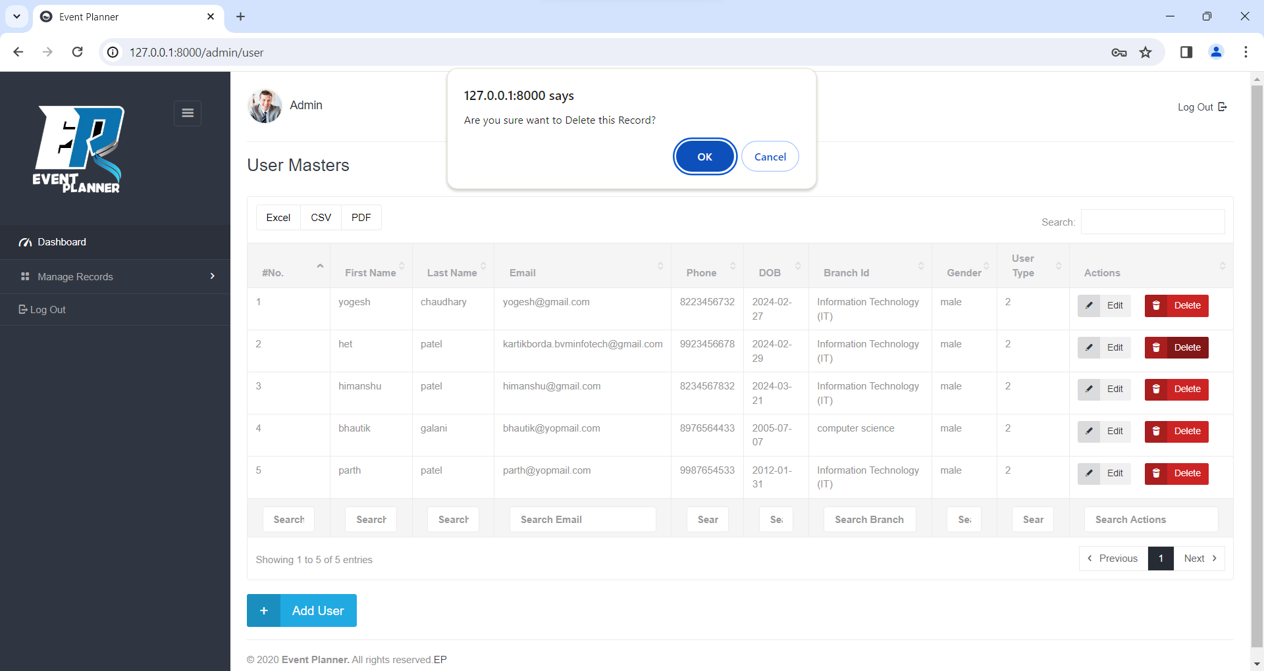

**Add Group**

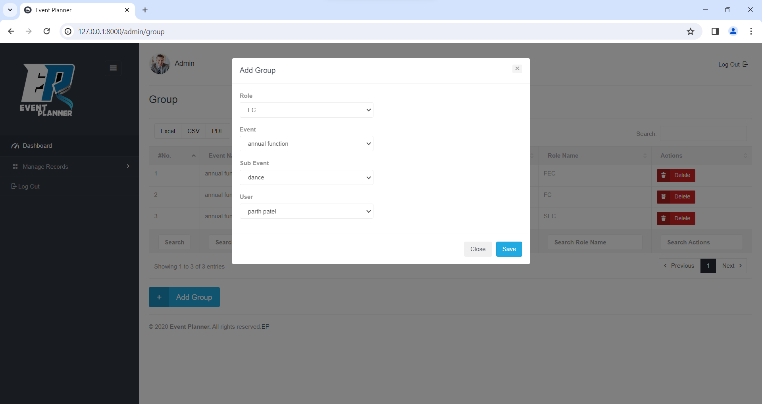

**View Group**

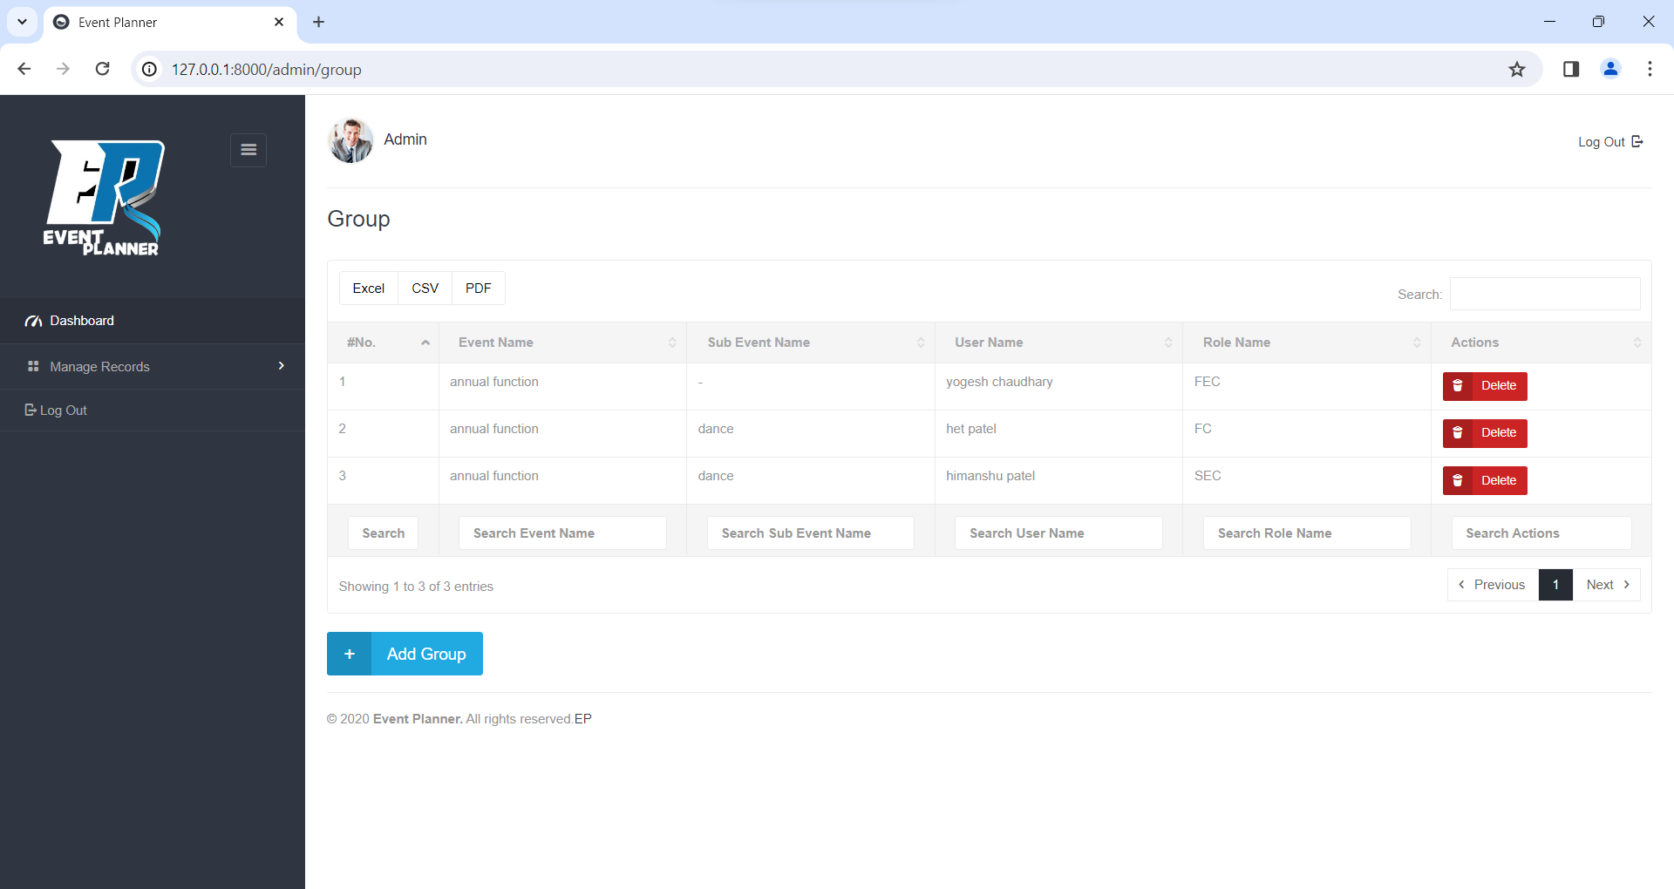

**Delete Group**

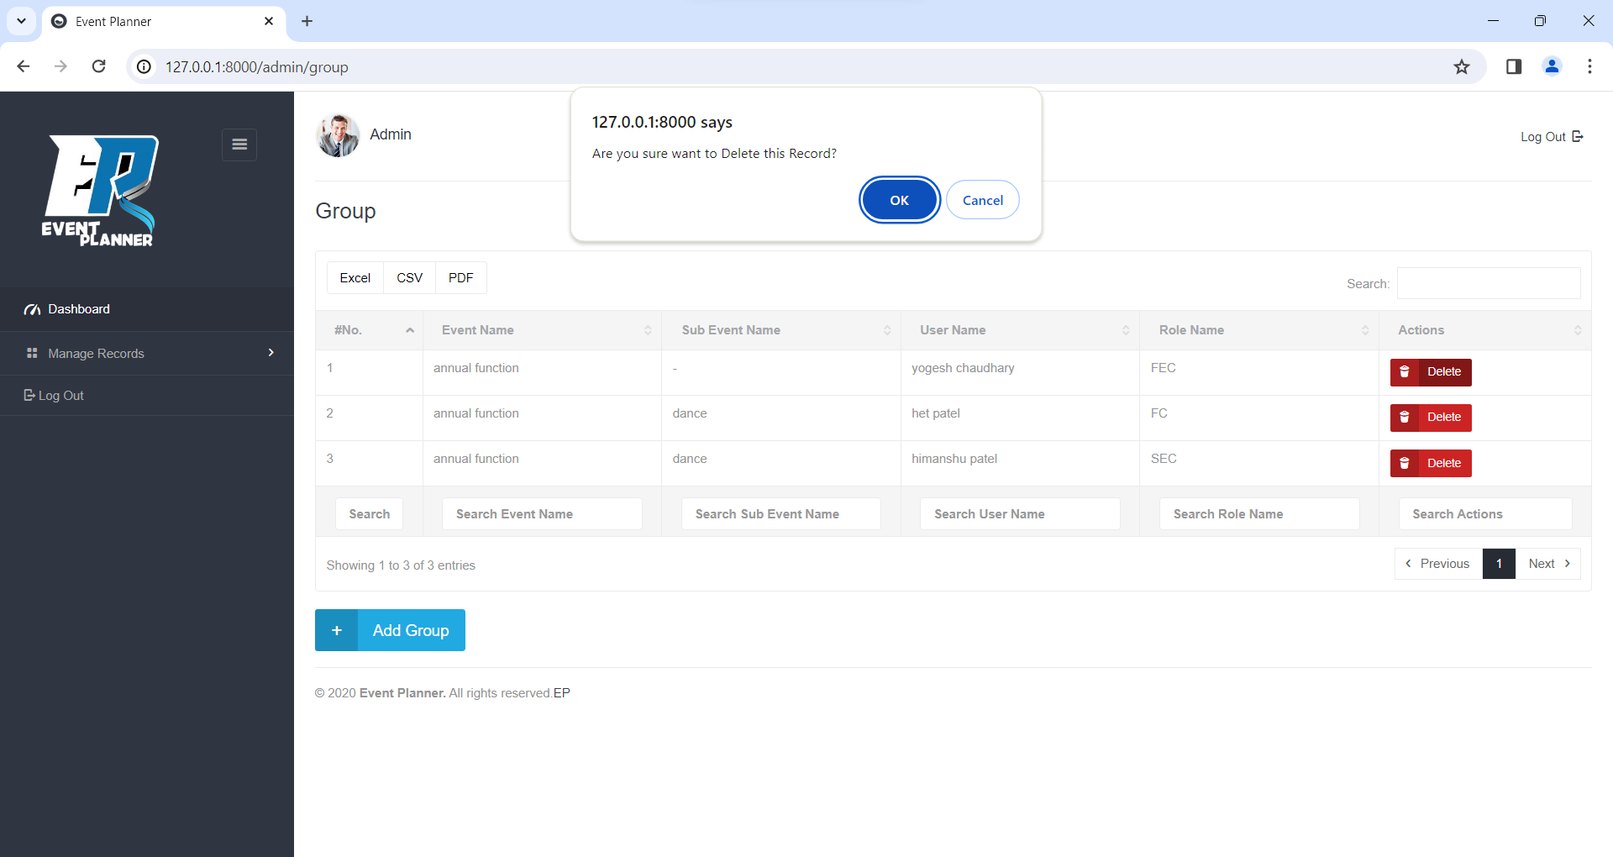

**Add Expense Type**

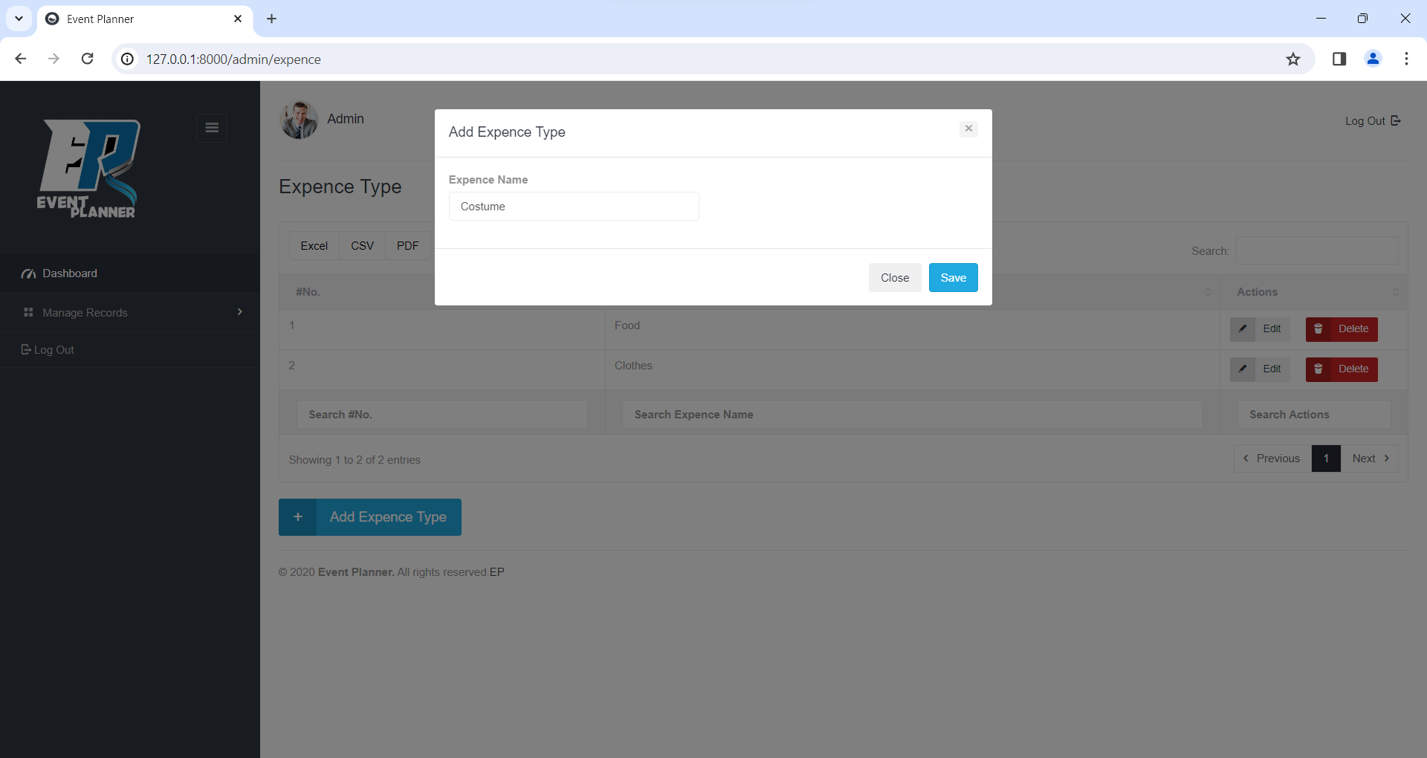

**View Expense Type**

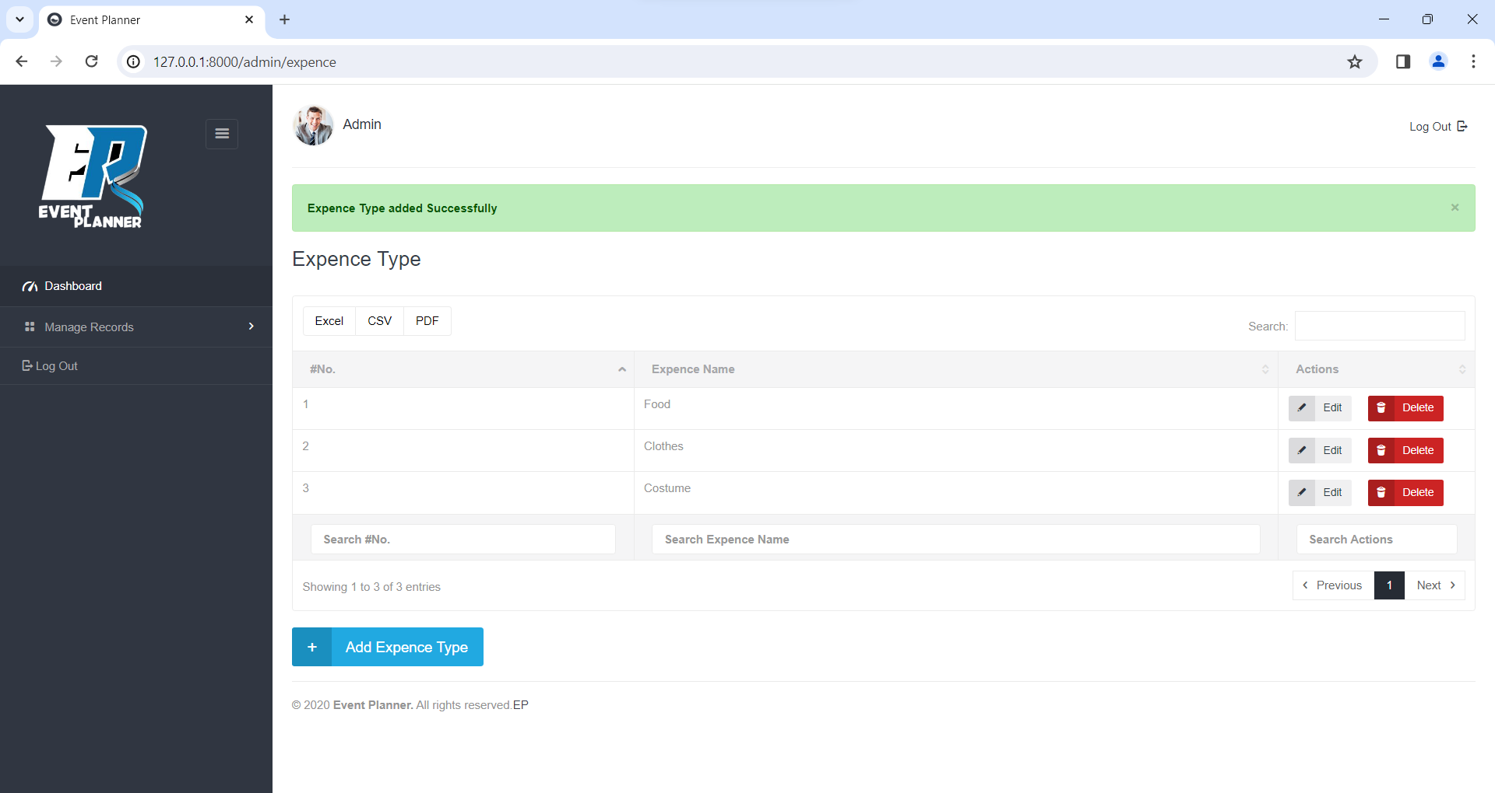

**Update Expense Type**

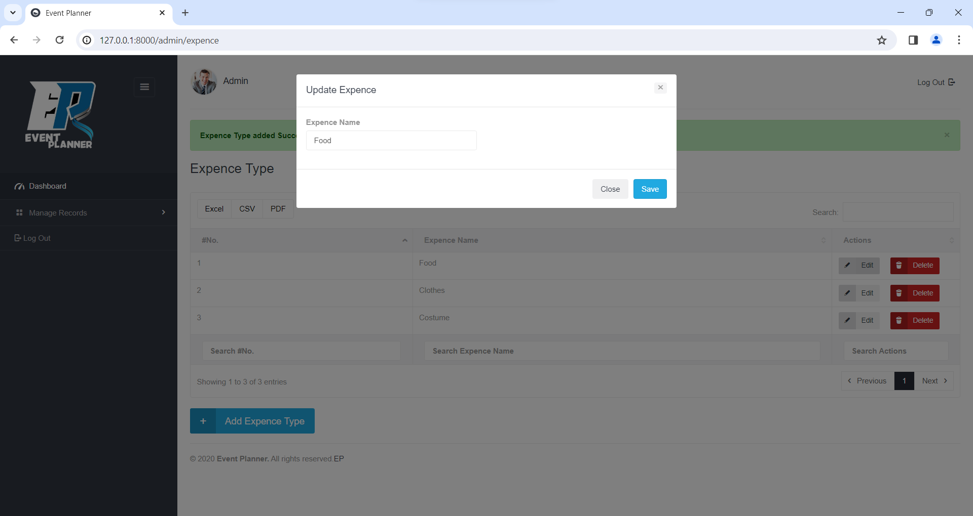

**Delete Expense Type**

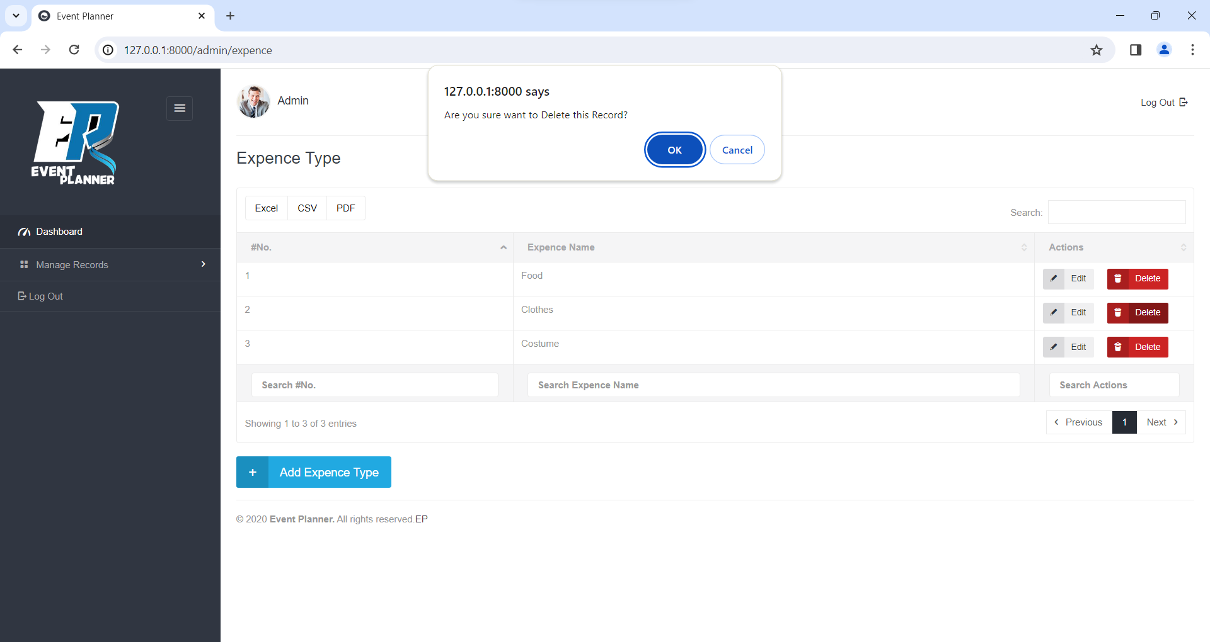

**User Side**

**Event Handler**

**Login**

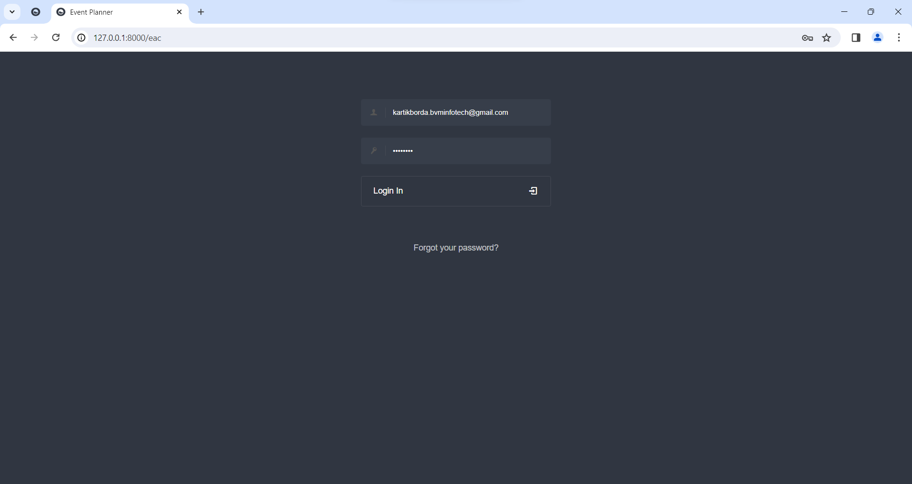

**Forgot Password**

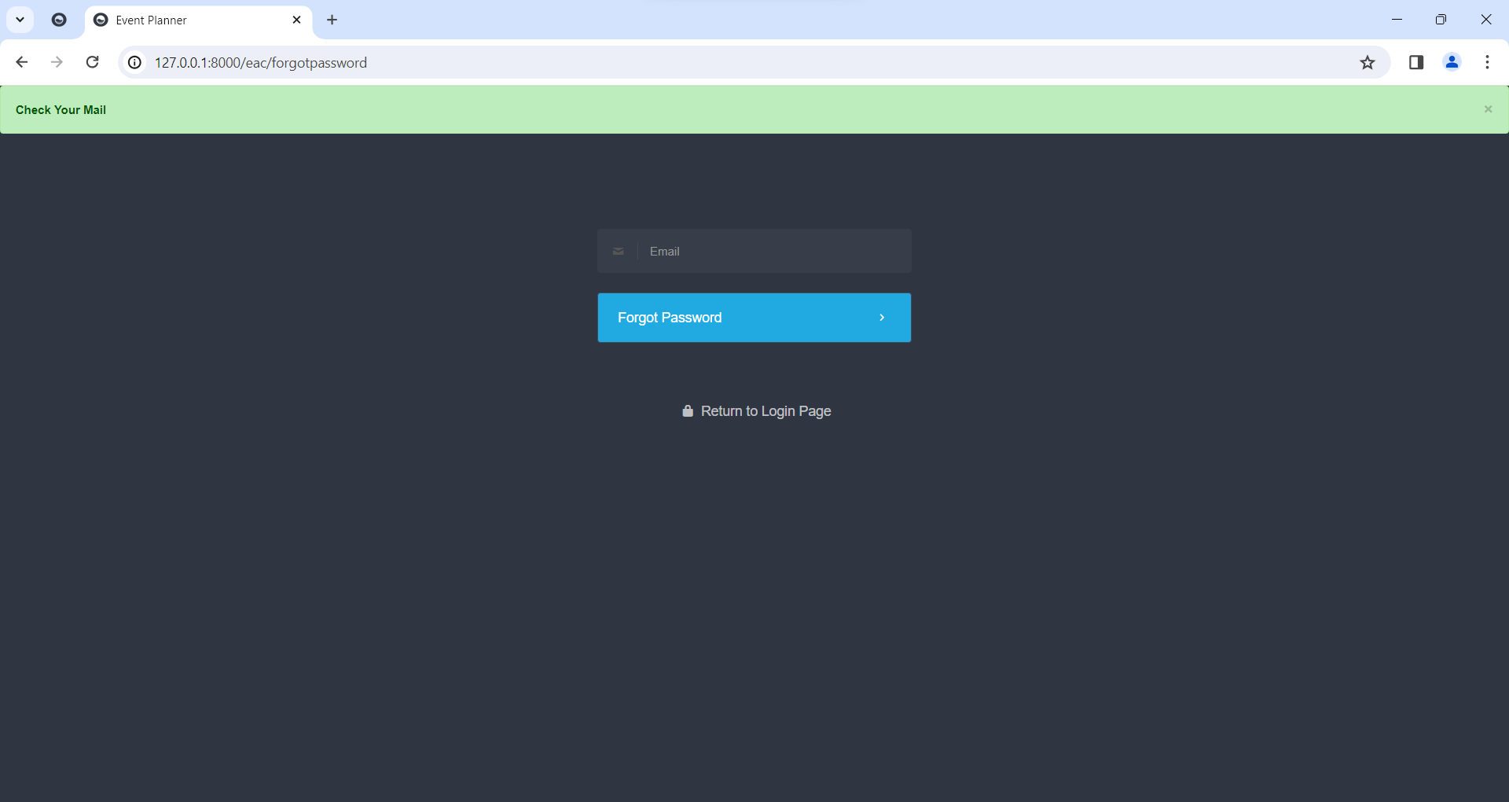

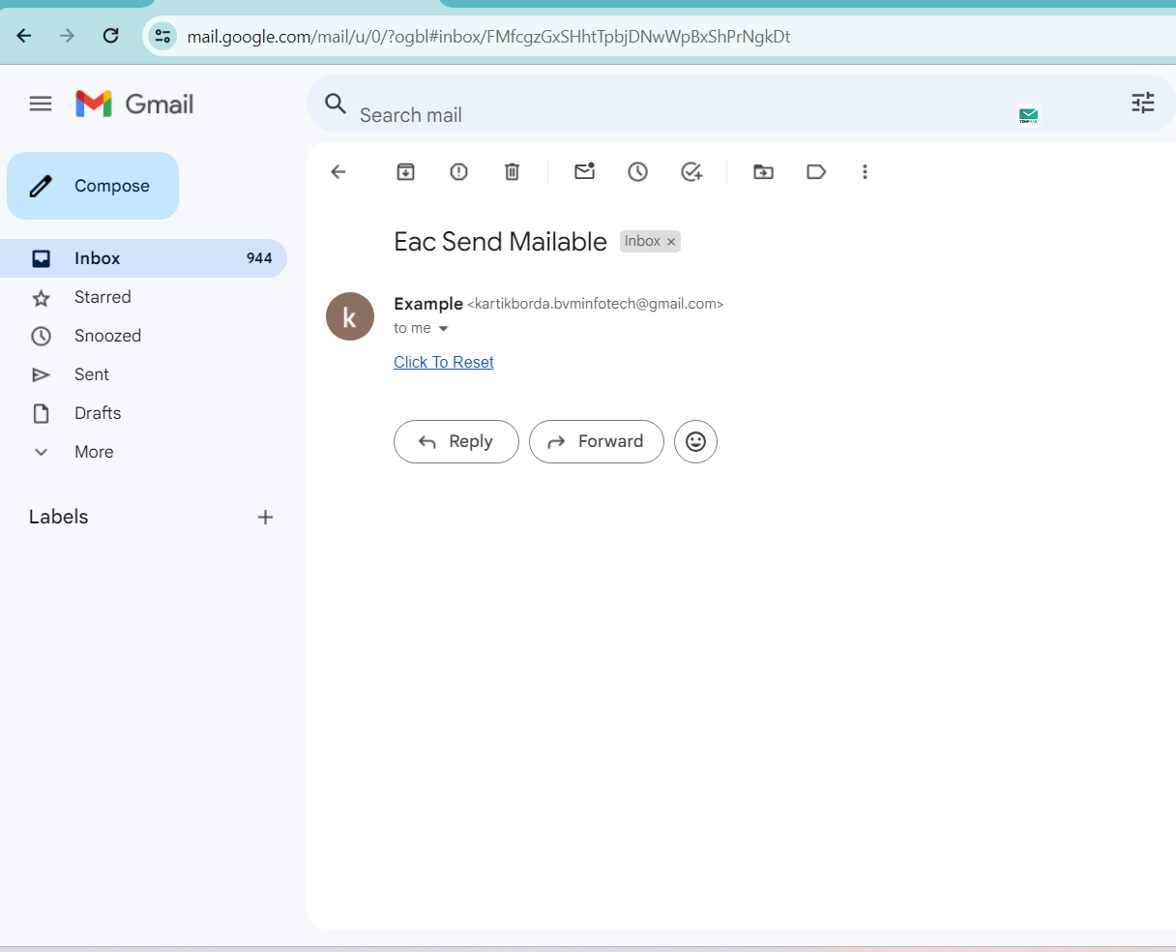

**Reset/Change Password**

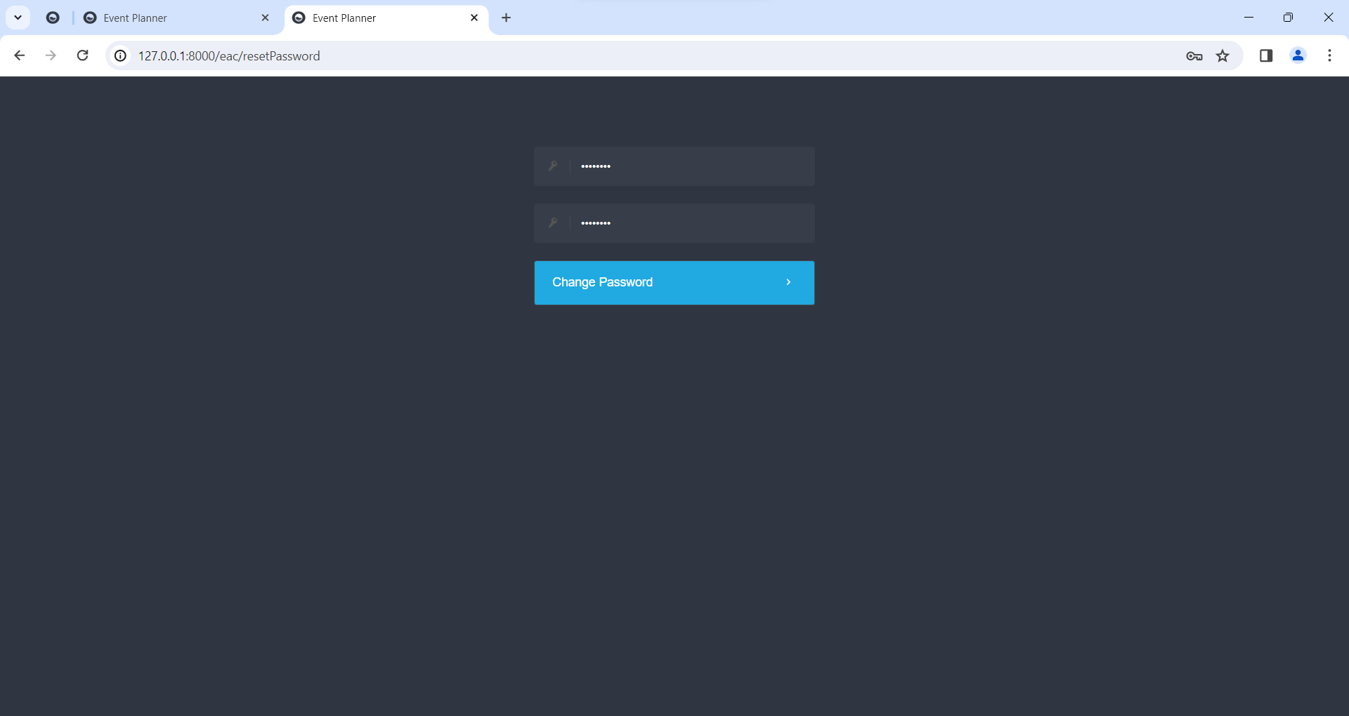

**Dashboard**

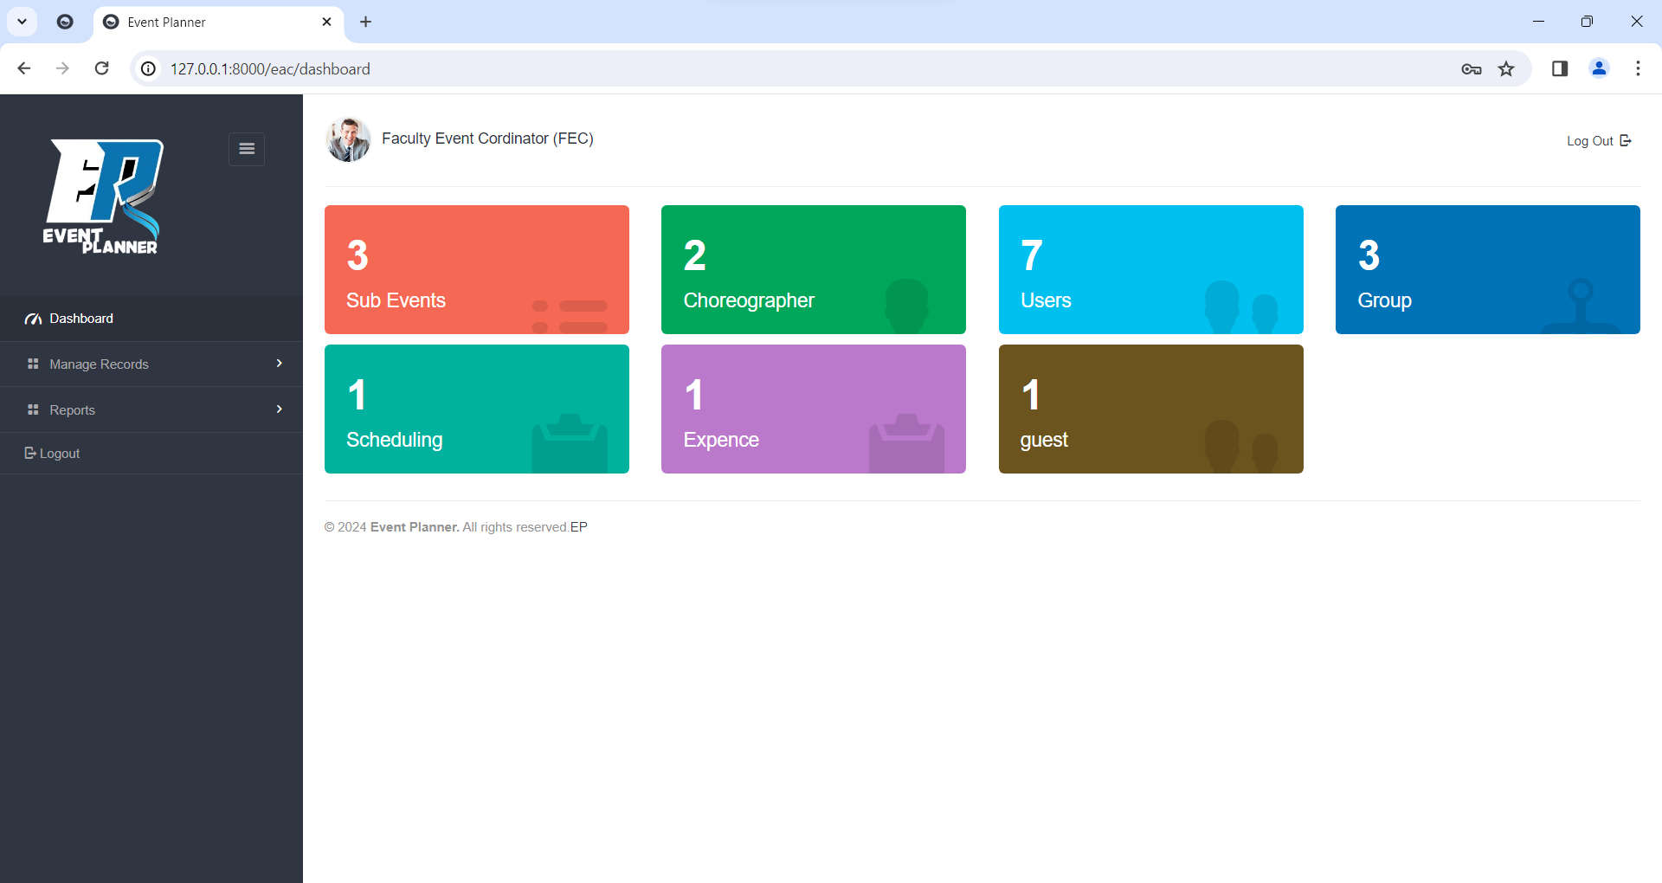

**Add Sub Event**

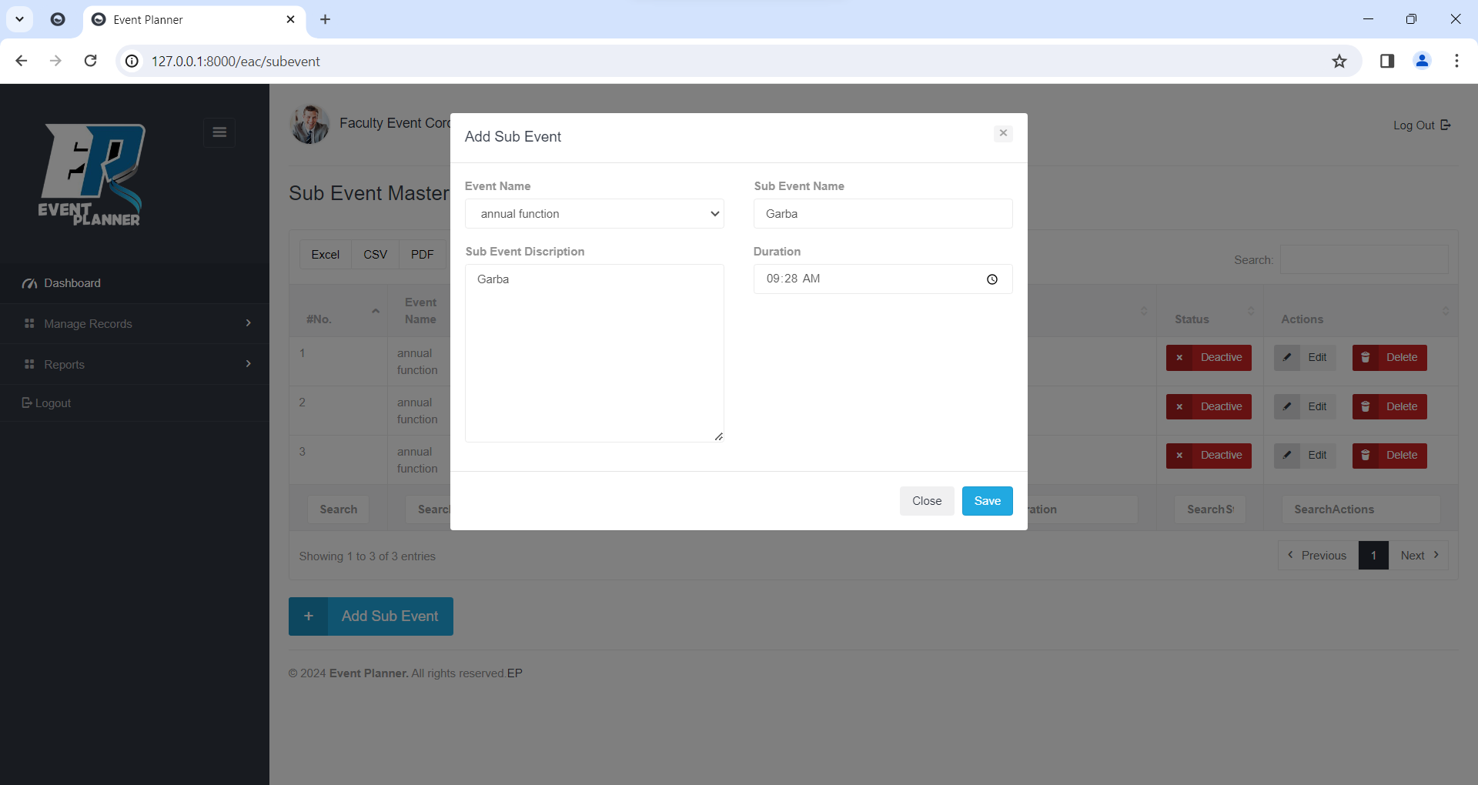

**View Sub Event**

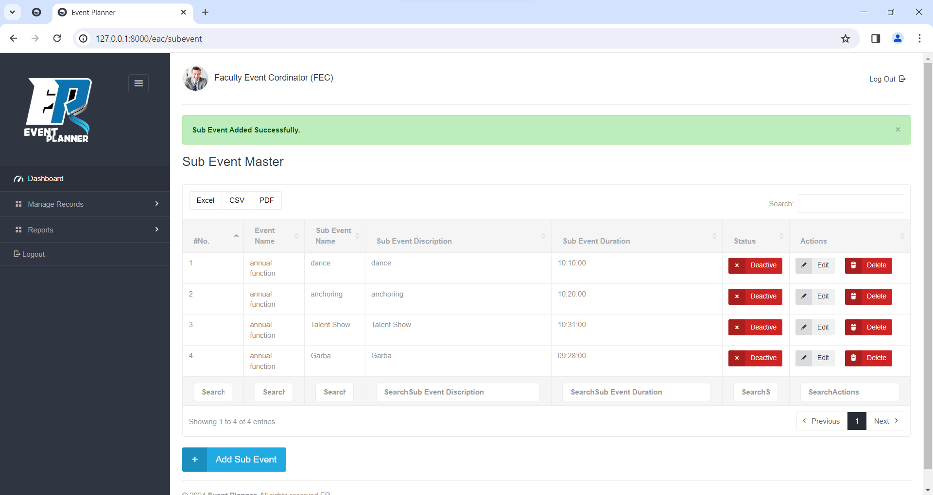

**Update Sub Event**

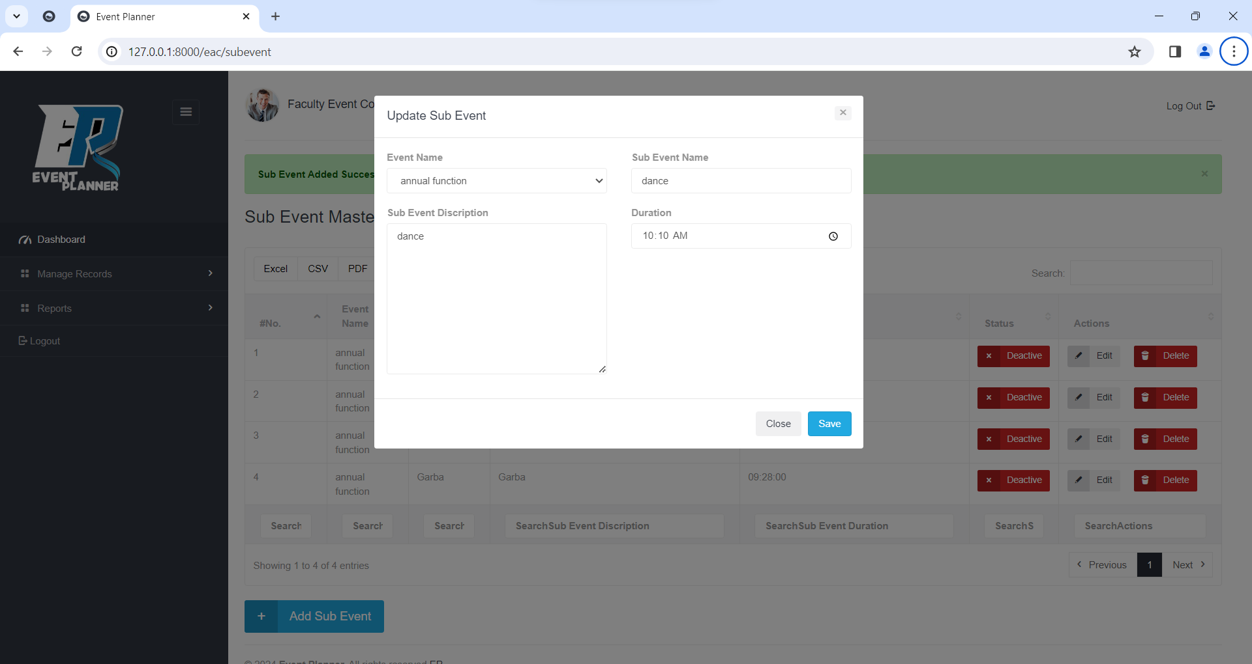

**Delete Sub Event**

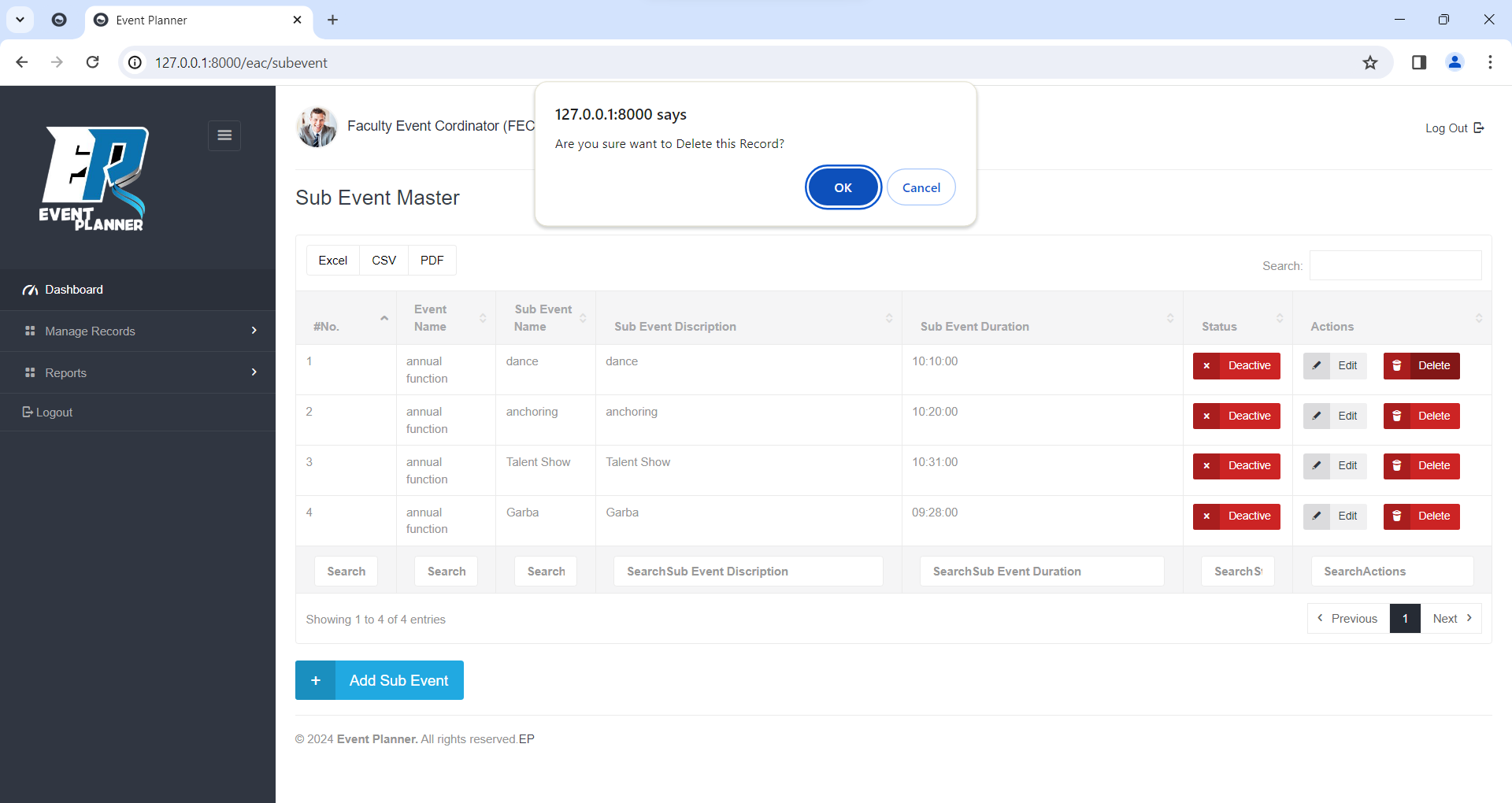

**Add Choreographer** (Sub Event Wise)

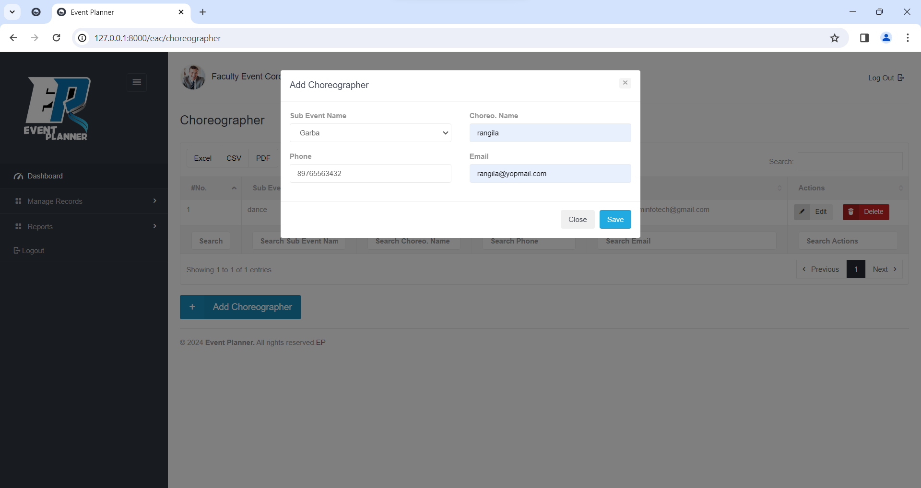

**View Choreographer**

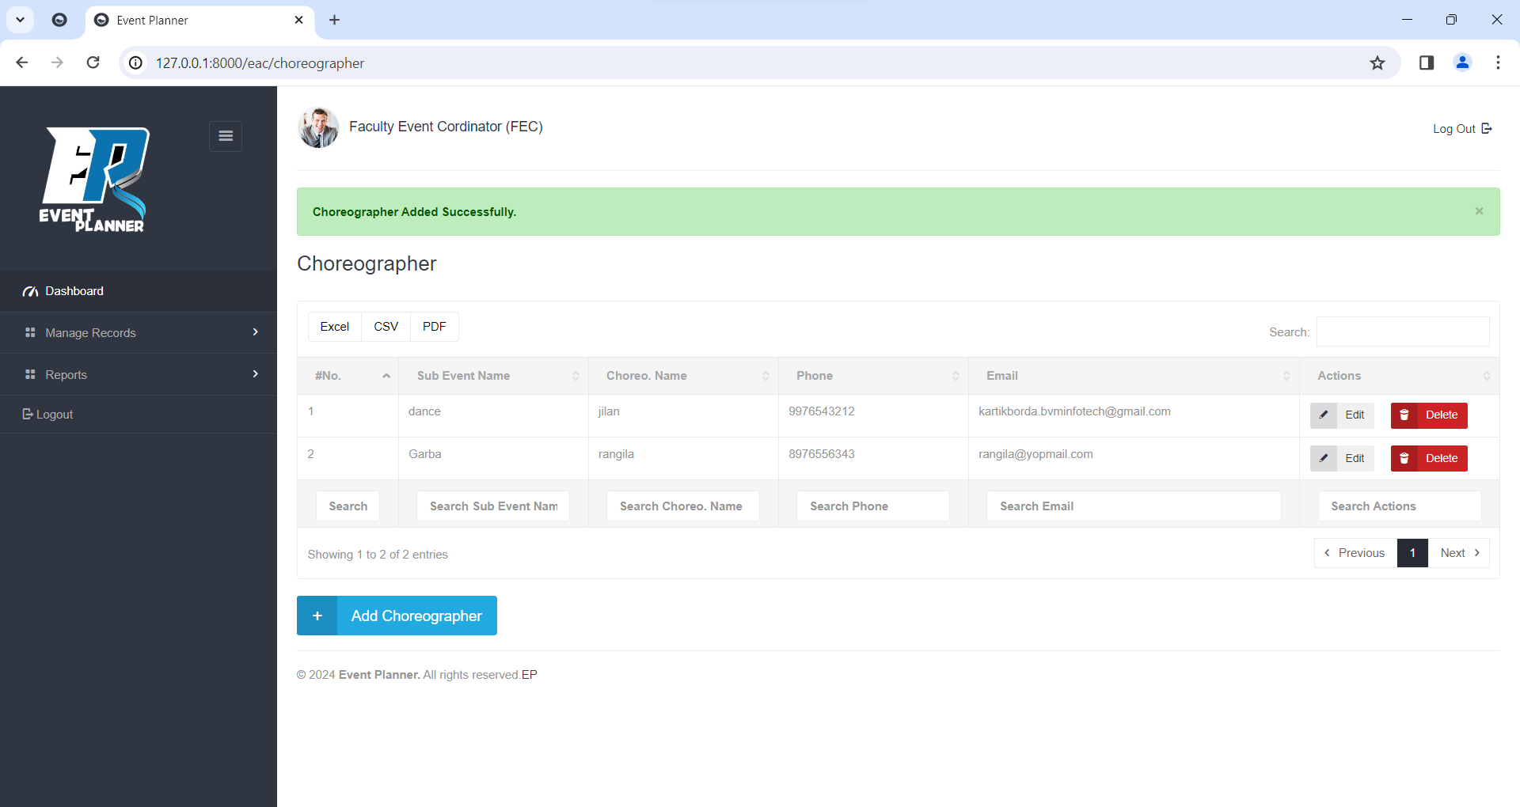

**Update Choreographer**

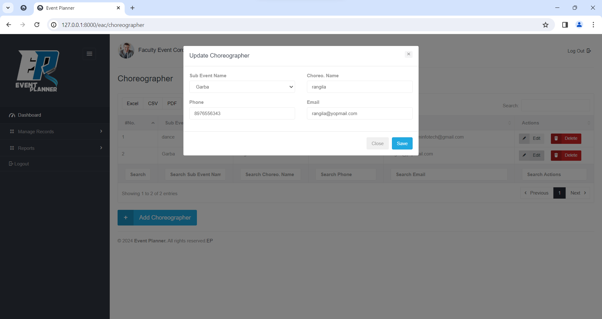

**Delete Choreographer**

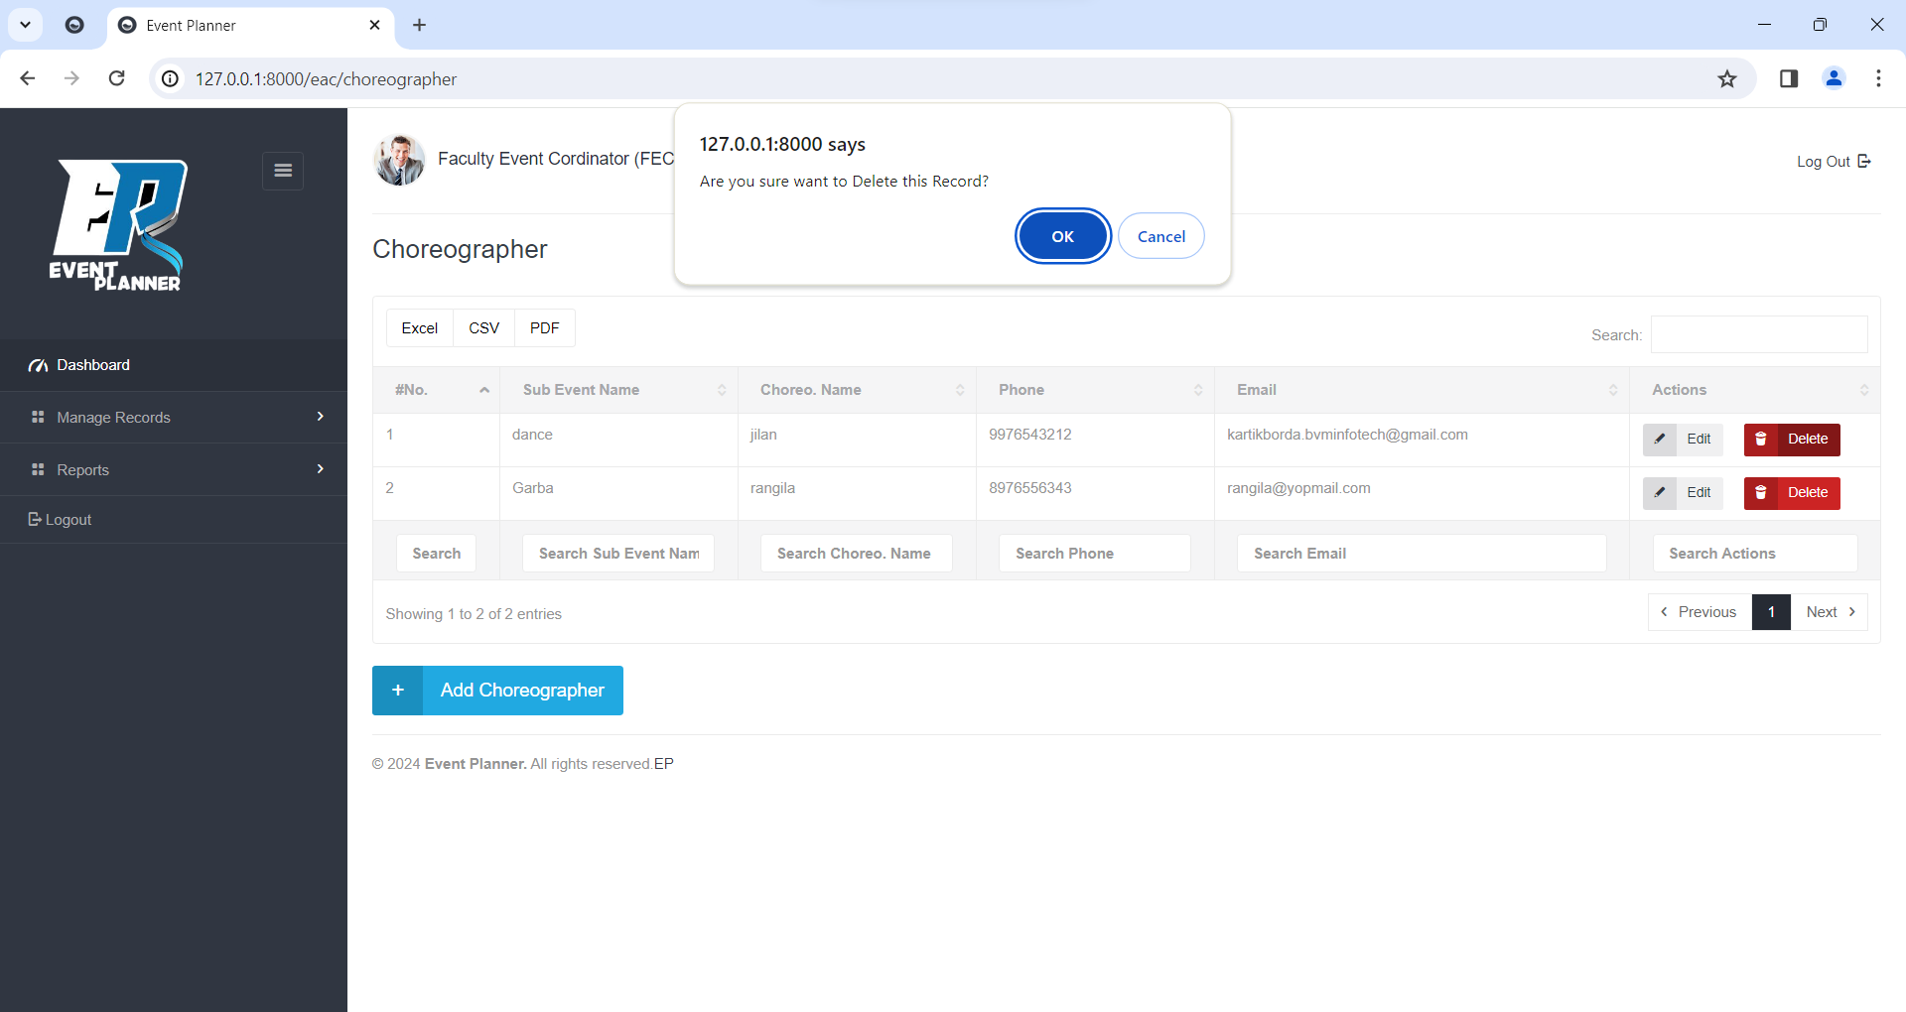

**Add User**

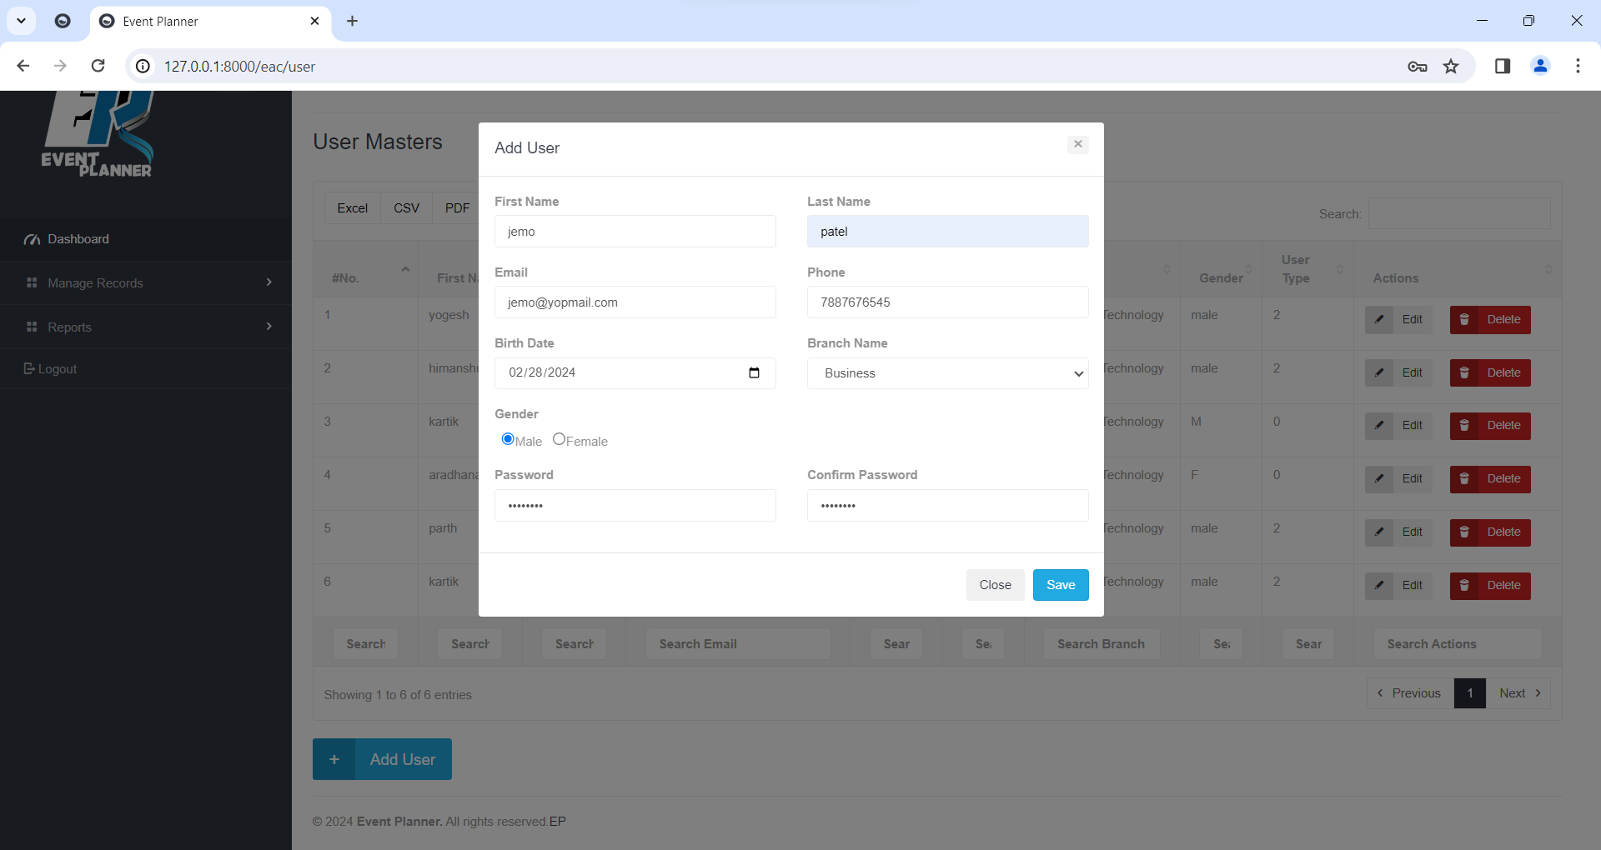

**View User**

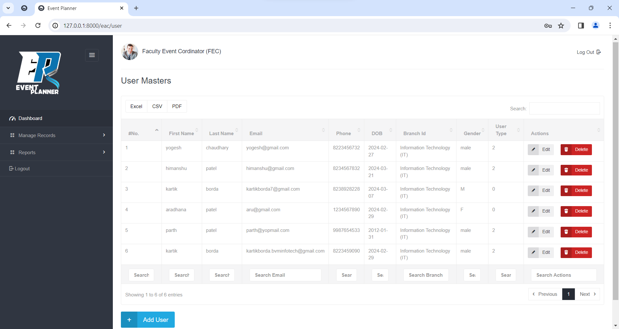

**Update User**

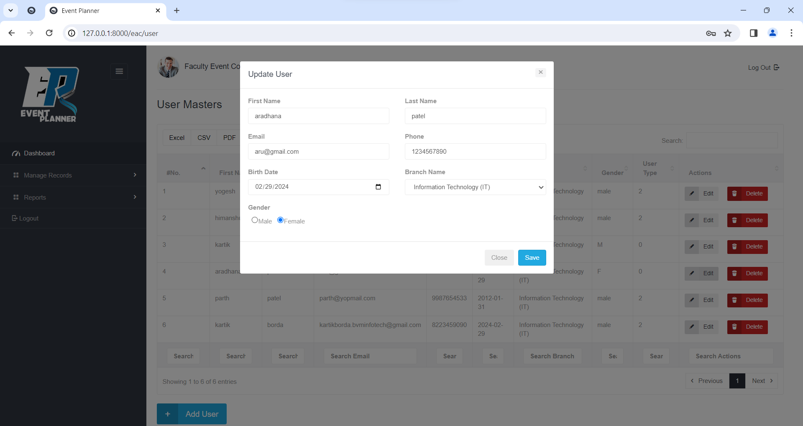

**Delete User**

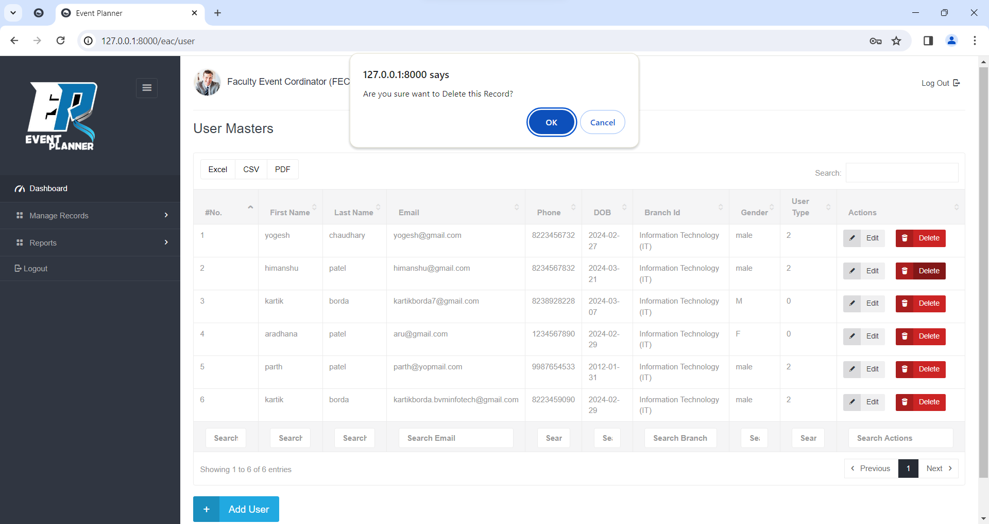

**Add Group**

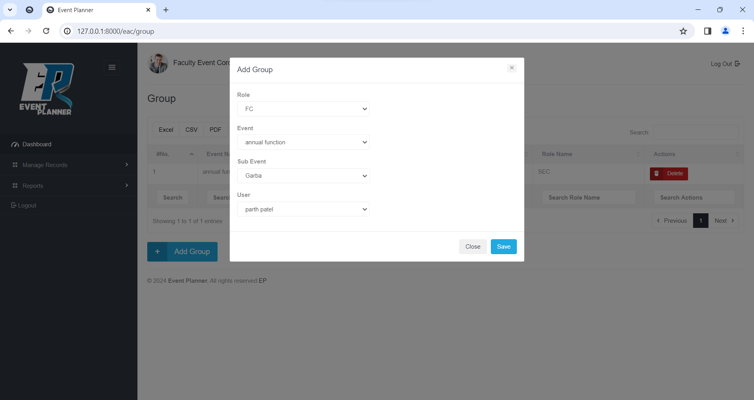

**View Group**

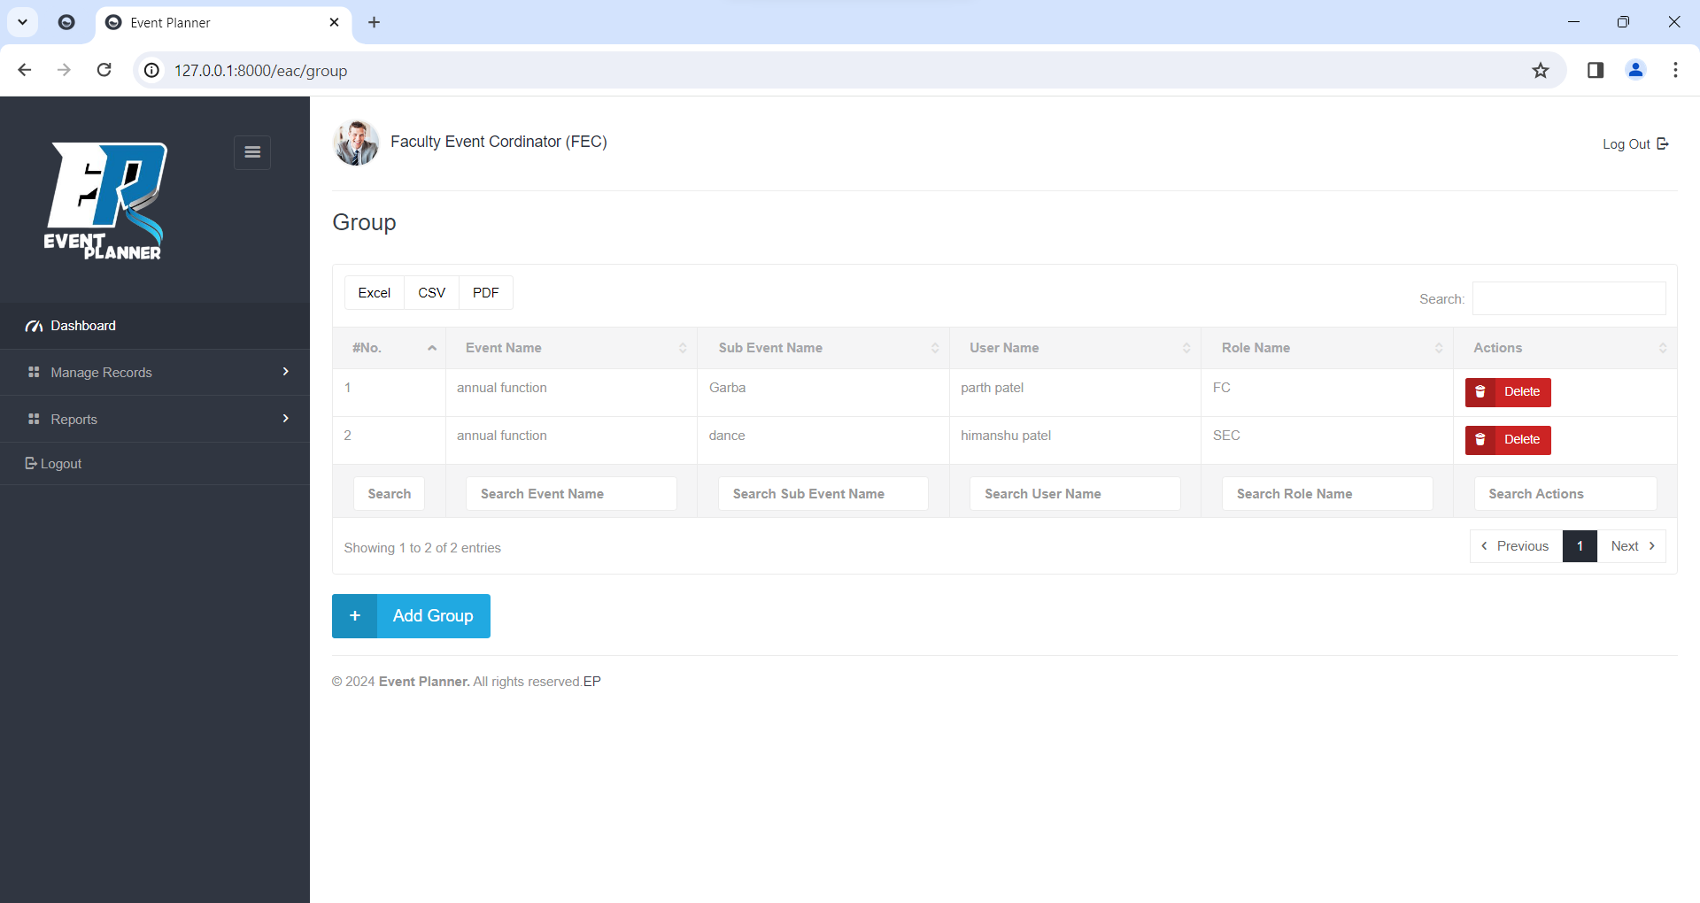

**Delete Group**

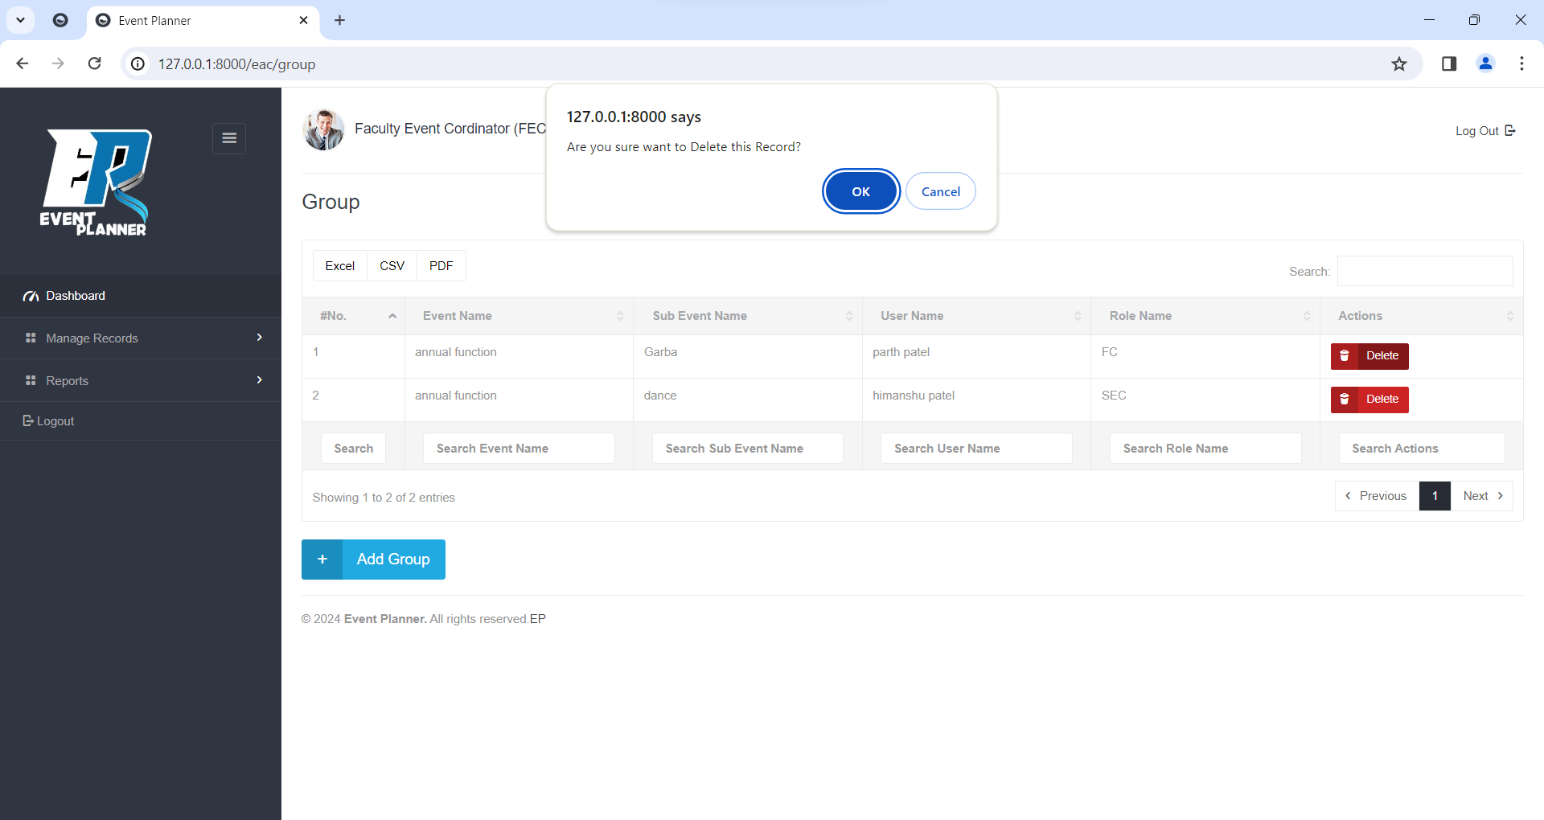

**View Attendance**

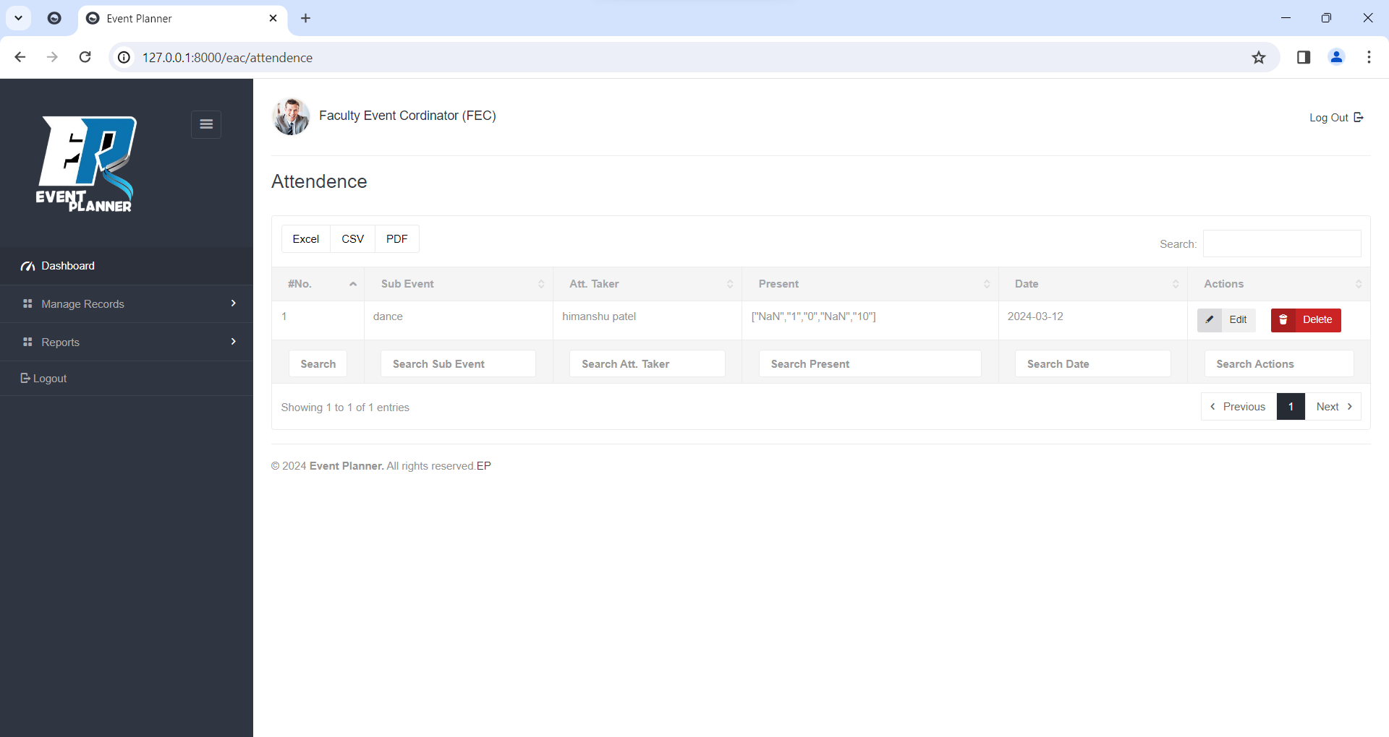

**Update Attendance**

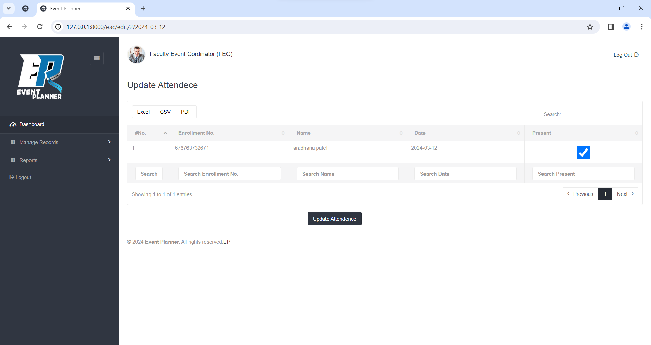

**Delete Attendance**

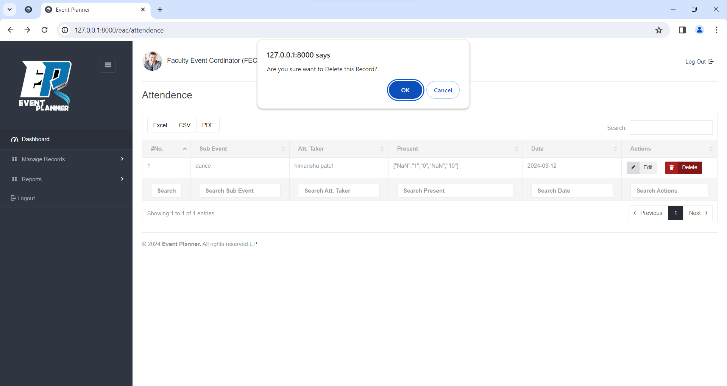

**Generate Scheduling**

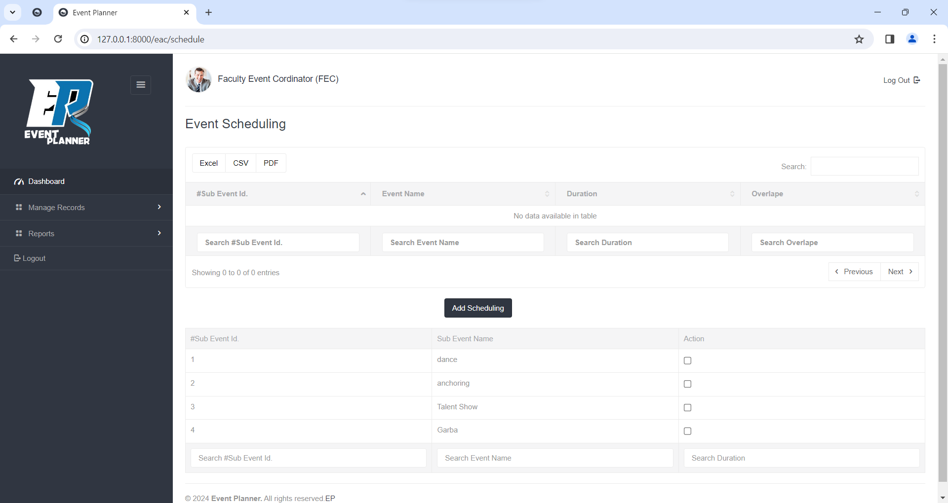

**View Scheduling**

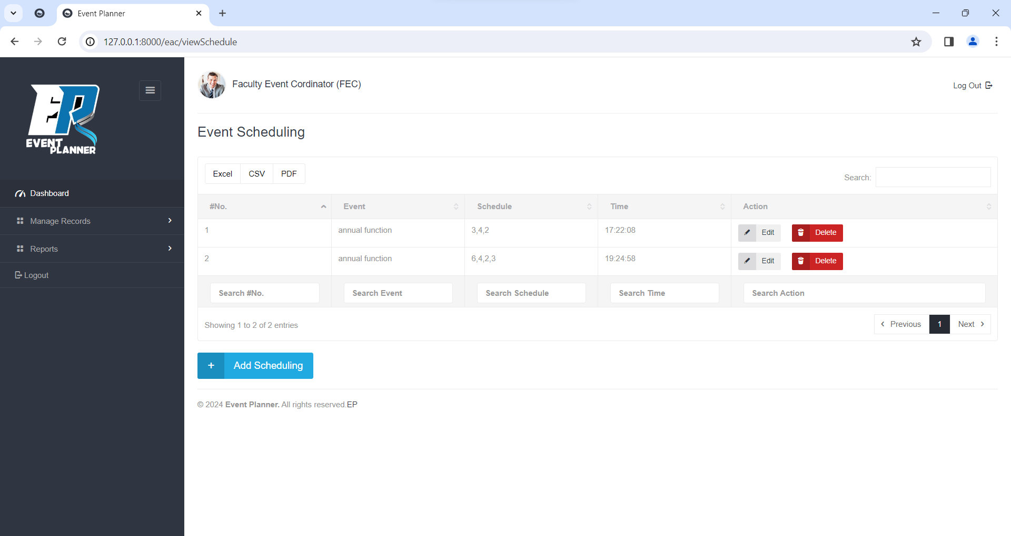

**Update Scheduling**

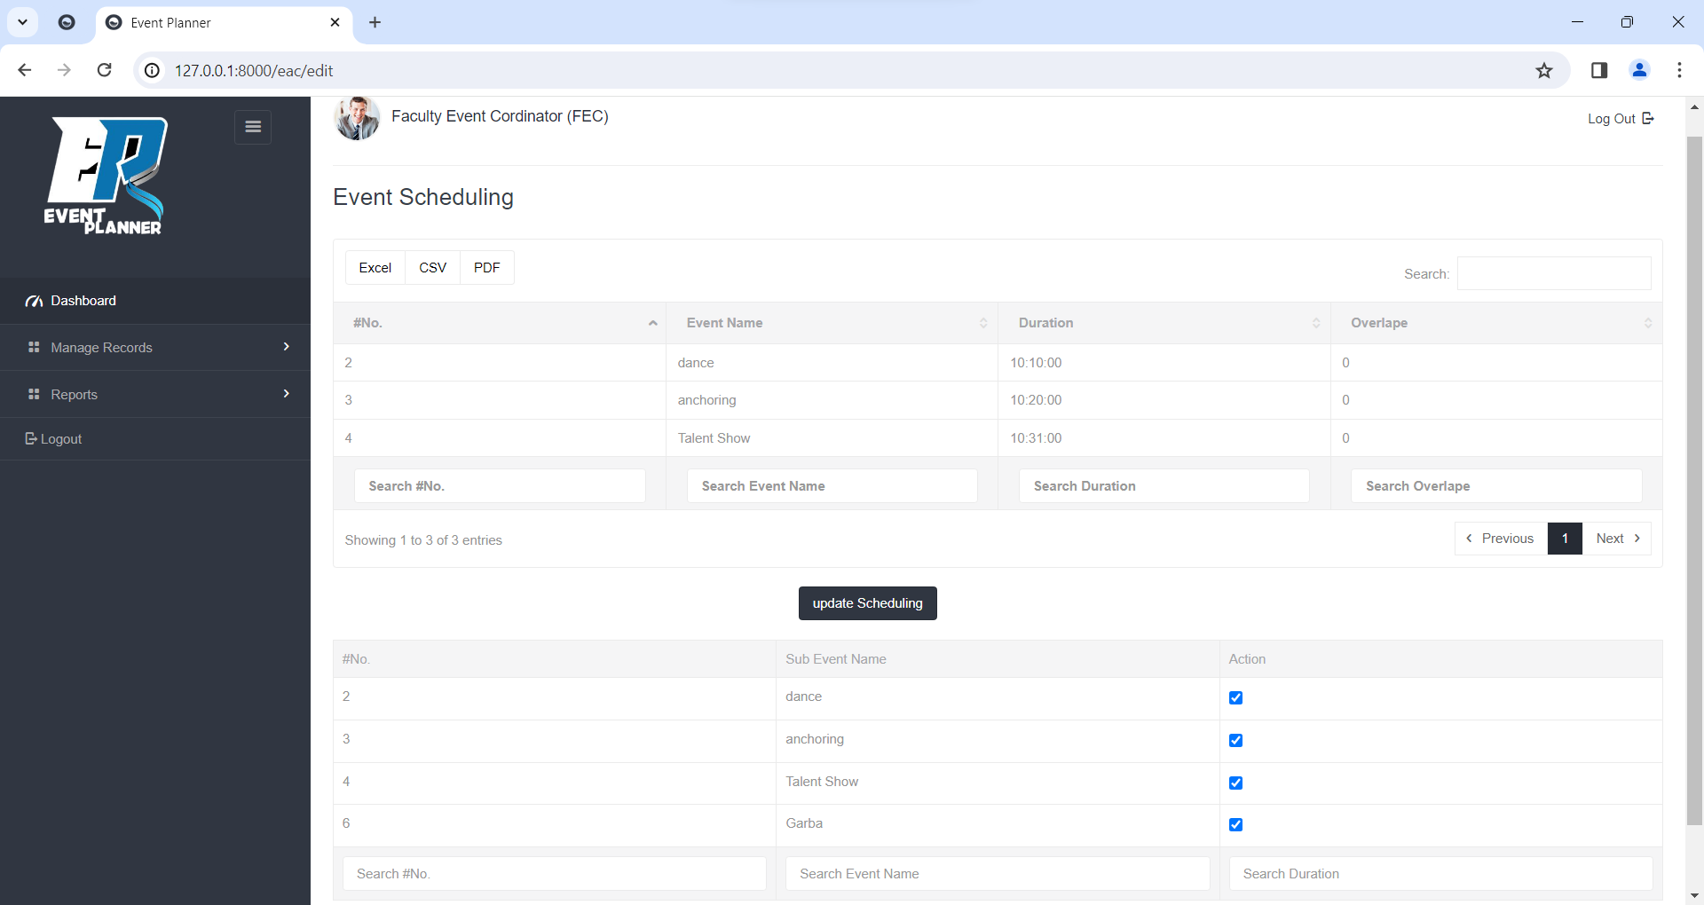

**Delete Scheduling**

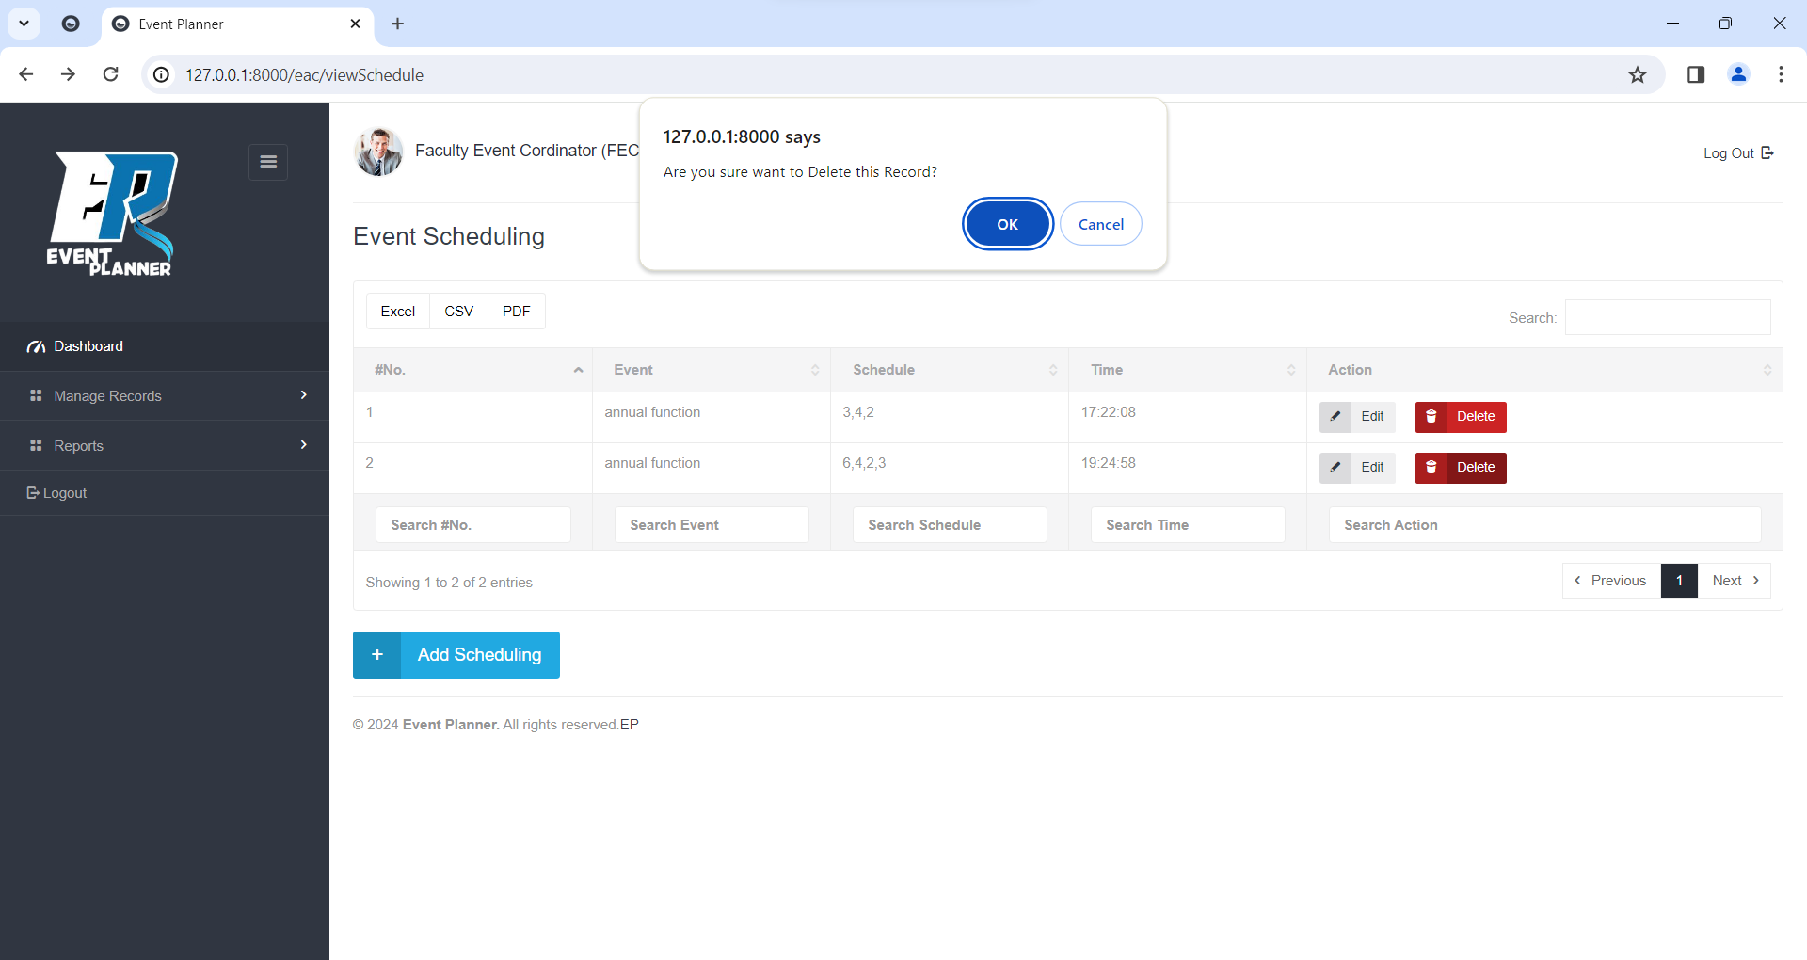

**Approved Expense**

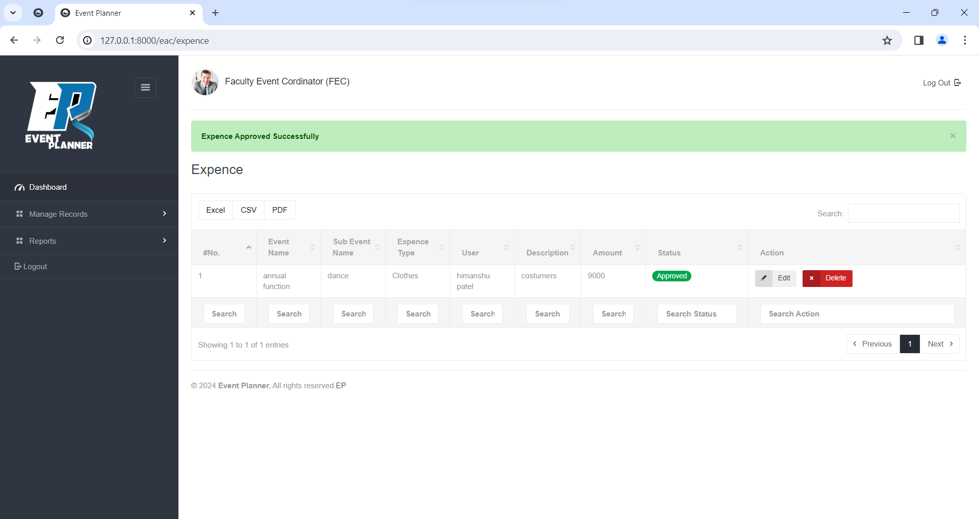

**Update Expense**

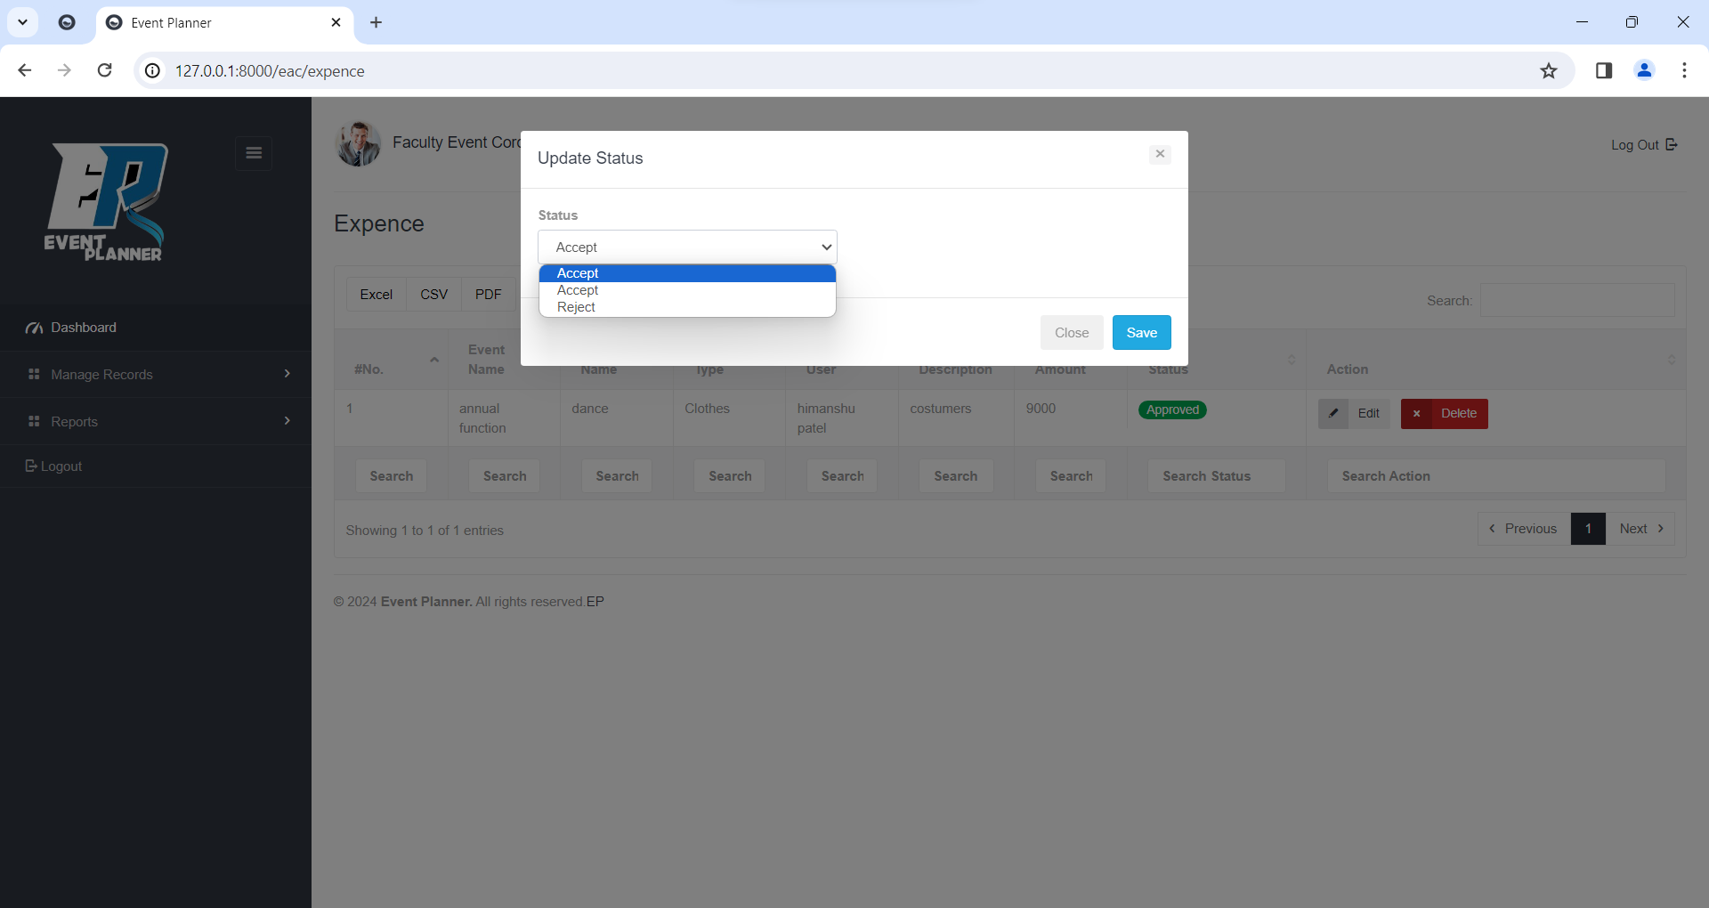

**Delete Expense**

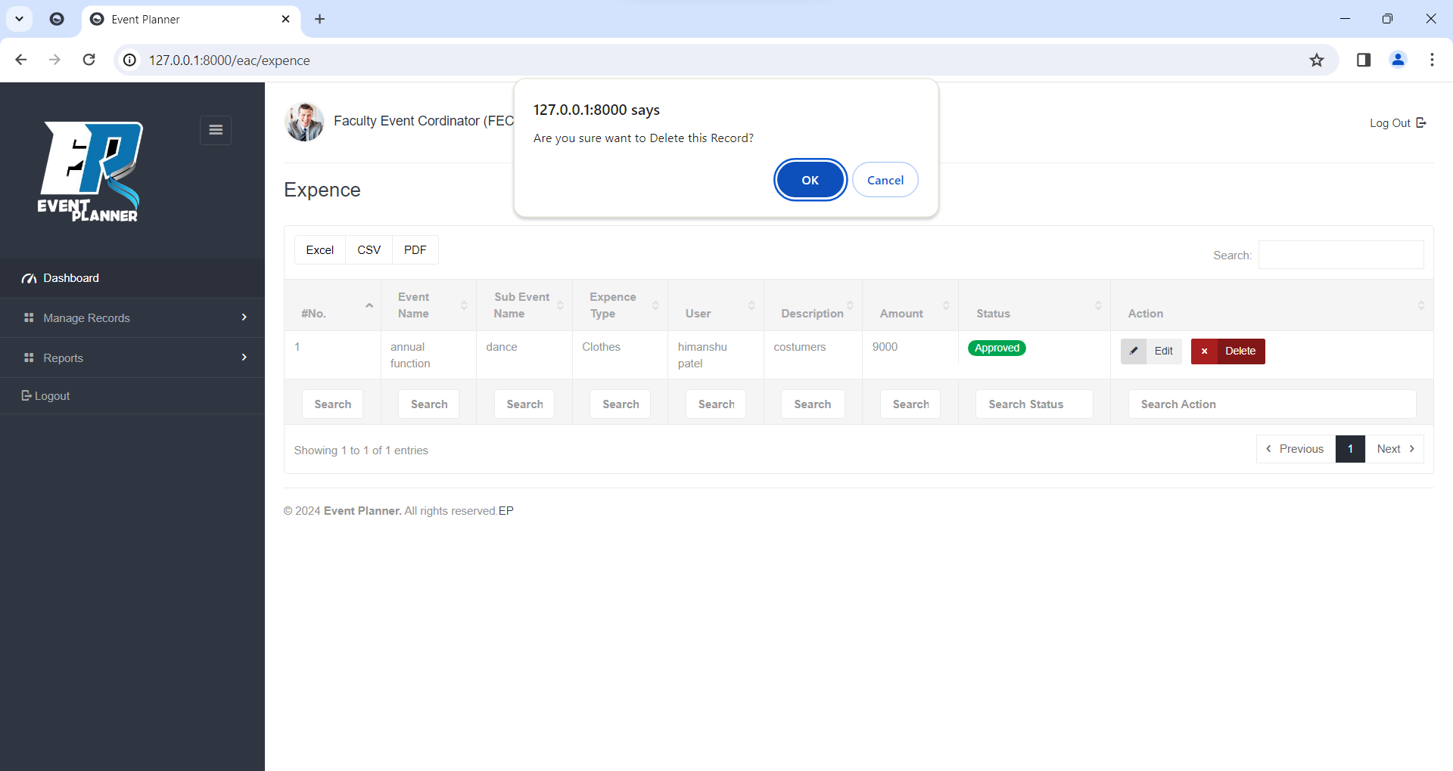

**Feculty Coordinator**

**Login**

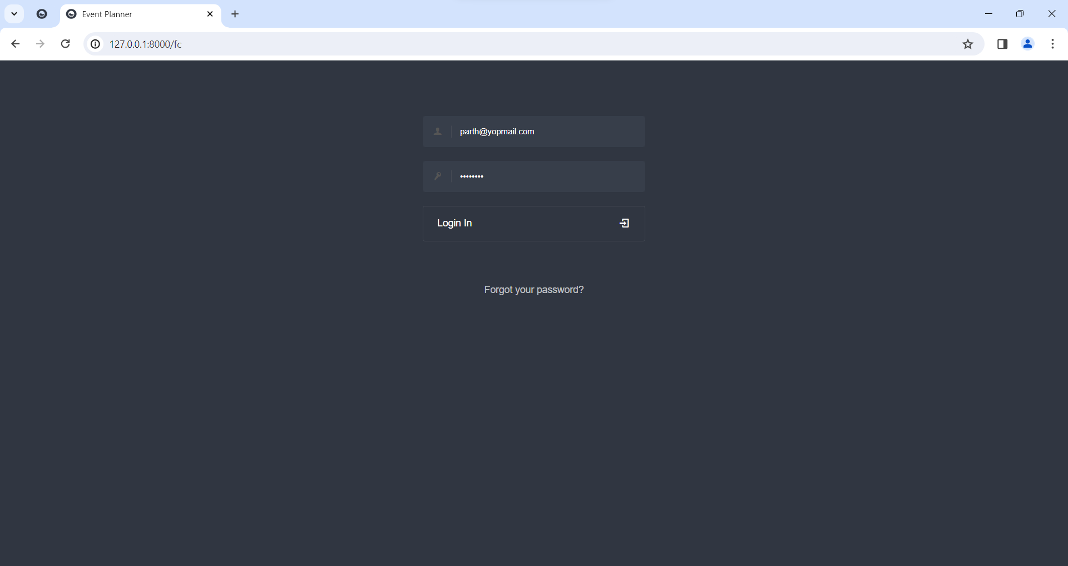

**Forgot Password**

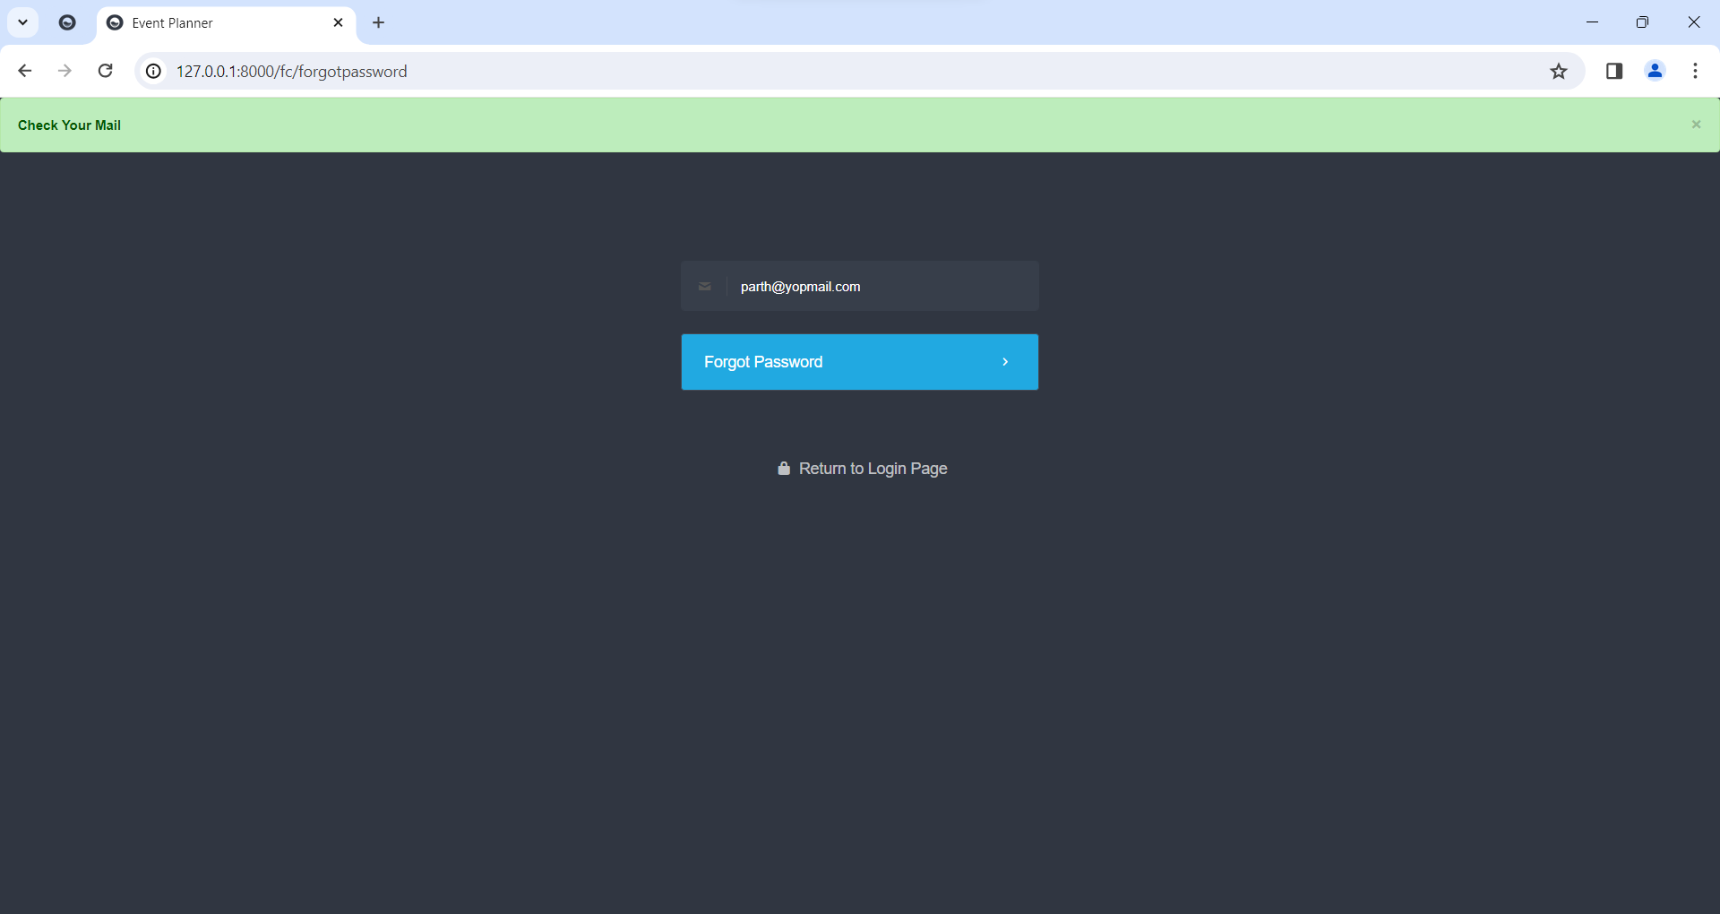

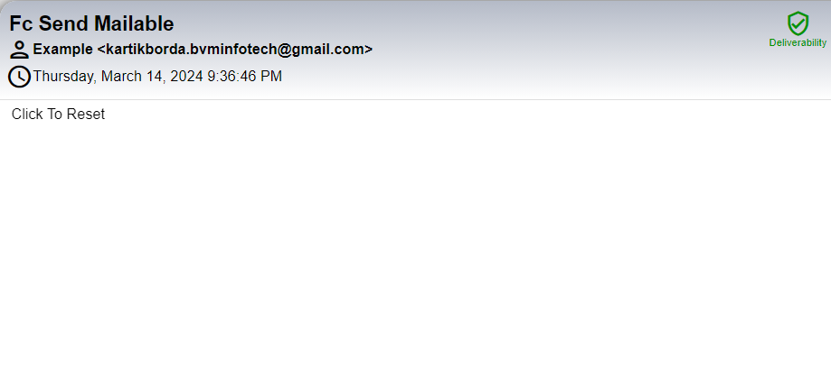

**Dashboard**

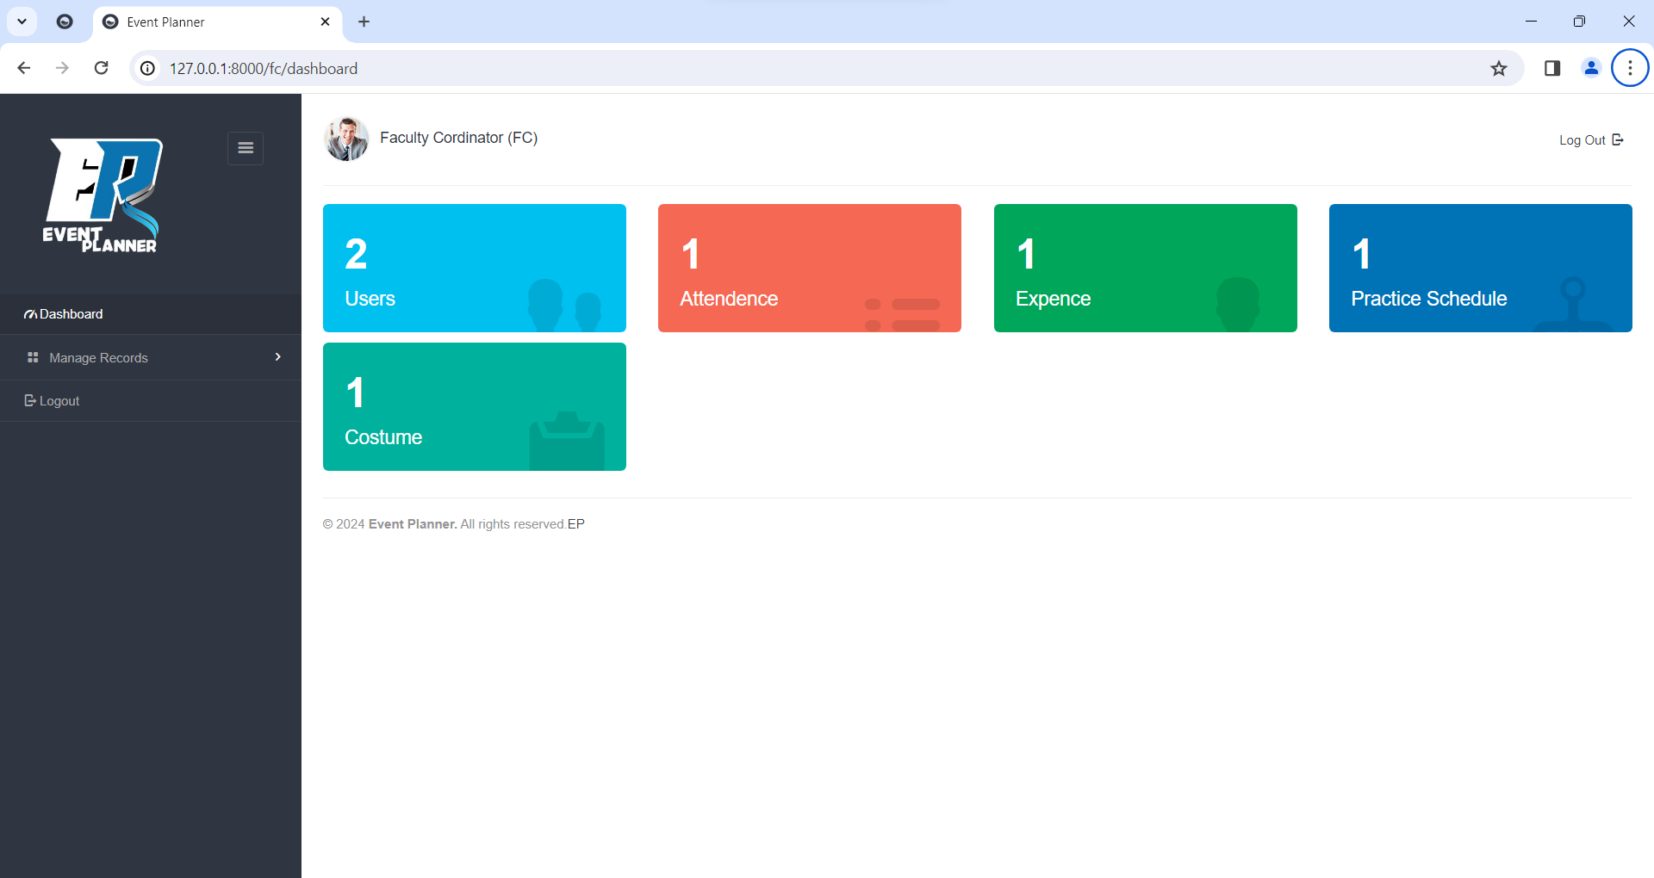

**Manage User Role**

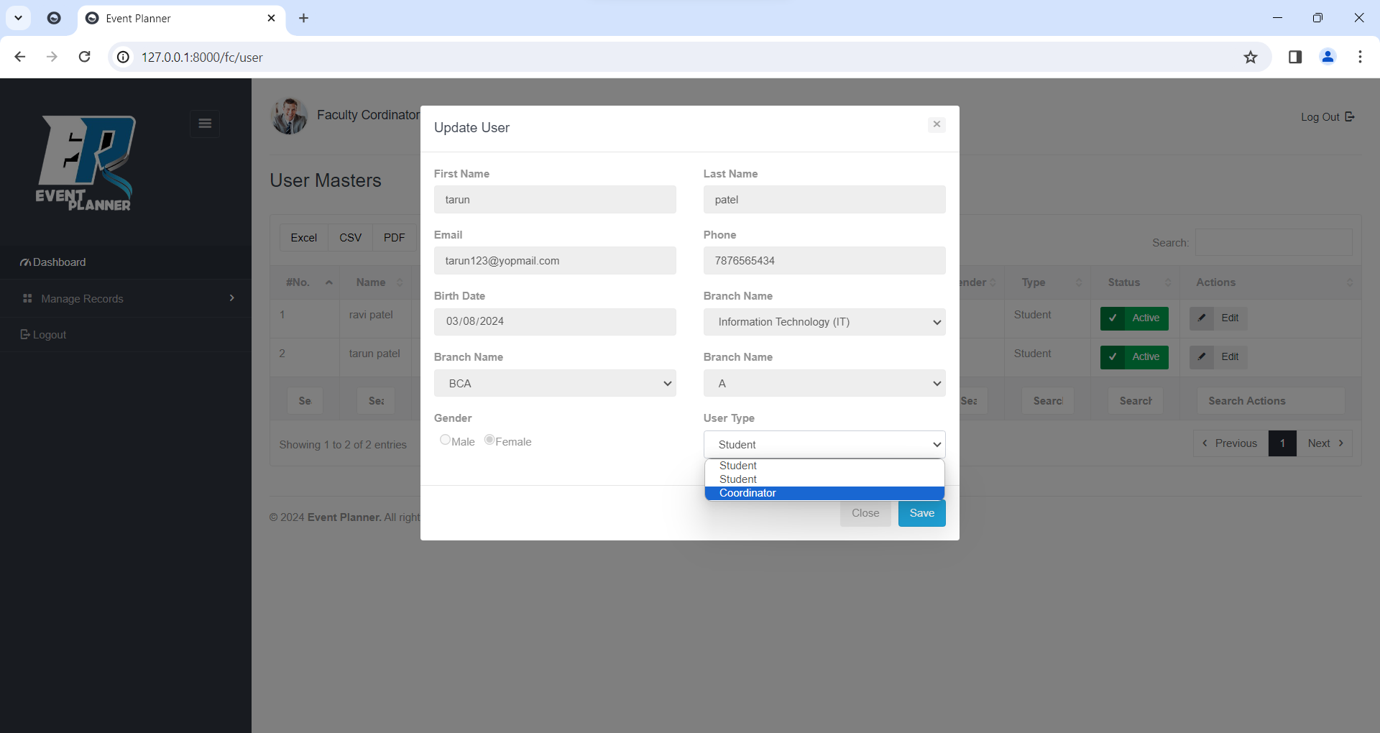

**View Students**

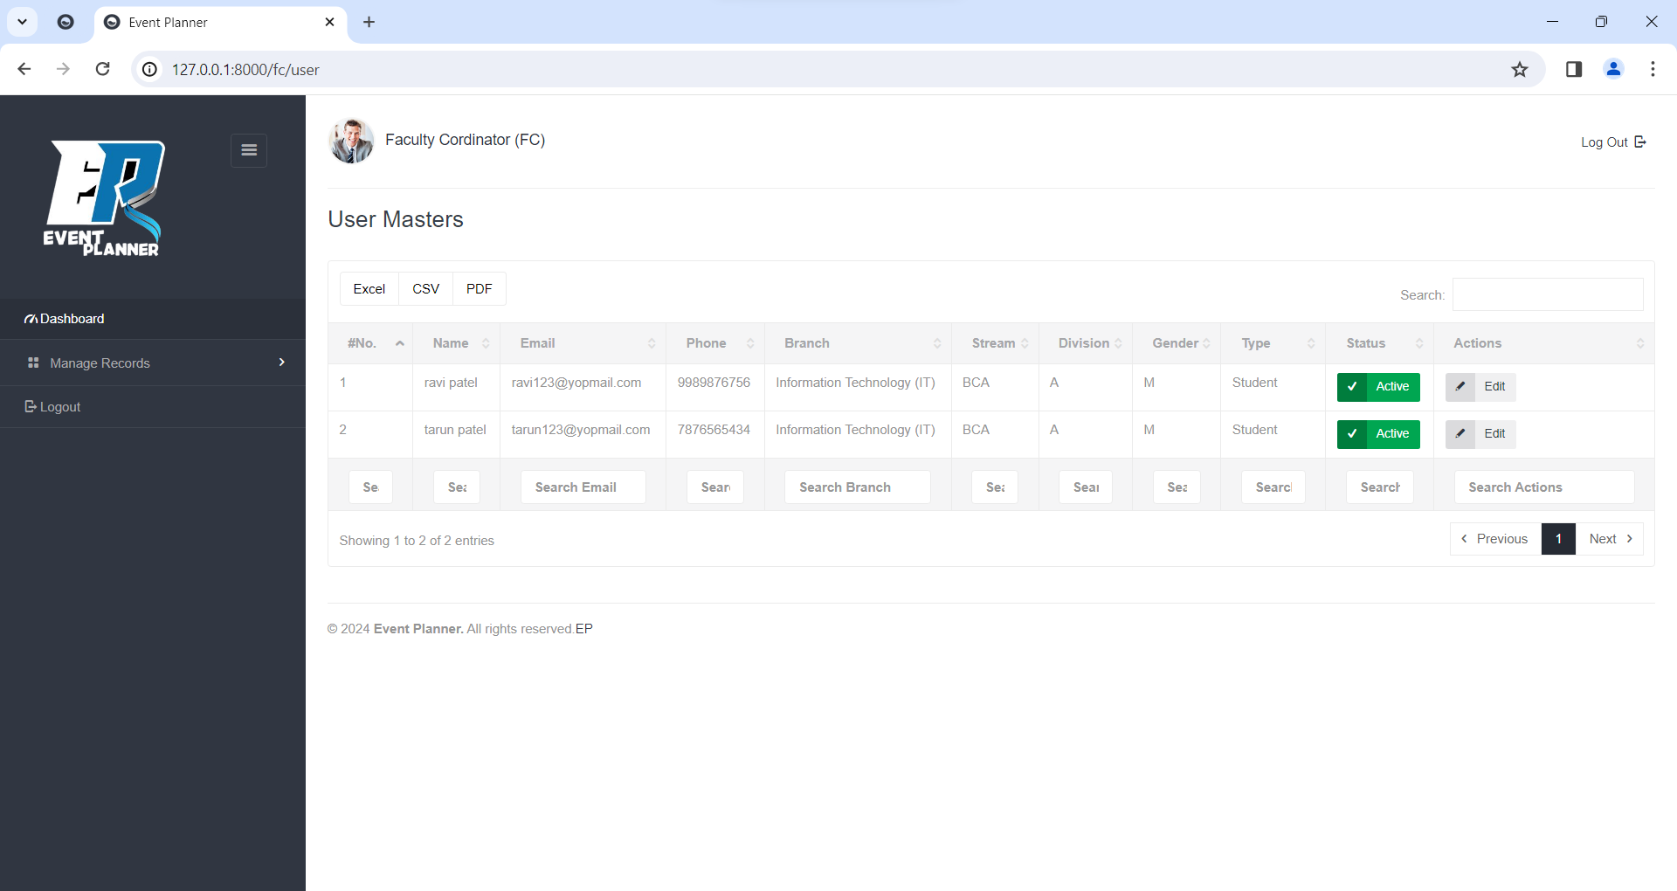

**Add Attendance**

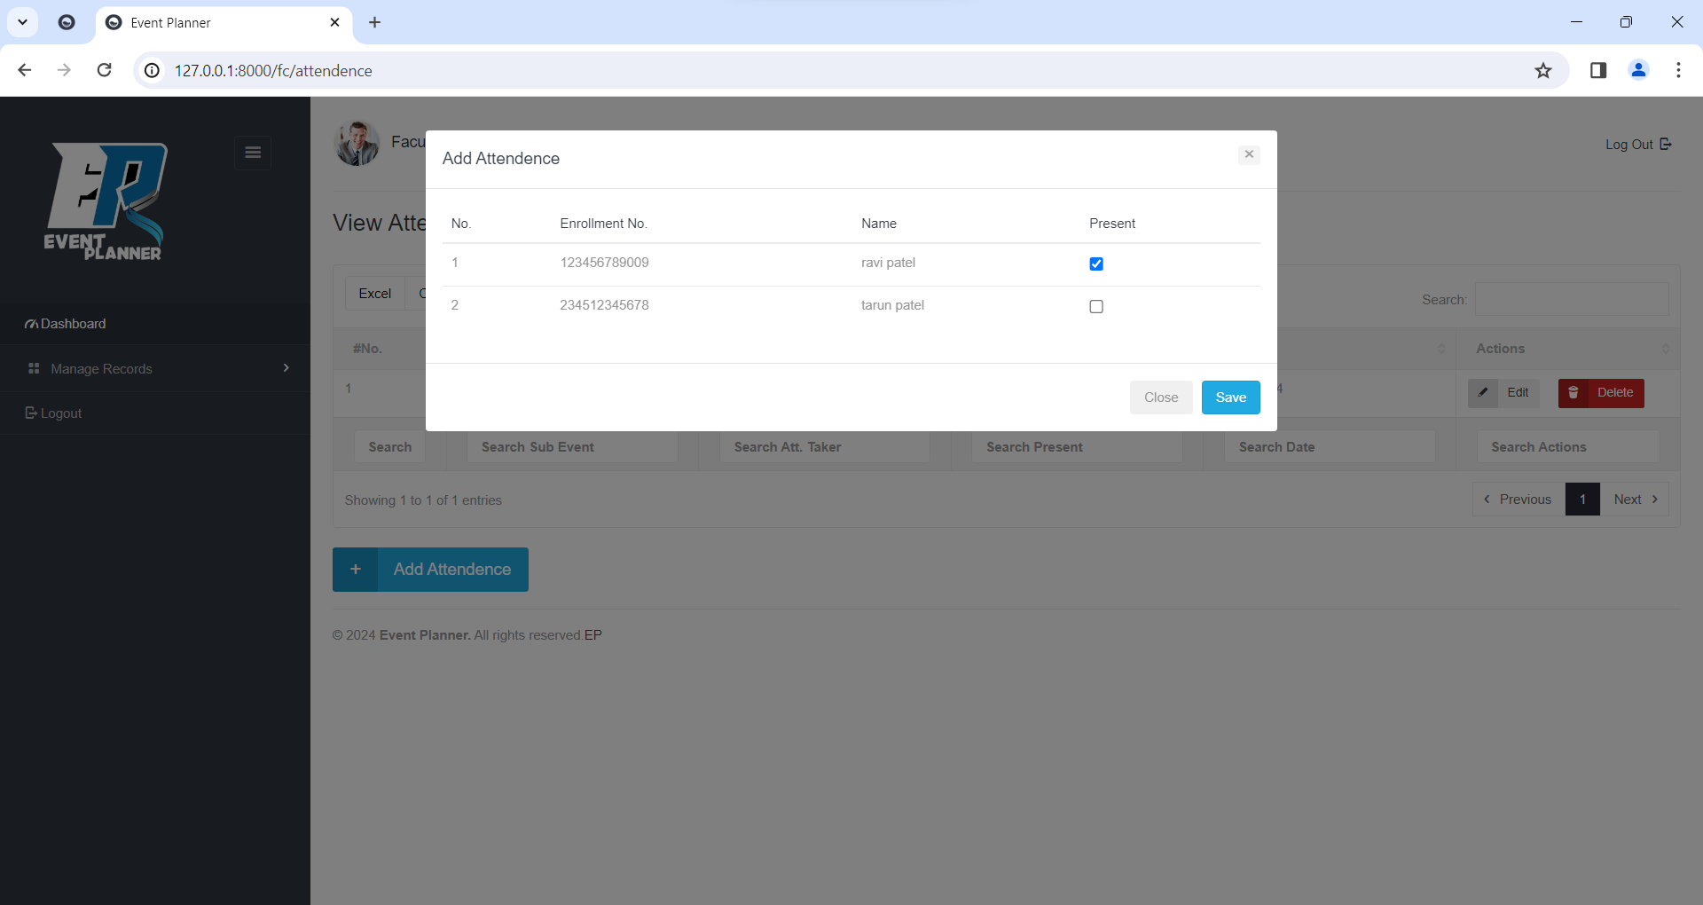

**Update Attendance**

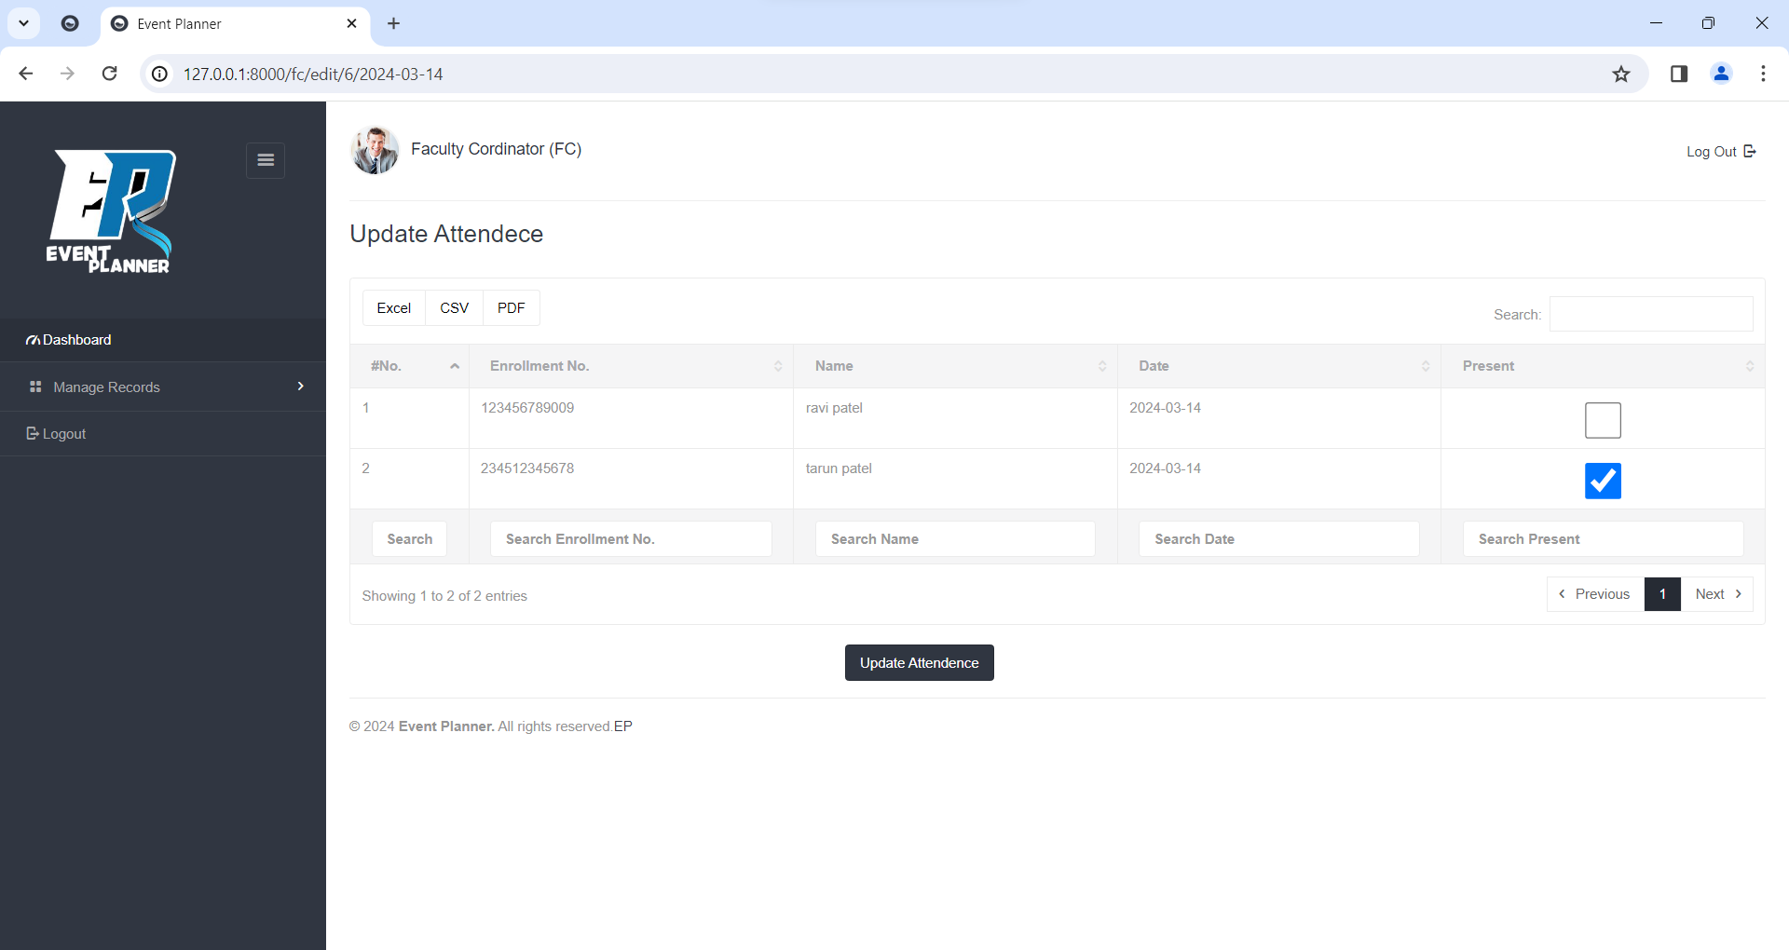

**View Attendance**

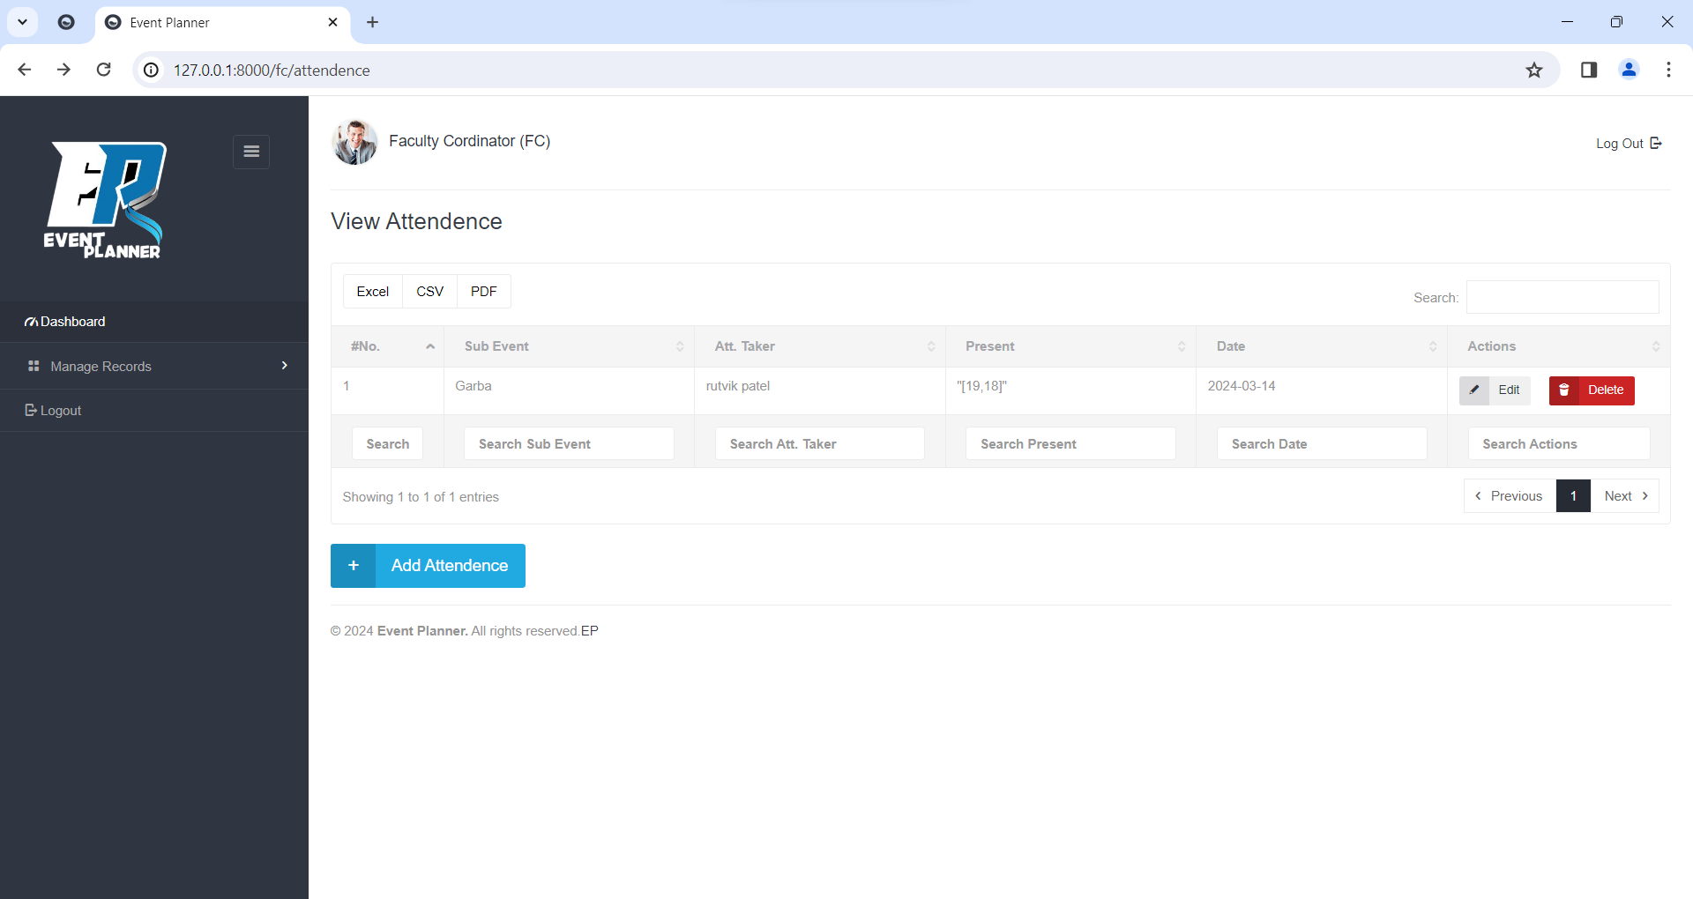

**Delete Attendance**

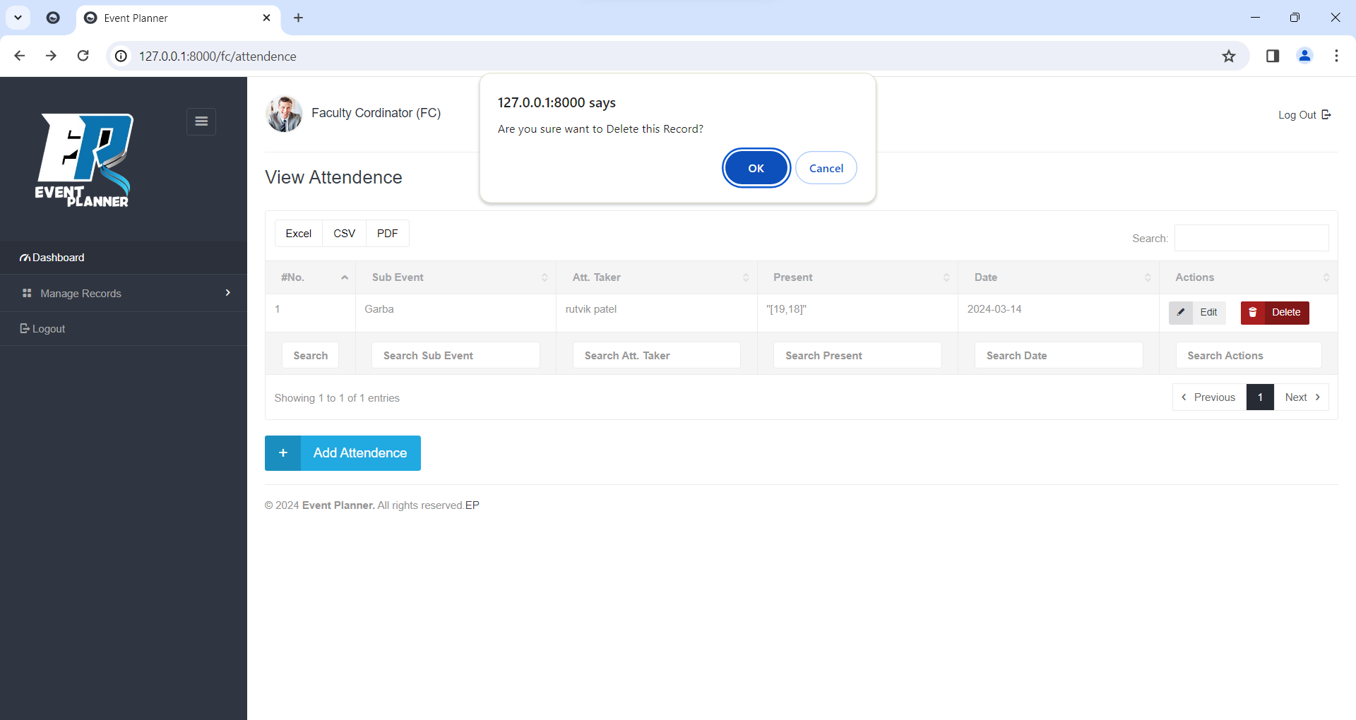

**Add Expense**

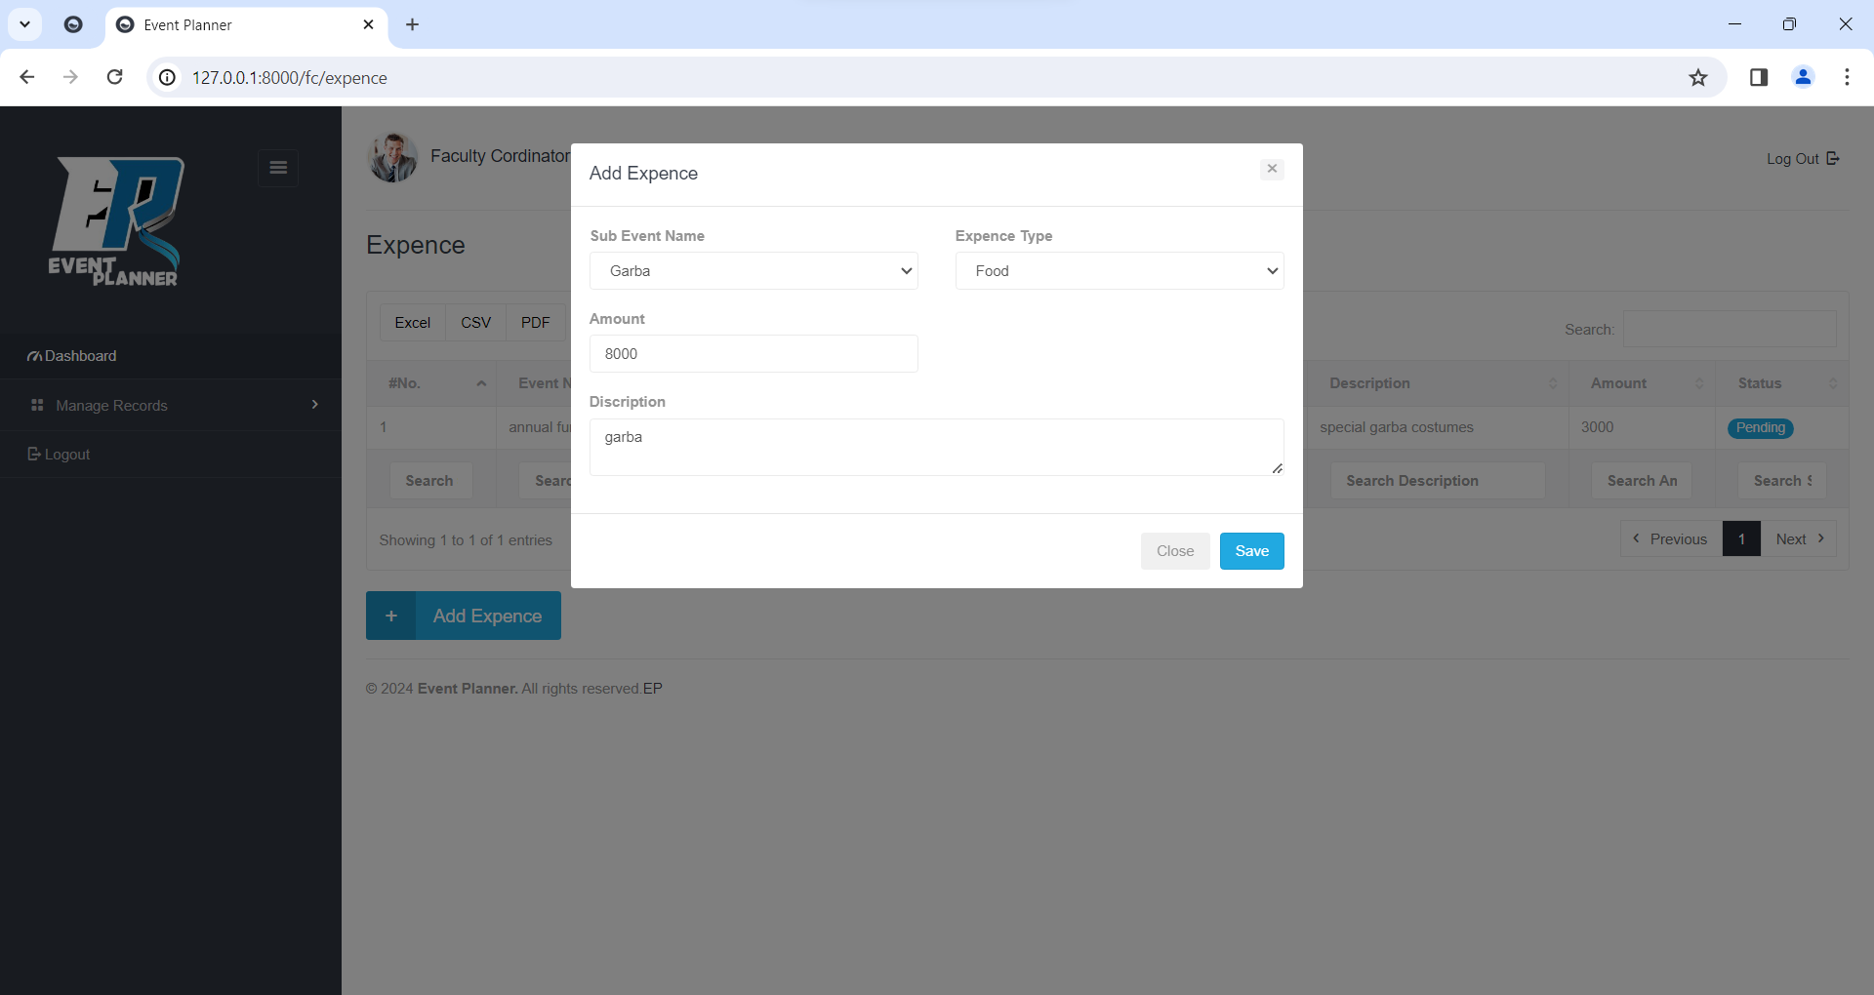

**View Expense**

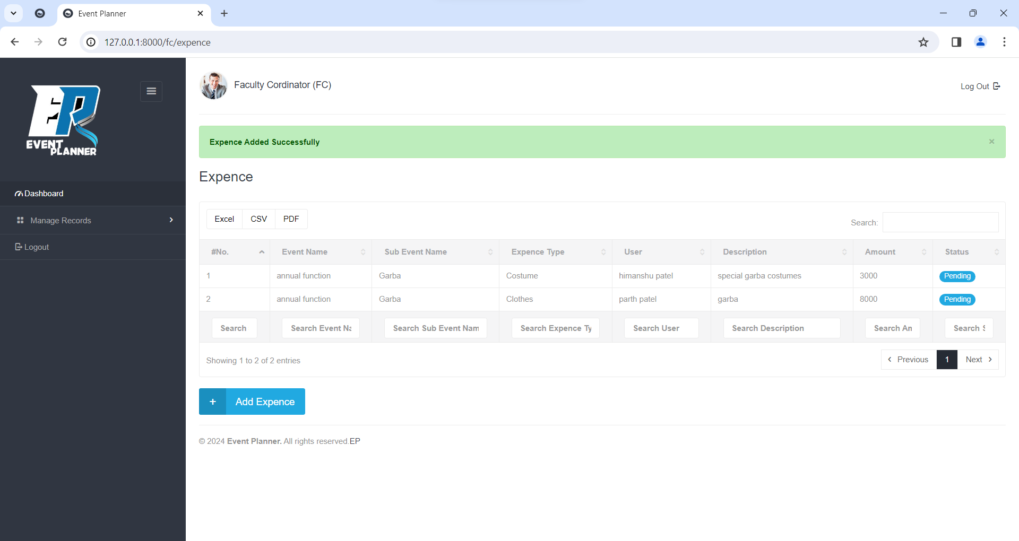

**Add Practice Scheduling**

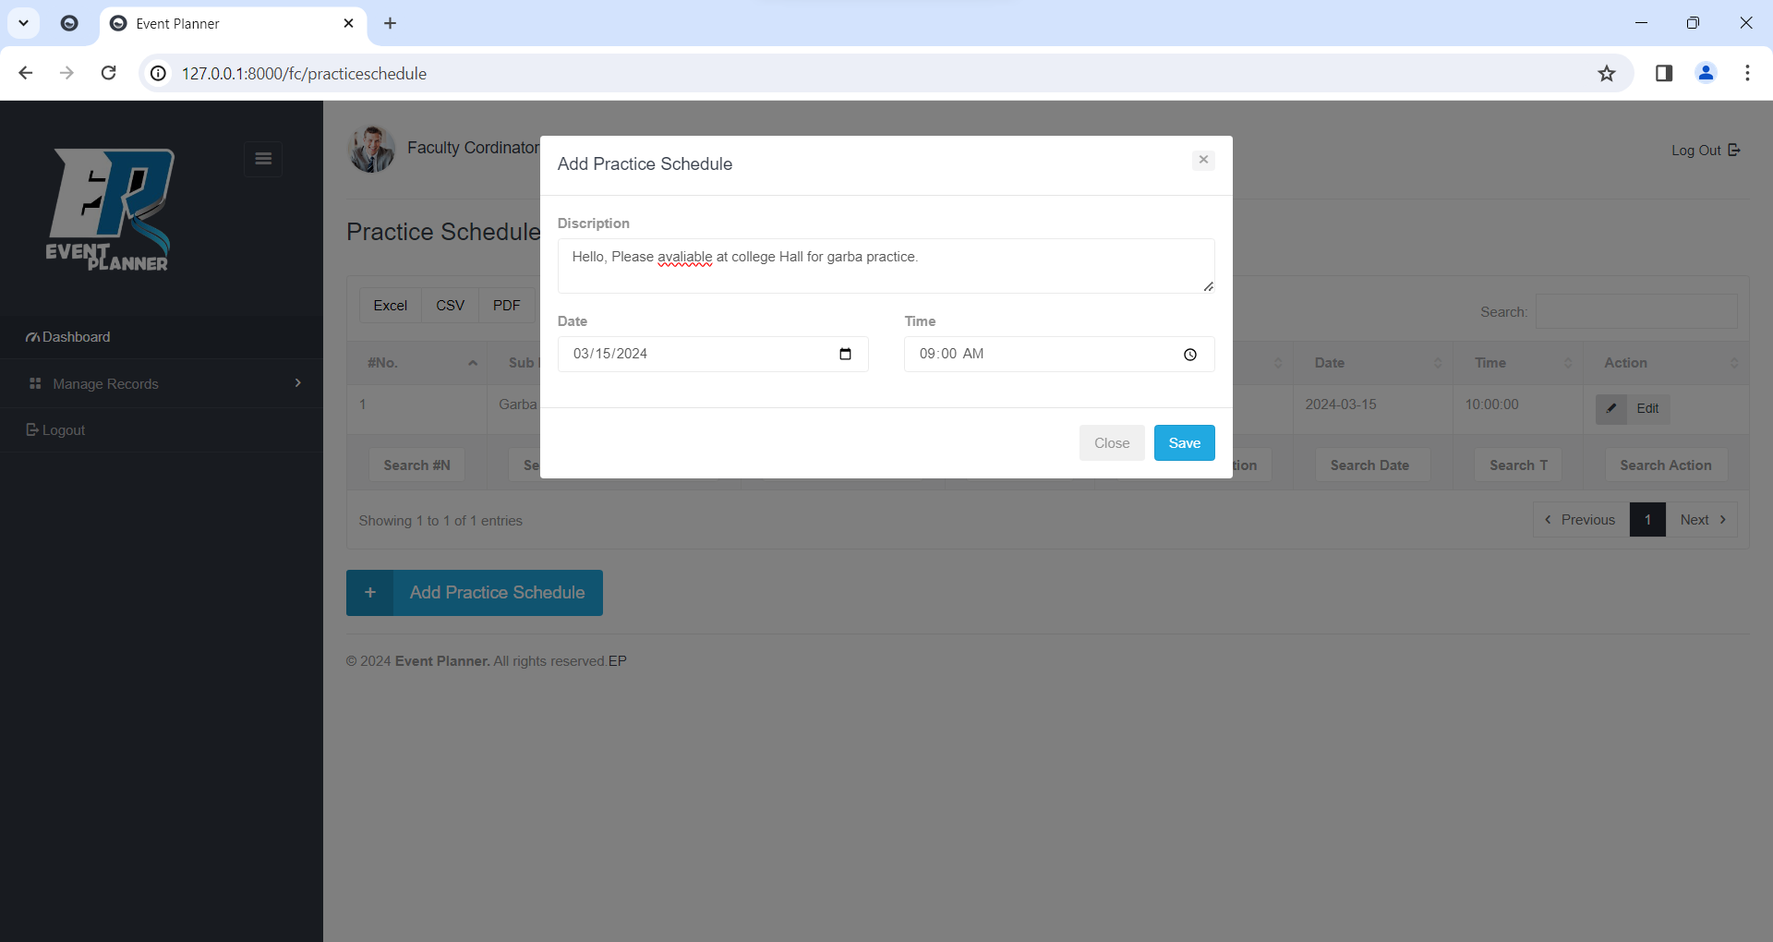

**Add Practice Scheduling**

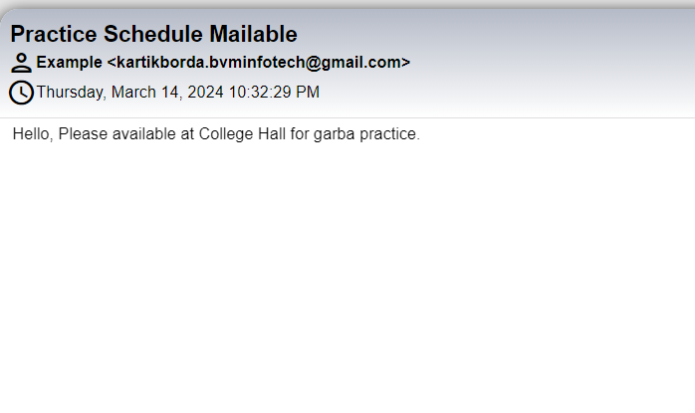

**View Practice Scheduling**

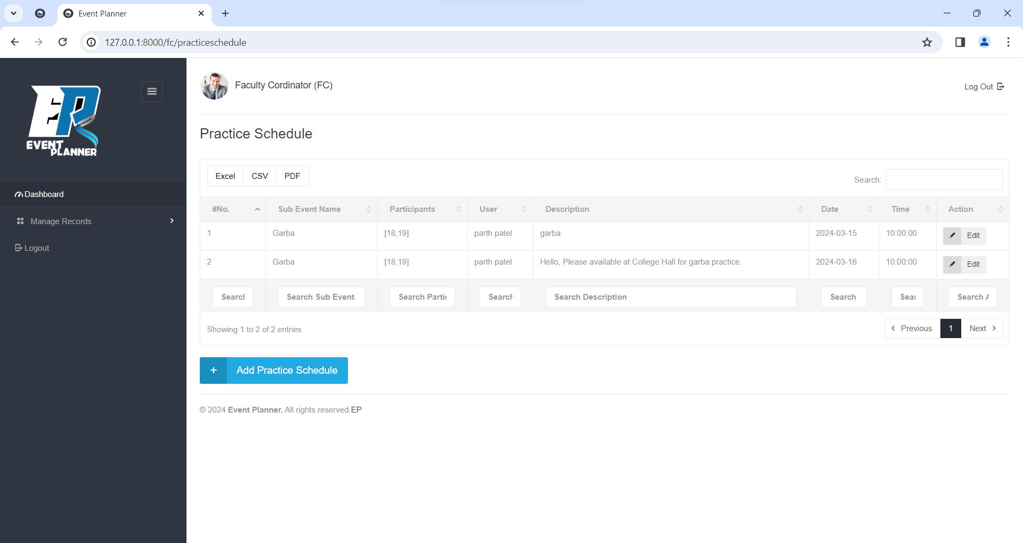

**Update Practice Scheduling**

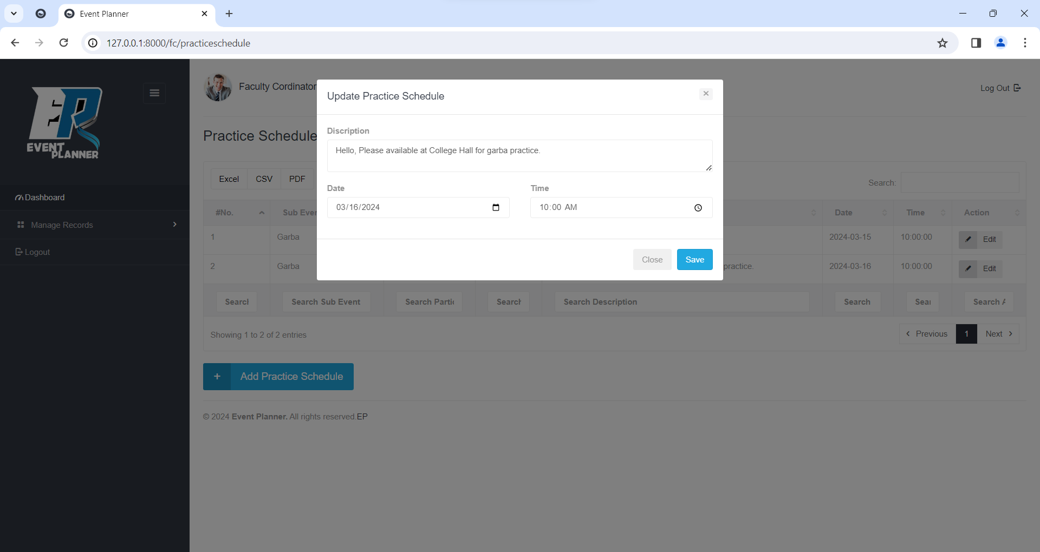

**Add Costume**

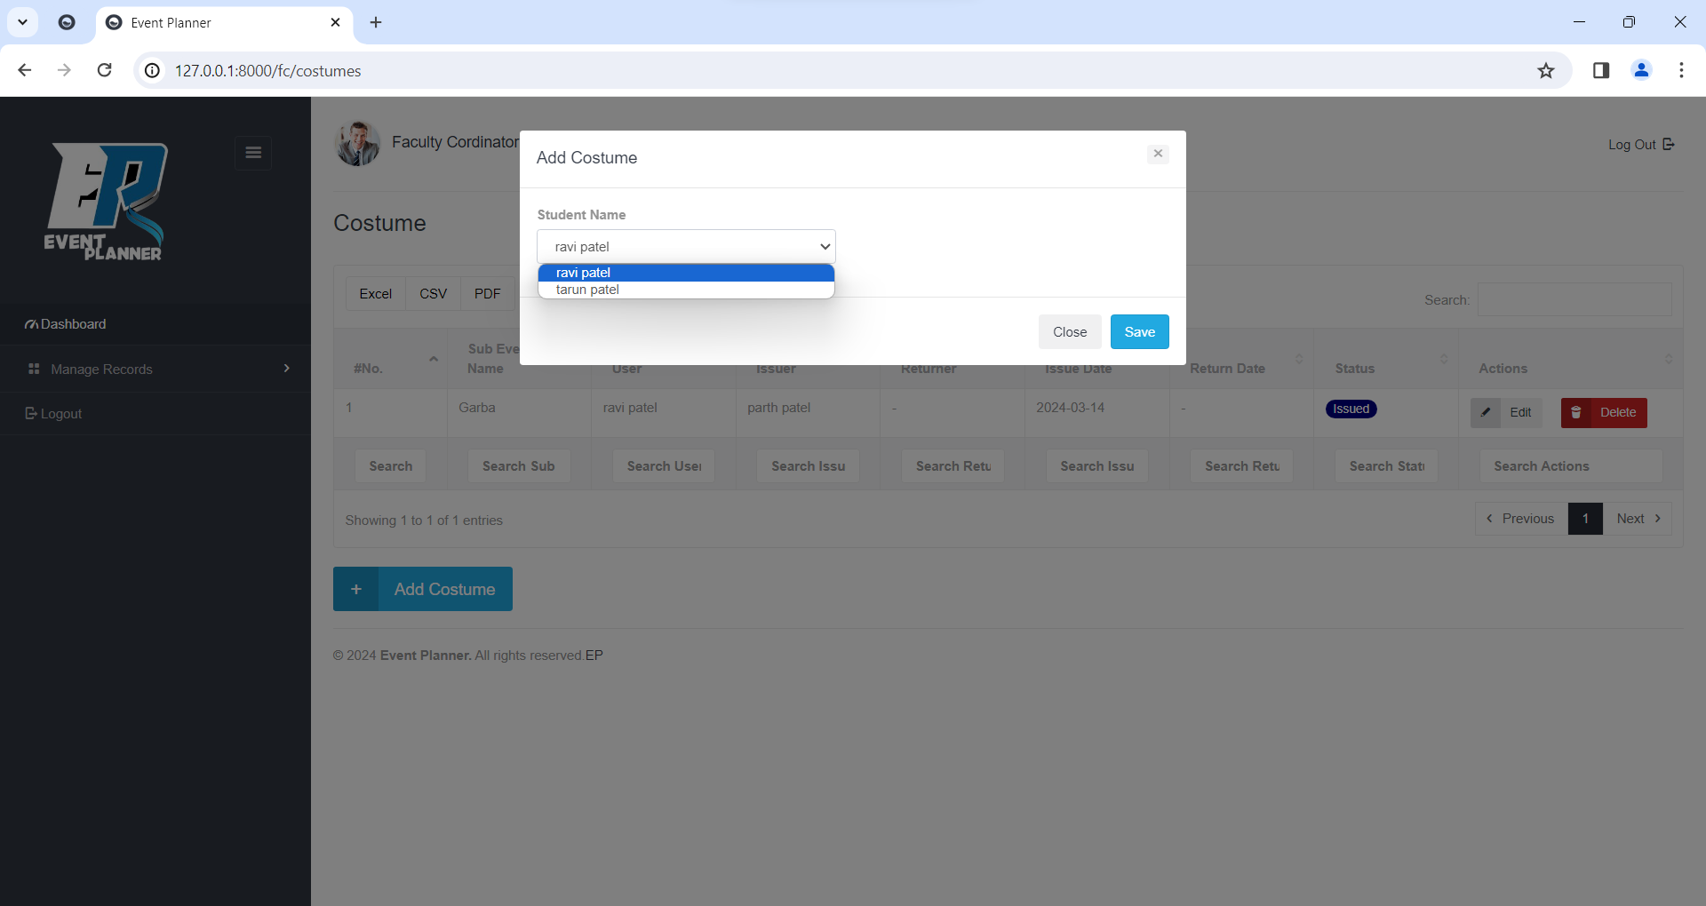

**View Costume**

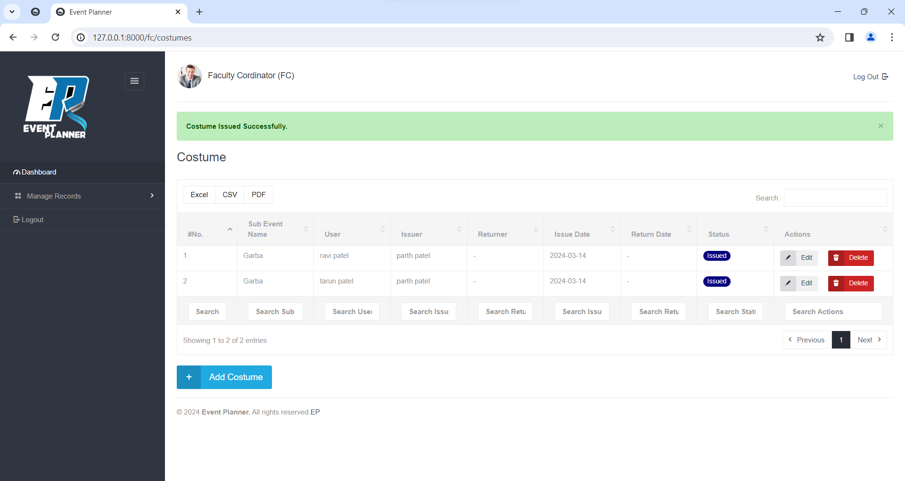

**Update Costume**

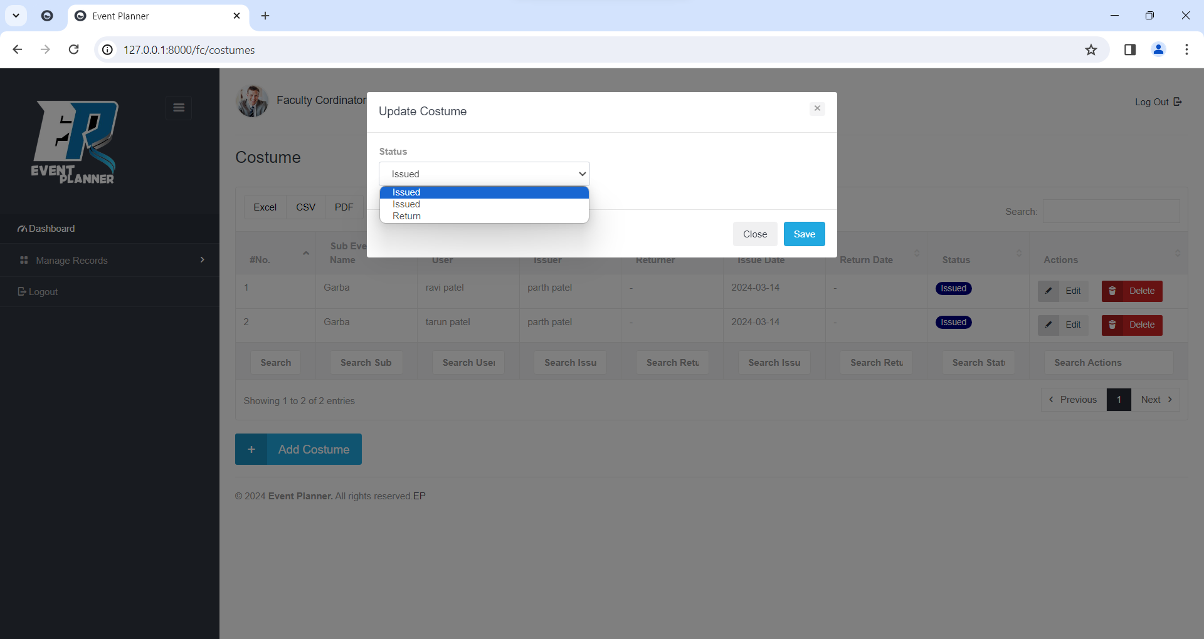

**Delete Costume**

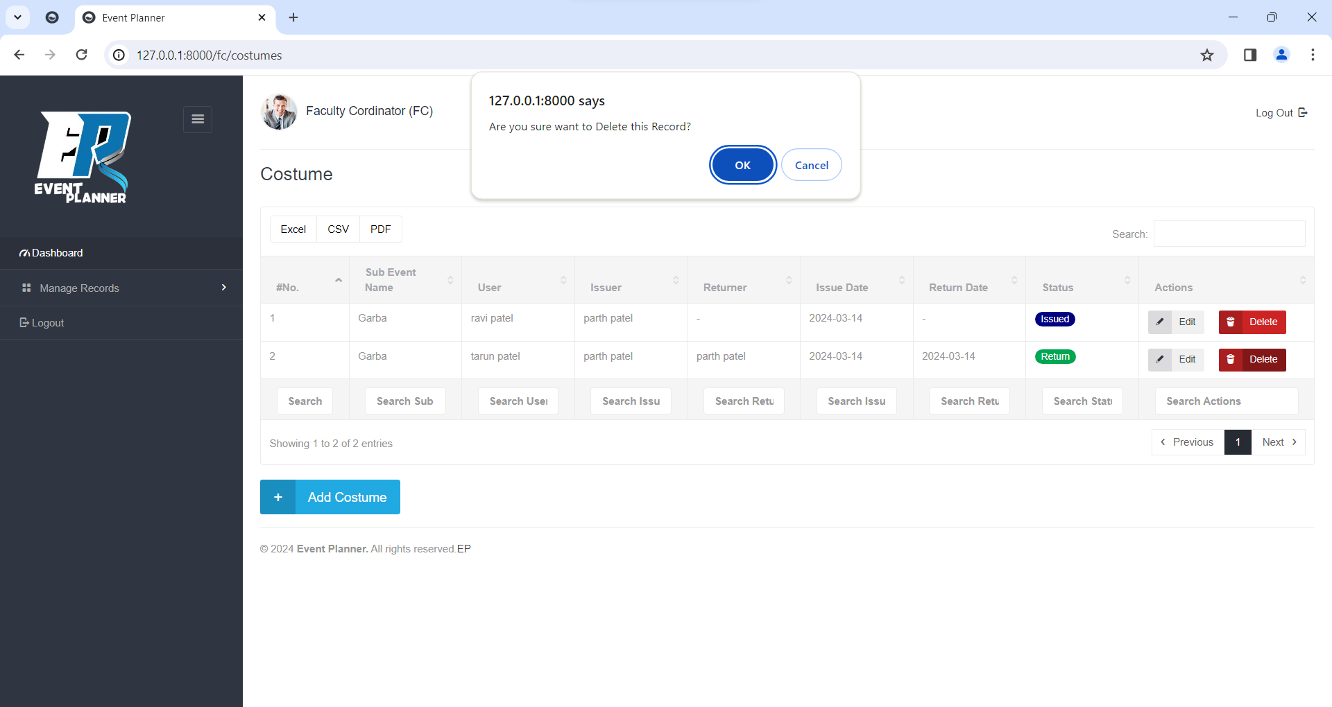

**Student Coordinator**

**Login**

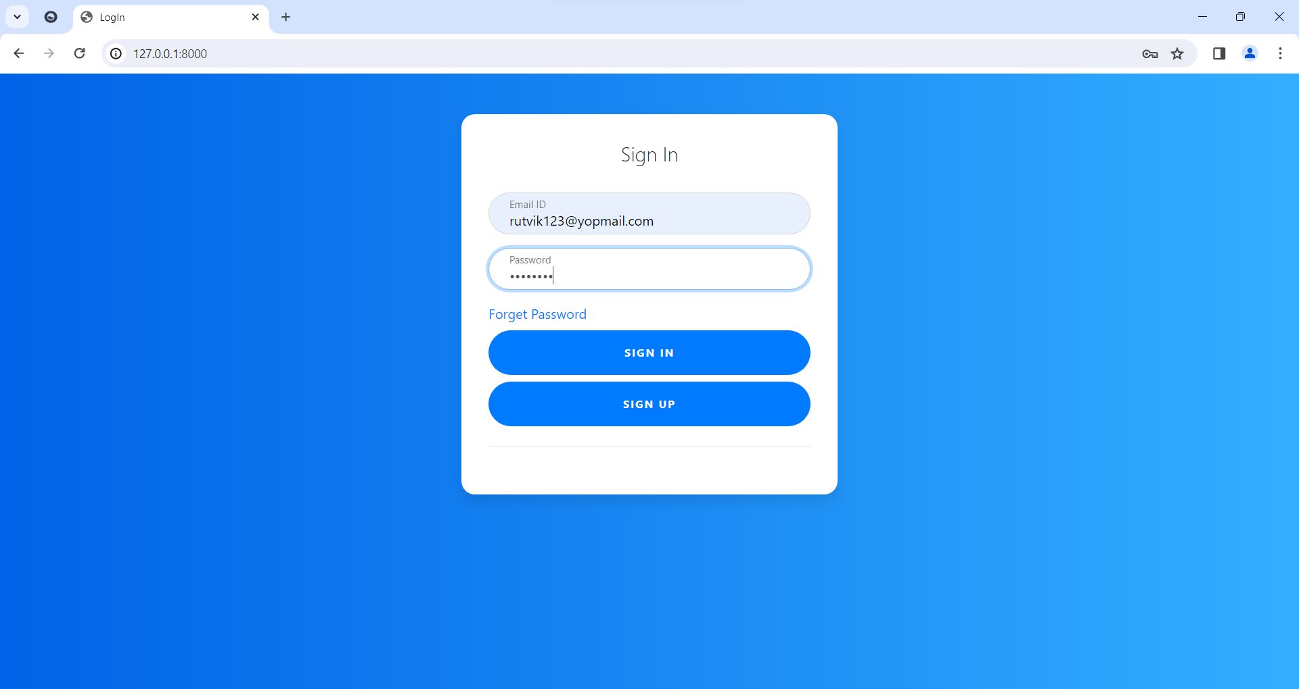

**Forgot Password**

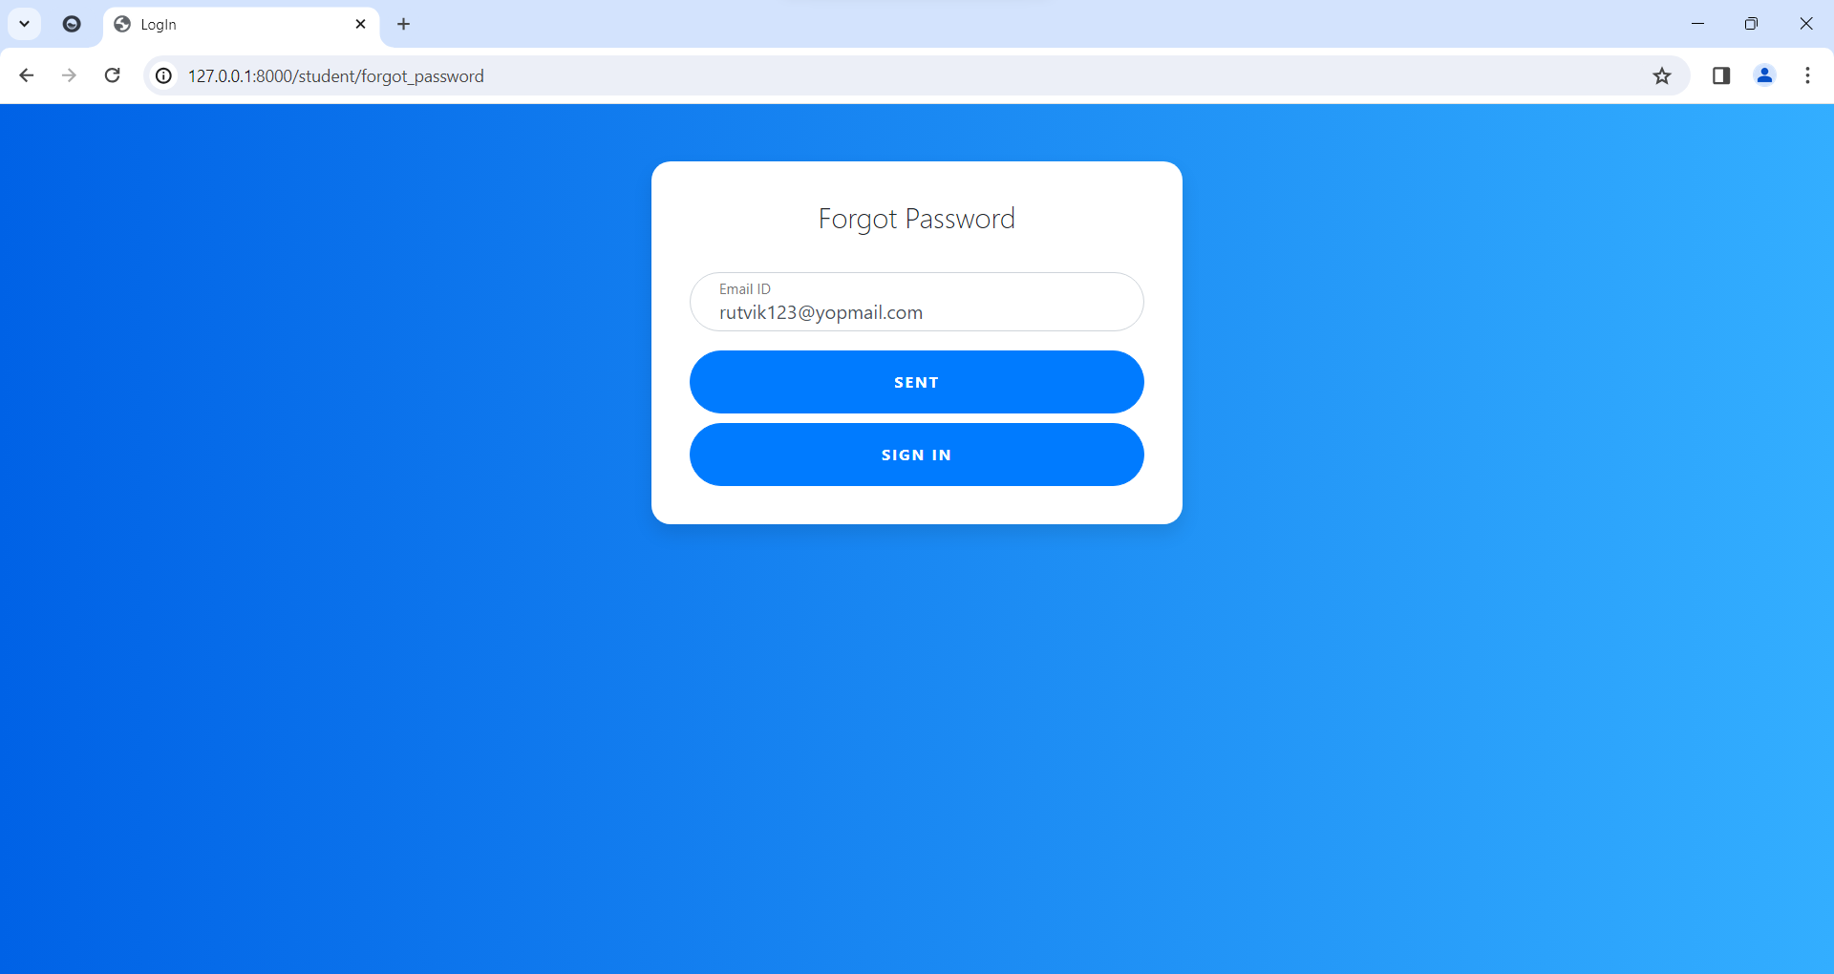

**View Event Lists**

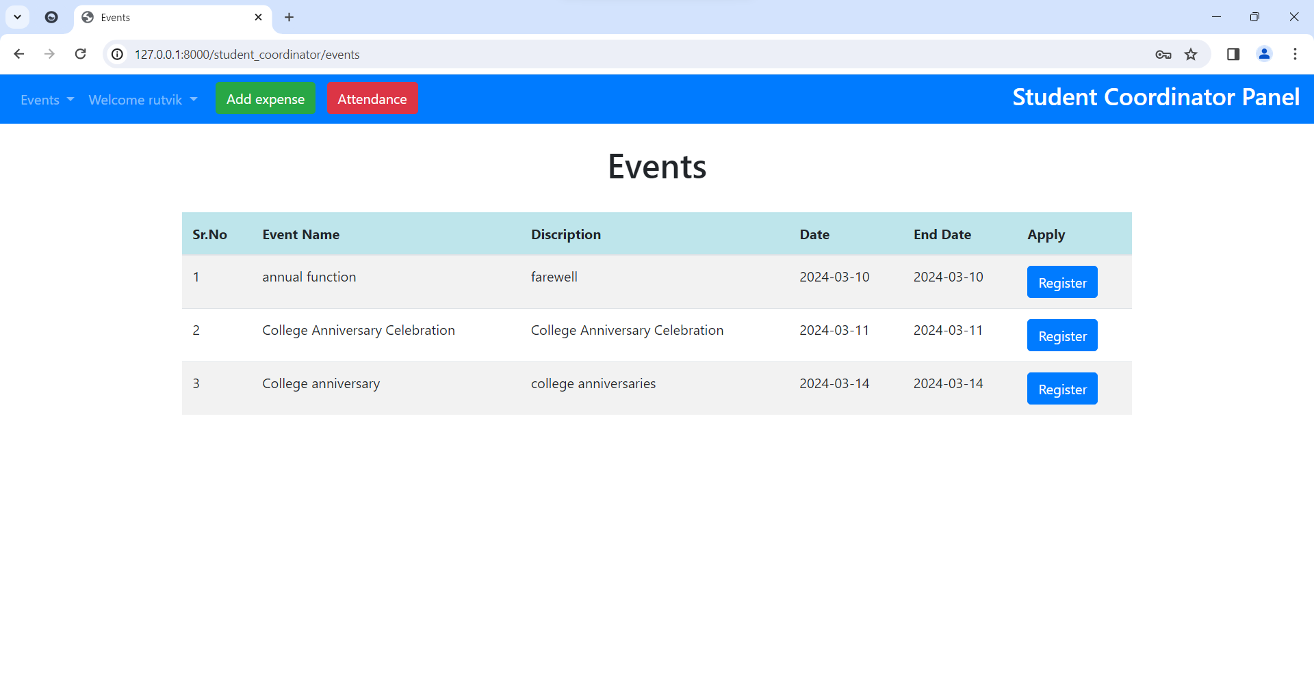

**Add Expense**

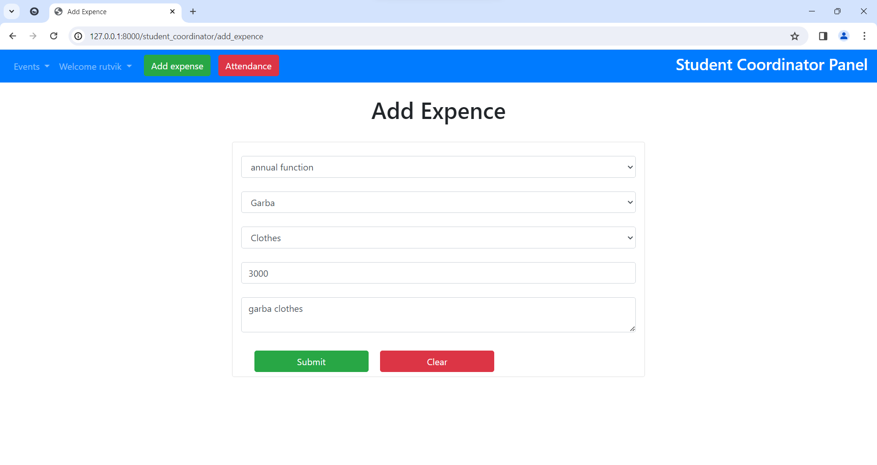

**View Expense**

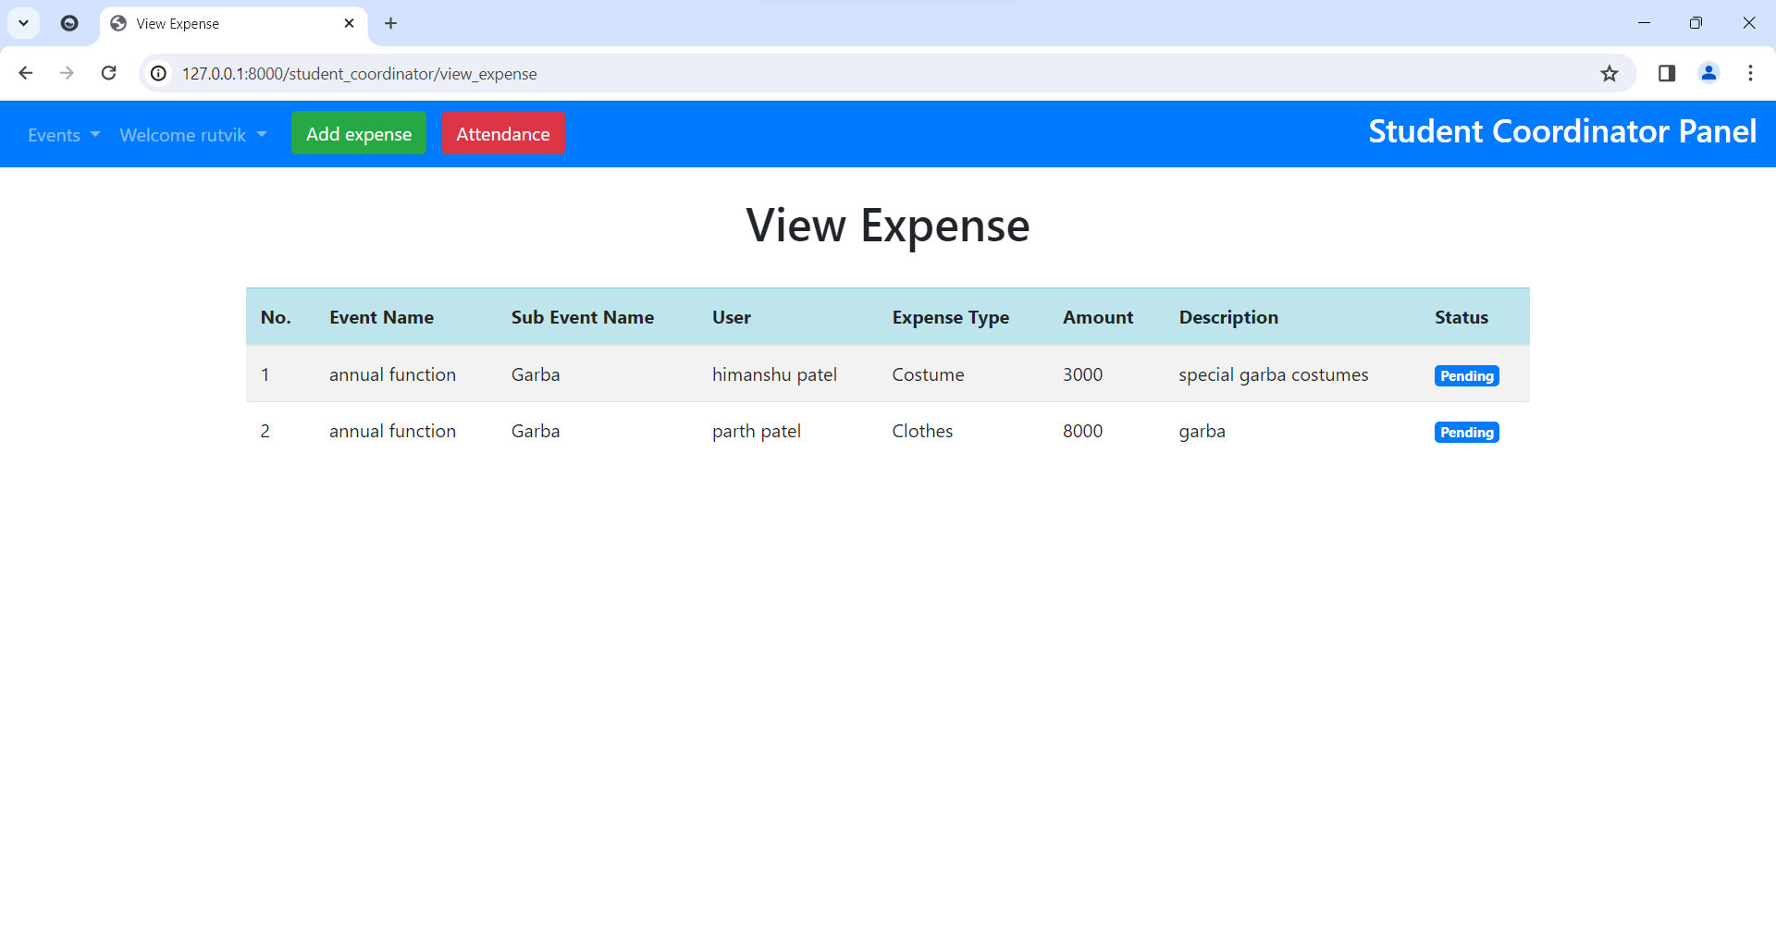

**Take Attendance**

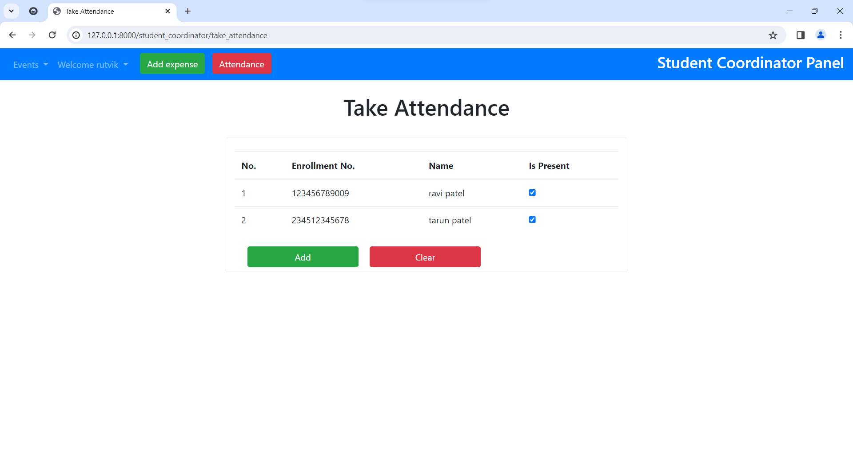

**View Attendance**

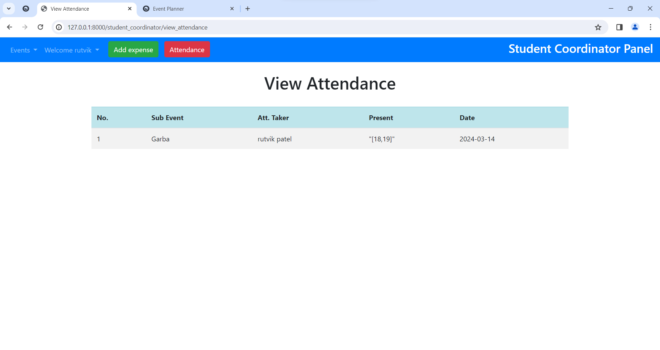

**Error Message (if Today’s Attendance already taken)**

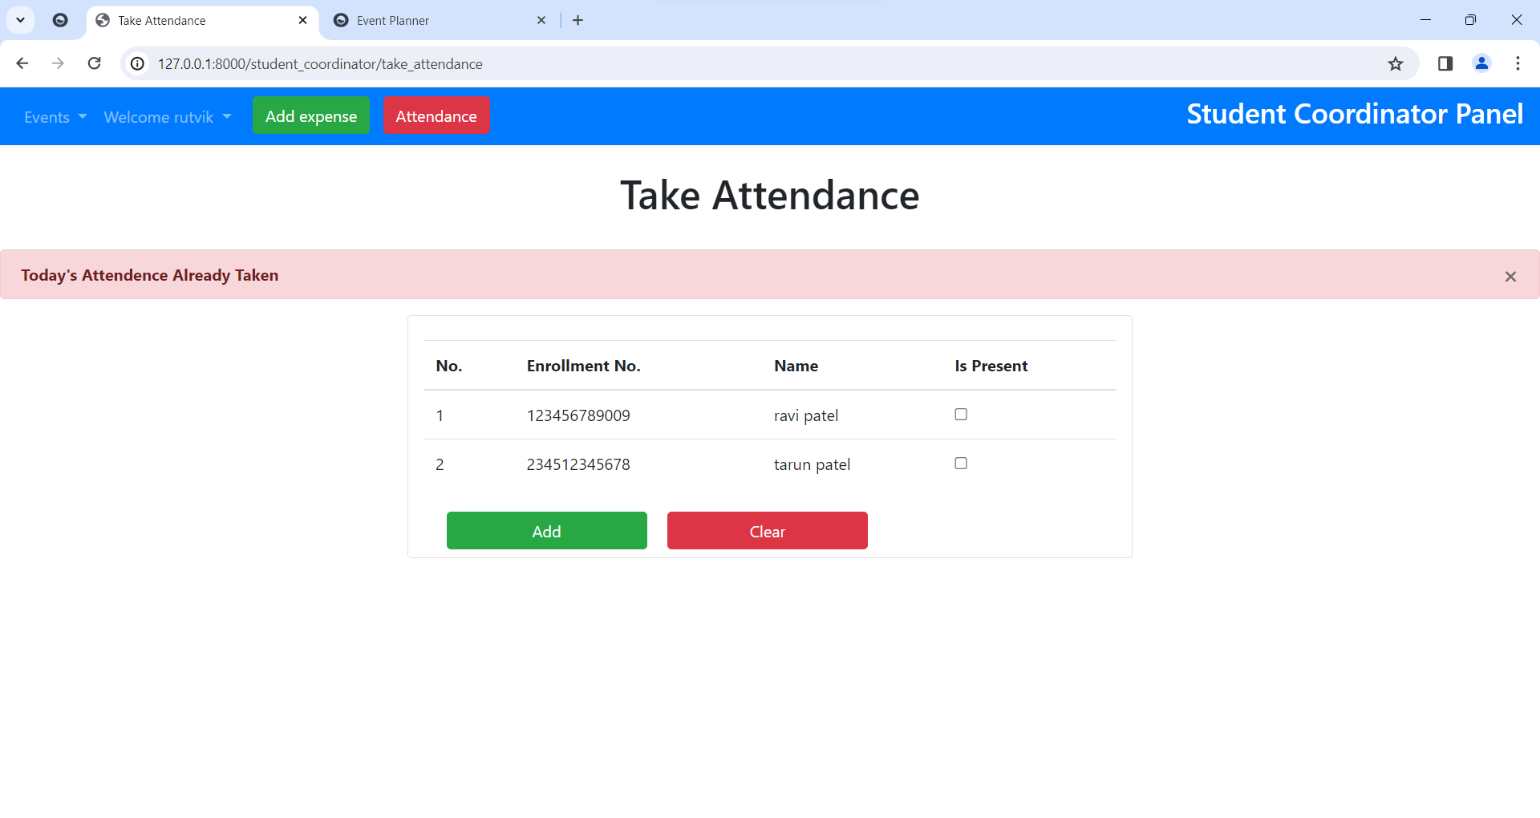

**Student**

**Registration**

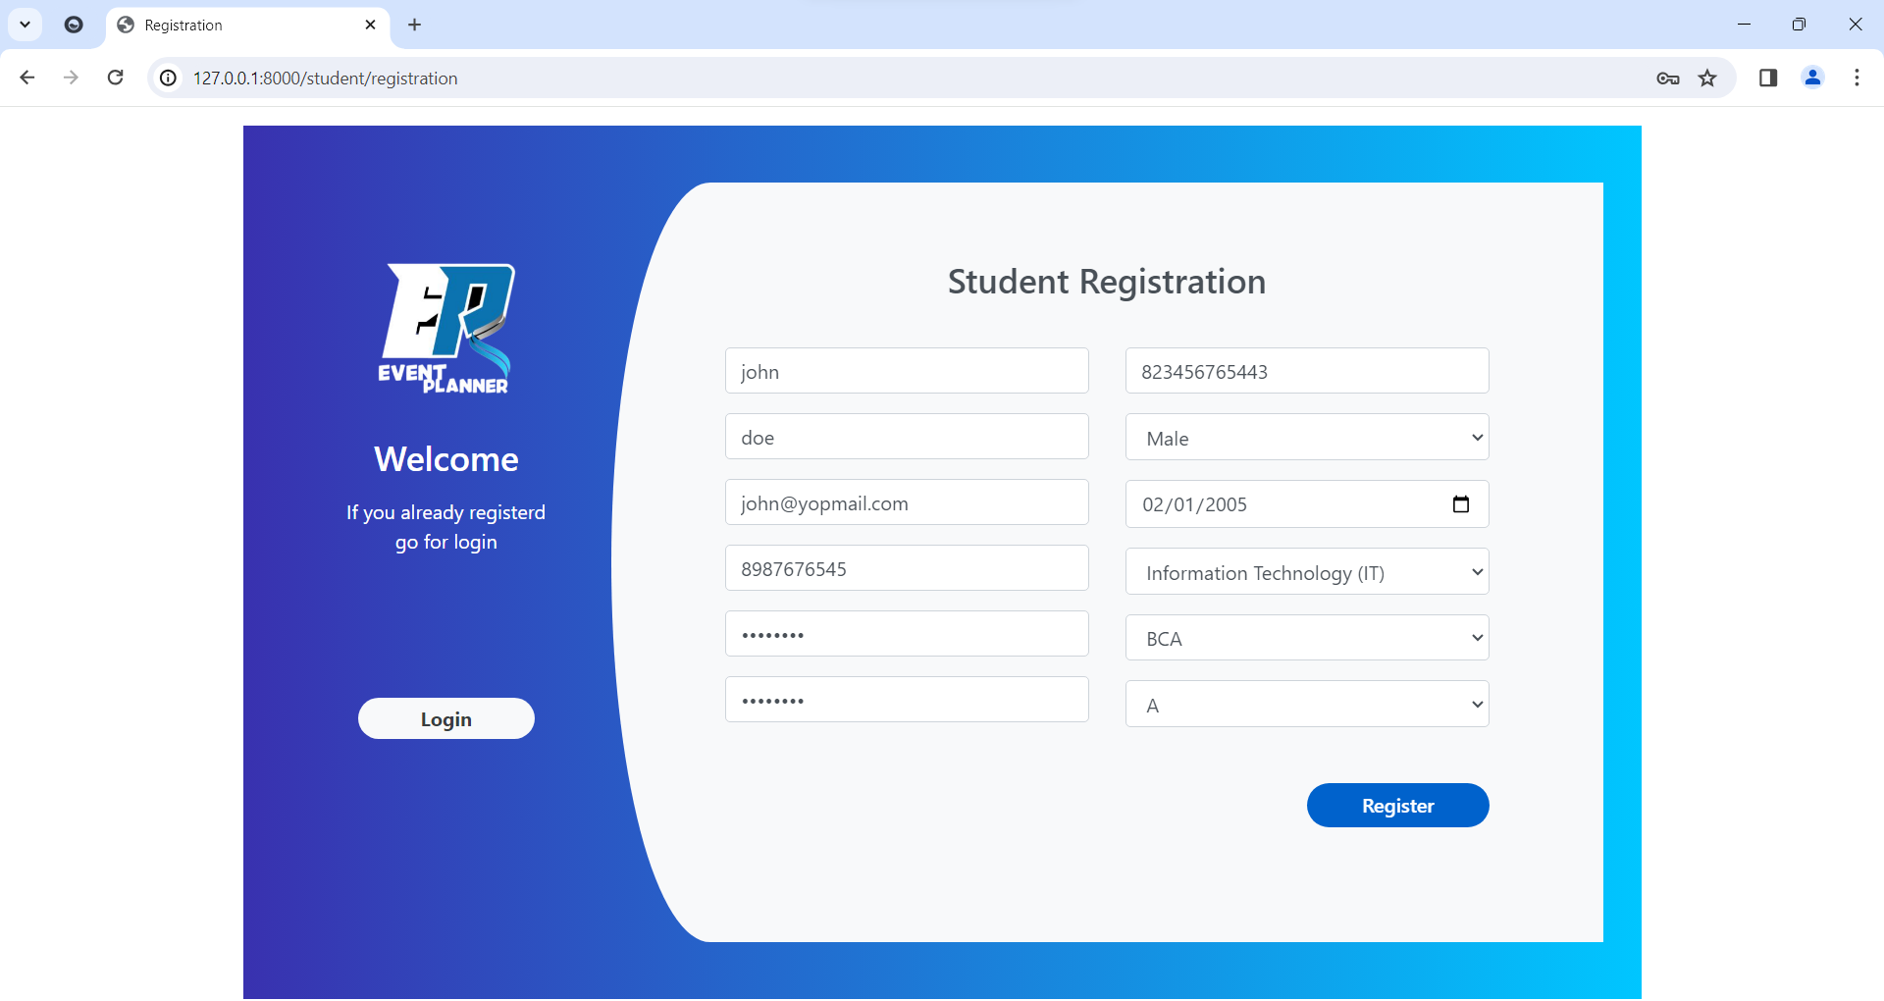

**Login**

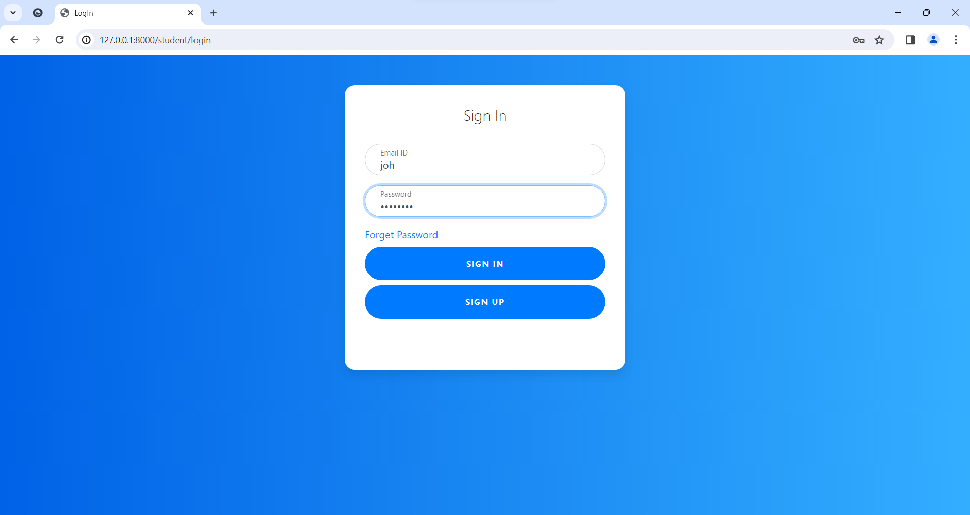

**View Event Lists**

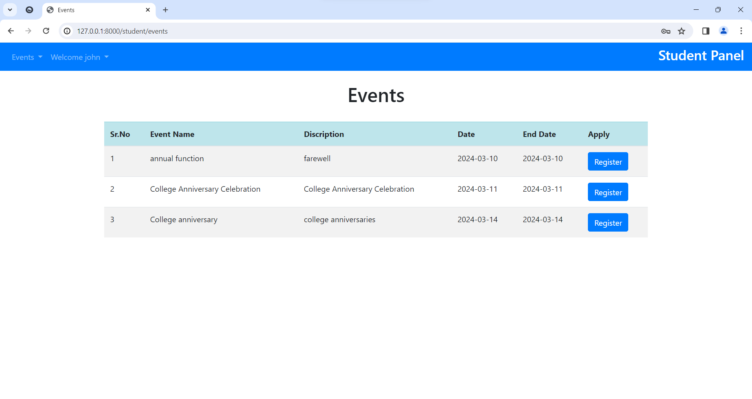

**Student Profile**

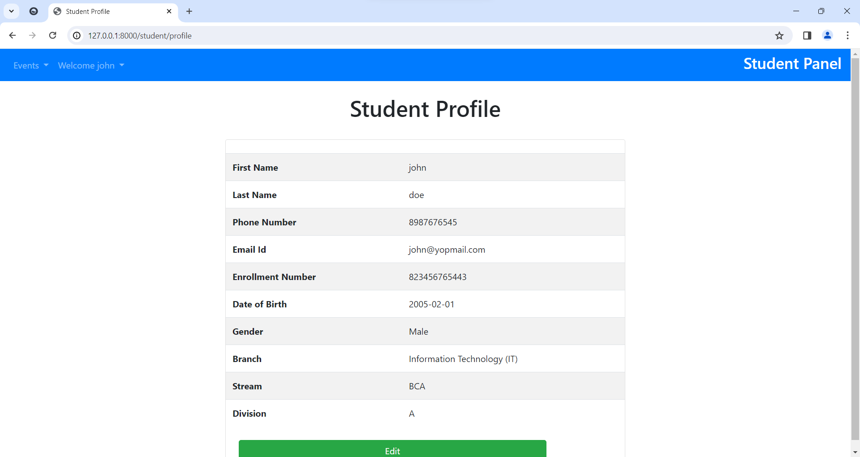

**Update Student Profile**

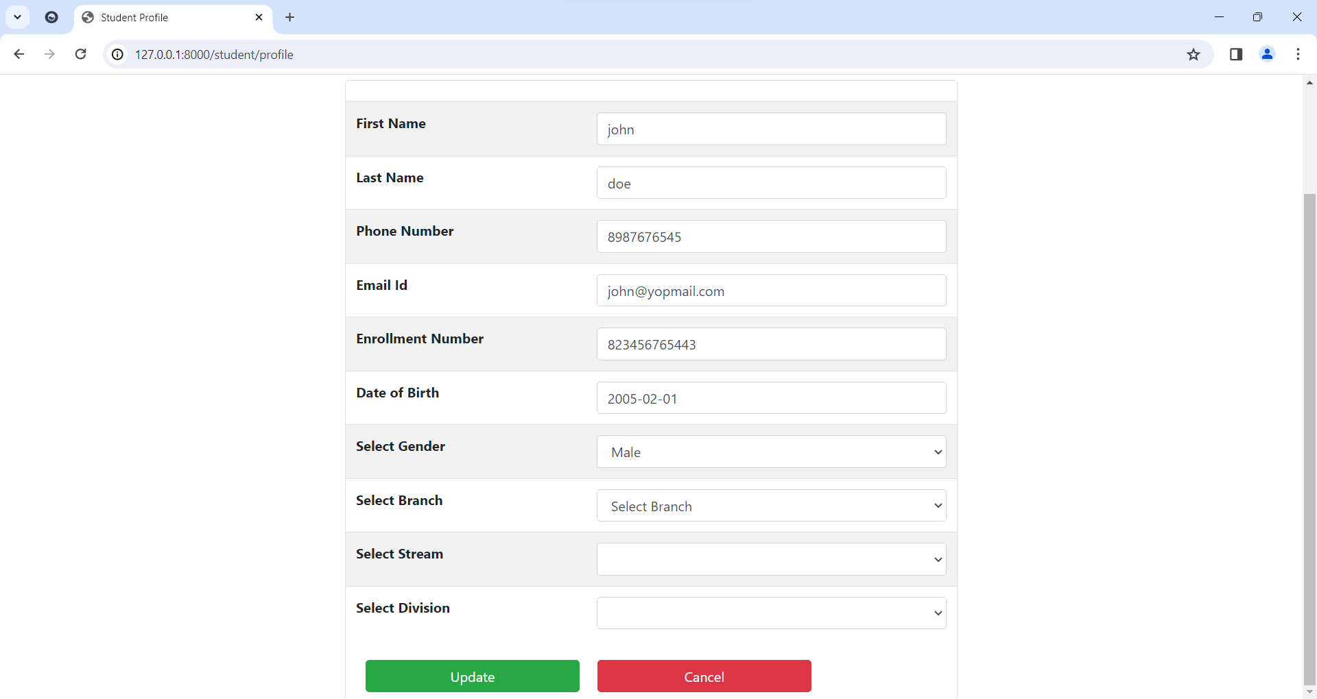

**Change Password**

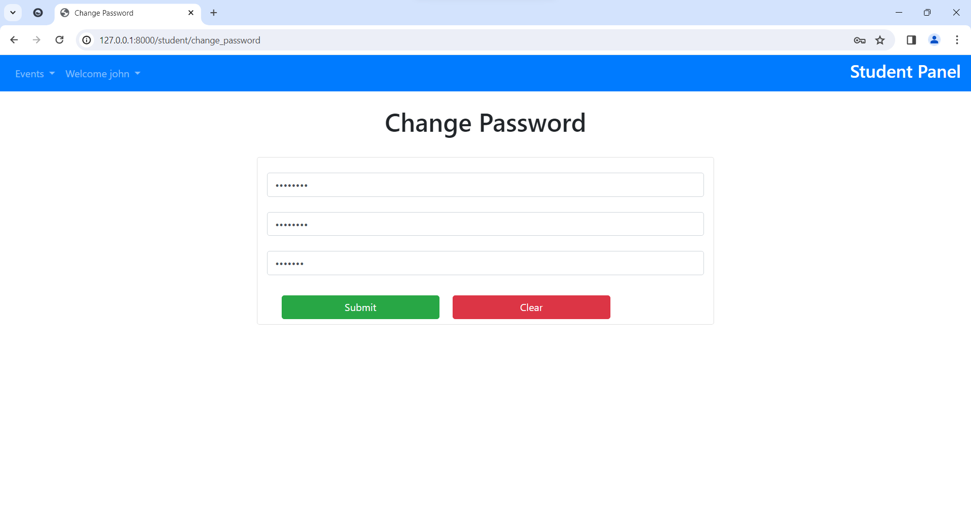

**Event Registration**

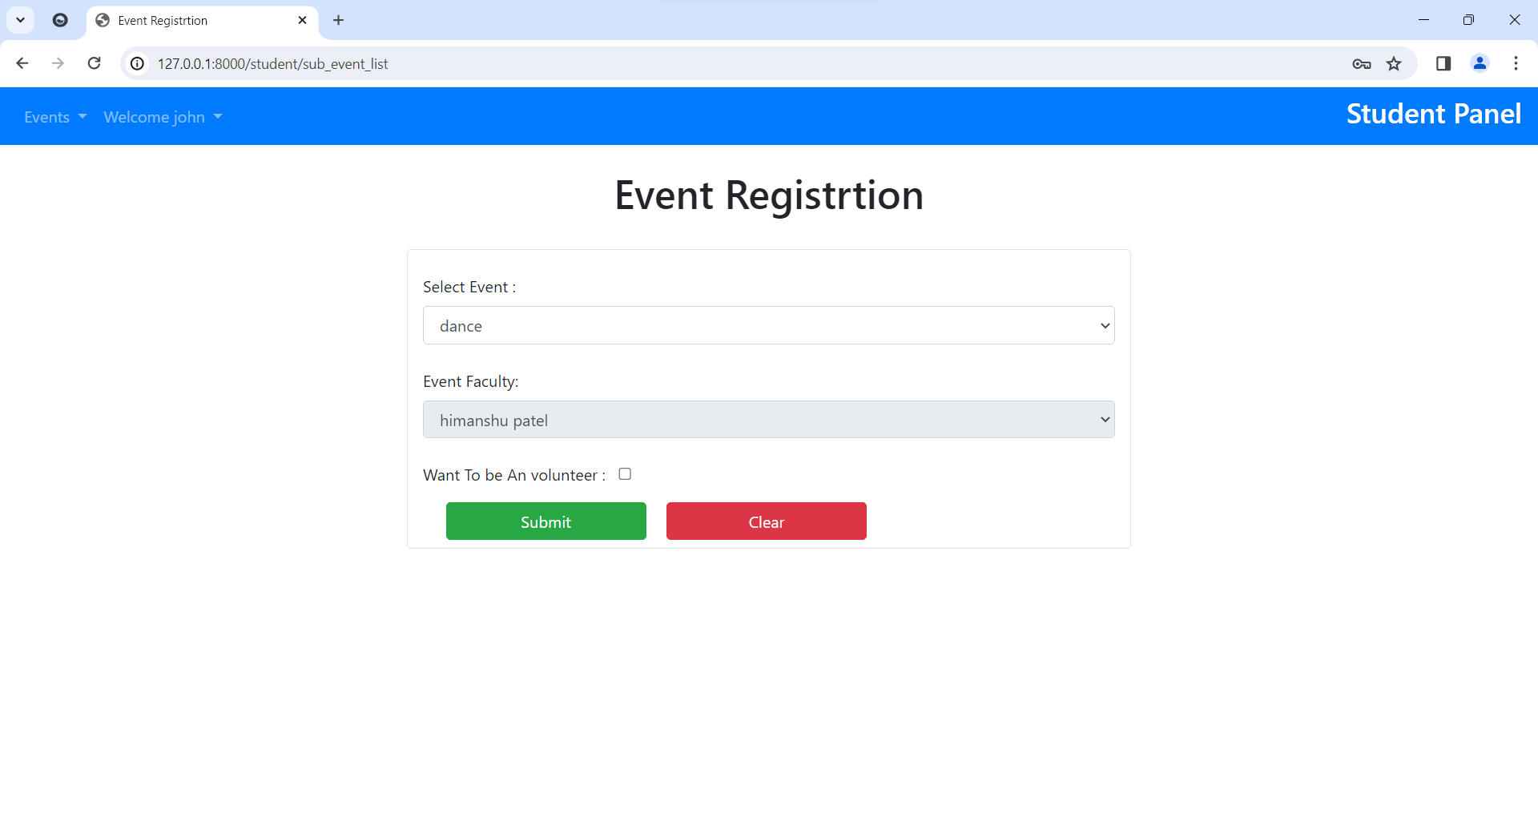

**Event Registration**

**View Events**

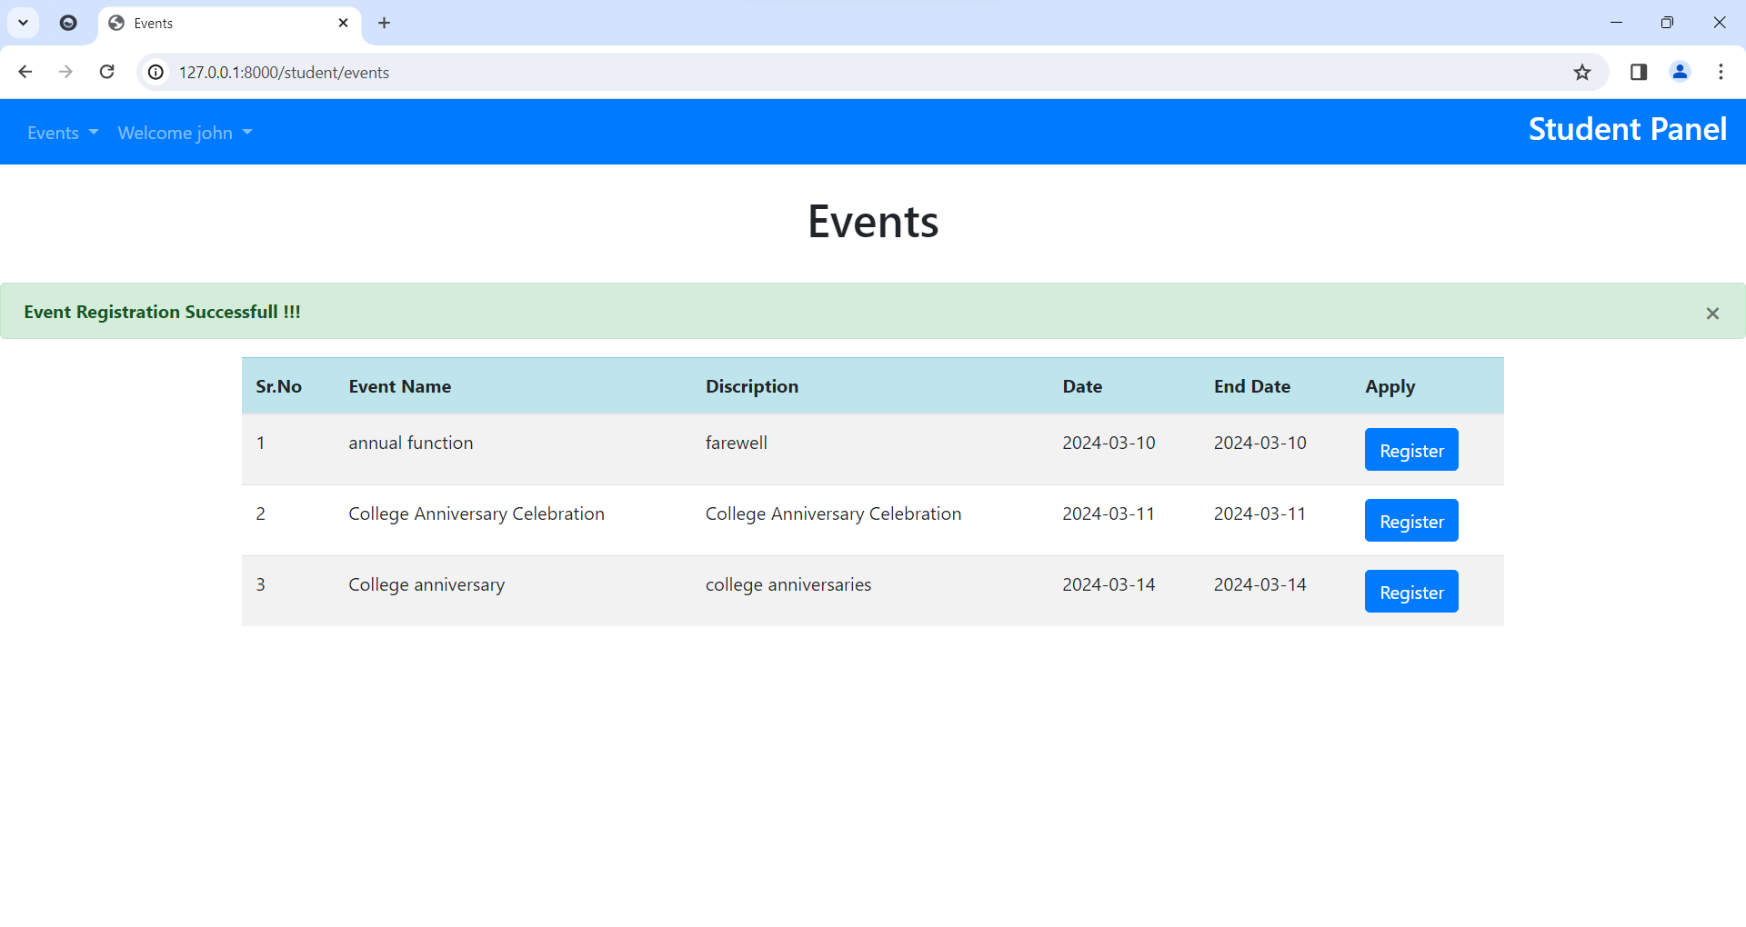

**View Registered Event**

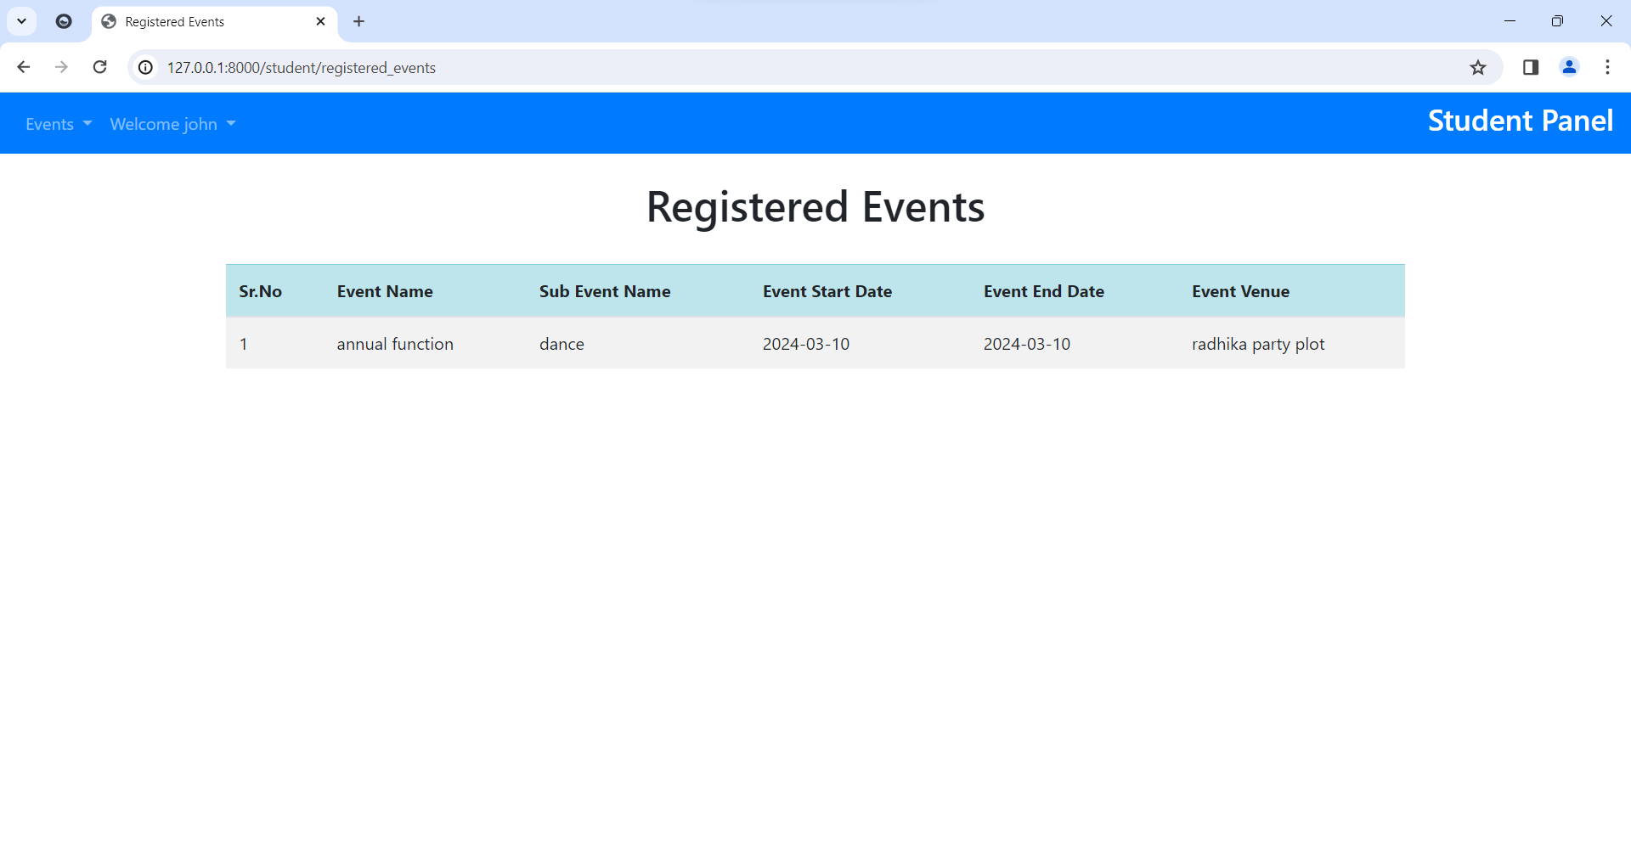

**Reports**

**Event Wise participants**

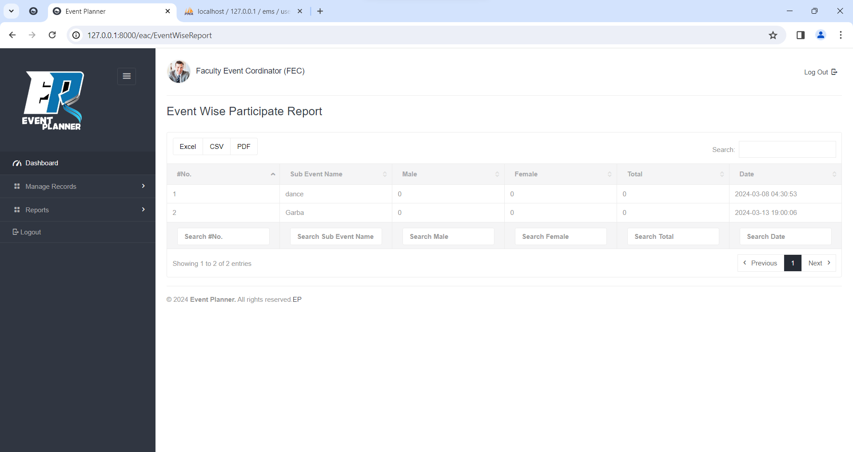

**Event wise Expense**

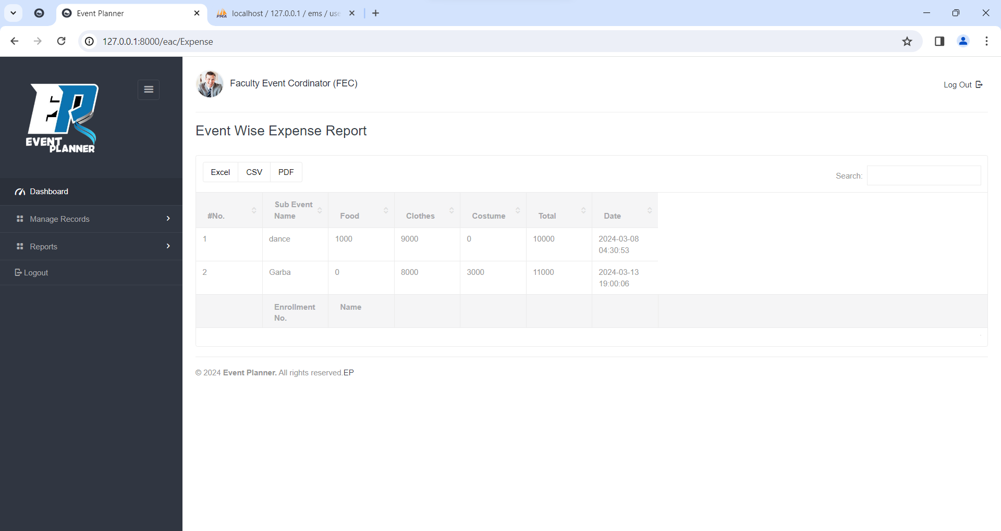

**Download PDF**

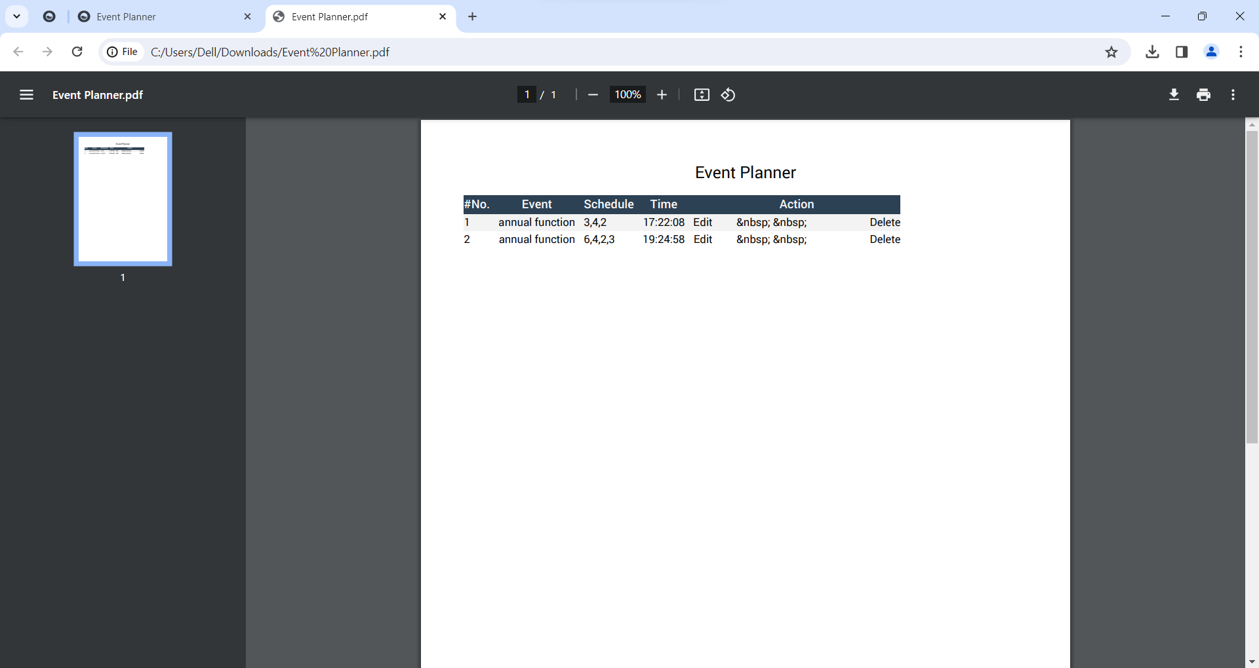

**Download Excel**

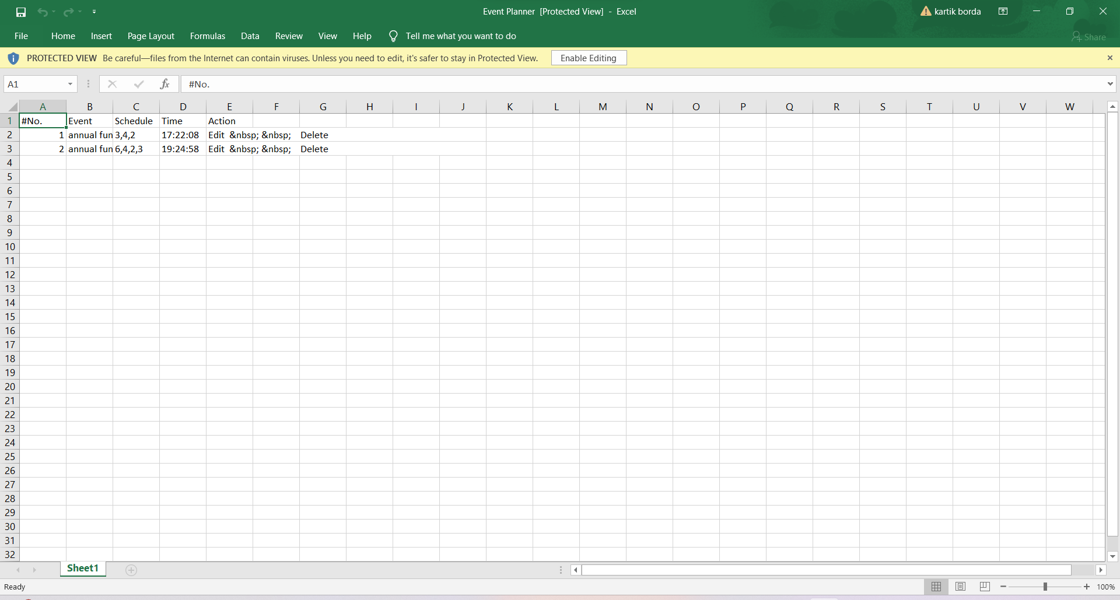

**6.1 Testing:**

Testing is the process of detecting errors. Testing performs a very critical role for the quality assurance and for ensuring the reliability of software. The results of testing are used later on during maintenance also.

**6.2 Objectives of Testing:**

* Testing is a process of executing a program with the intent of finding an error.
* A good test case is one that has a high probability of finding as yet undiscovered error.
* A successful test is one that uncovers as yet undiscovered error.

**6.3 Levels of Testing:**

* **Unit Testing**

Unit testing focuses verification effort on the smallest unit of software design (i.e.), the module. Unit Testing exercise specific paths in a module’s control structure to ensure complete coverage and maximum error detection.

* **Integration Testing**

Integration testing is a systematic technique for constructing the program structure while at the same time conducting tests to uncover errors associated with interfacing.

* **Validation Testing**

At the end of Integration Testing, software is completely assembled as a package, interfacing errors have been uncovered and correction testing begins. Software Testing and Validation is achieved through serried of Black Box tests that demonstrate conformity with the requirements.

* **System Testing**

System testing is series of different tests whose primary purpose is to fully exercise the computer based system. Types of system test includes : recovery testing, security testing, stress testing, performance testing. Although each test has a different purpose, all the work should verify that all system elements have been properly integrated and perform allocated functions.

* **Performance Testing**

Performance testing is designed to test run-time performance of application within the context of an integrated system . Proper response time for user actions is critical to maintaining and enhancing user base.

* **Load Testing**

Load testing demonstrates how the application performs under concurrent user sessions for typical user scenarios. Setting up common scenarios that execute for a short period of time allows seeing how the application operates under a multiple-user load.

* **Stress Testing**

Stress test allows examining how the application behaves under a maximum user load. To stress test application, remove the think time for load scripts and execute the scripts against the server to overload use of the application. If there are unhandled exceptions in a stress test, the application may not be robust enough to handle a sudden unexpected increase in user activity. Stress tests generally execute for a longer period of time, and can be used to catch difficult-to-diagnose problems like subtle memory leaks in the application.

**6.4 Test Cases:**

* **Login:**

This test procedure is used to see whether student is properly login to a system or not and for authorizing the student for login.

|  |  |  |  |  |
| --- | --- | --- | --- | --- |
| Sr. no | Measure | Expected result | Actual result | Remark |
| **1.** | If first name field is not filled | Error | This field is required | Error |
| **2.** | If password field is not filled | Error | This field is required | Error |
| **3.** | Enter valid email & invalid password | Error | invalid password | Error |
| **2.** | Enter invalid email & valid password | Error | Enter valid email | Error |
| **3.** | Enter invalid username & invalid password | Error | Enter valid username & valid password | Error |
| **4.** | Enter valid username & valid password | Login successful | Login successful | Login successful |

* **Registration:**

This test procedure is used to see whether student is properly registration to a system or not and for authorizing the student for registration.

|  |  |  |  |  |
| --- | --- | --- | --- | --- |
| Sr. no | Measure | Expected result | Actual result | Remark |
| **1.** | If first name field is not filled | Error | This field is required | Error |
| **2.** | If last name field is not filled | Error | This field is required | Error |
| **3.** | If email field is not filled | Error | This field is required | Error |
| **4.** | if in email is not including @ | Error | Please include an **@** intheemailaddress. | Error |
| **5.** | If password field is not filled | Error | This field is required | Error |
| **6.** | If confirm password field is not filled | Error | This field is required | Error |
| **7.** | If password length less than eight characters | Error | password must be 8 character long | Error |
| **8.** | Enter invalid confirm password | Error | Confirm password must be same as password | Error |
| **9.** | If mobile number field is not filled | Error | This field is required | Error |
| **10.** | When mobile number length less than and more than ten | Error | Mobile Number Should be 10 number only | Error |

|  |  |  |  |  |
| --- | --- | --- | --- | --- |
| Sr. no | Measure | Expected result | Actual result | Remark |
| **11.** | If Enrolment number field is not filled | Error | This field is required | Error |
| **12.** | When Enrolment number length less than and more than twelfth | Error | Enrolment Number Should be 12 digits | Error |
| **13.** | If gender is not select | Error | Please Select Gender | Error |
| **14.** | If birth of date is not select | Error | Please Select Date of Birth | Error |
| **15.** | If branch is not select | Error | Please Select branch | Error |
| **16.** | If stream is not select | Error | Please Select Stream | Error |
| **17.** | If division is not select | Error | Please Select Division | Error |
| **18.** | Enter all valid information | Error | Register Successfully | Register Successfully |

**7.1 Limitation:**

**1.Complexity:** Depending on the size and scope of the college and its events, the system may become overly complex. Managing multiple events with different requirements and stakeholders can lead to a convoluted system that is difficult to navigate and use efficiently.

**2.Customization:** Many event management systems offer customization options, but they may not always align perfectly with the unique needs of every college or event. Customization limitations can hinder the system's ability to adapt to specific requirements or workflows.

**3.Scalability:** Some event management systems may struggle to handle a high volume of events or users, particularly during peak times such as the beginning or end of a semester. Scalability issues can lead to slowdowns, system crashes, or other performance problems.

**4.Accessibility:** Ensuring that the event management system is accessible to all users, including those with disabilities, can be a challenge. Accessibility standards and requirements may vary between jurisdictions, leading to compliance issues.

**5.Cost:** Implementing and maintaining an event management system can be expensive, particularly for smaller colleges with limited budgets. Licensing fees, customization costs, and ongoing support expenses can add up over time.

**6.User Adoption:** Even the most feature-rich event management system will be ineffective if users are unwilling or unable to adopt it. Resistance to change, lack of training, or a perceived lack of benefits can all hinder user adoption.

**7.Data Security:** Managing sensitive data such as student information, financial records, and event details requires robust security measures. A breach of security could lead to serious consequences, including legal liabilities and reputational damage.

**8.Technical Support:** Colleges may rely on external vendors or internal IT departments for technical support, but response times and expertise can vary. Inadequate technical support can prolong downtime and frustrate users.

**7.2 System Enhancement:**

**1.Improved User Interface (UI) and User Experience (UX):** Enhance the system's interface to make it more intuitive, visually appealing, and user-friendly. Implement features such as drag-and-drop functionality, interactive calendars, and streamlined navigation to improve the user experience.

**2.Mobile Accessibility:** Develop a mobile-responsive version of the event management system or create dedicated mobile apps for iOS and Android platforms. This allows users to access the system anytime, anywhere, and improves convenience and accessibility.

**3.Integration with Existing Systems:** Enhance integration capabilities to seamlessly connect the event management system with other college systems such as student information systems, learning management systems, and financial systems. This ensures data consistency, eliminates duplicate entry, and improves overall efficiency.

**4.Customization Options:** Provide users with more customization options to tailor the system to their specific needs and preferences. Allow users to customize event registration forms, email notifications, reporting dashboards, and other aspects of the system.

**5.Enhanced Communication Features:** Improve communication features within the system to facilitate collaboration and coordination among event organizers, participants, and stakeholders. Implement features such as messaging tools, discussion forums, and real-time notifications to keep everyone informed and engaged.

**6.Automated Workflows:** Implement automated workflows and approval processes to streamline event planning and management tasks. For example, automate the approval process for event proposals, room reservations, and budget requests to reduce manual effort and speed up decision-making.

**7.Advanced Reporting and Analytics:** Enhance reporting and analytics capabilities to provide insights into event performance, attendance trends, budget utilization, and other key metrics. Develop customizable reports, dashboards, and data visualization tools to help users make informed decisions and optimize future events.

**8.Enhanced Security Features:** Strengthen security measures to protect sensitive data and prevent unauthorized access or data breaches. Implement features such as role-based access control, encryption, and multi-factor authentication to enhance system security.

**9.Feedback and Evaluation Tools:** Incorporate feedback and evaluation tools to gather input from event participants and organizers, and use this feedback to improve future events. Implement post-event surveys, ratings, and reviews to collect feedback on event satisfaction, content quality, and overall experience.

**10.Scalability and Performance Optimization:** Ensure that the system is scalable and can handle a growing number of events, users, and data volumes. Optimize system performance through load balancing, caching, and other techniques to minimize downtime and ensure responsiveness during peak usage periods.

**8.Bibliography:**

* **Site reference:**
* <https://stackoverflow.com/>
* <https://laravel.com/docs/6.x>
* <https://www.wikipedia.org/>
* <https://www.freecodecamp.org/news/tag/laravel/>
* <https://github.com/>
* **Book reference:**
* **Name:** Laravel Up & Running: A Framework for Building Modern PHP Apps

**Author:** Matt Stauffer